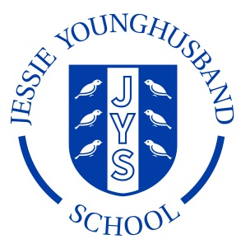

**School Council Agenda 4**

**Aspire ~ Respect ~ Enjoy**

|  |
| --- |
| Meeting of: JYS School Council |
| Place: Mrs Sadler’s Office |
| Date: Wednesday 7th December |
| Time: 2.30–3pm |
| Apologies for absence: |
| Minutes of the last meeting:   * Are they agreed as an accurate record? * Matters arising from these minutes: * Playtime equipment recap |
| This meeting’s business:   1. Agree a chairperson and a secretary for the next meeting. 2. Feedback about water fountains. 3. Feedback about condition of playhouse. 4. Feedback about condition of car track. |
| Any other business:   * Agree a date and group to form an action plan for playtime developments. |
| Date of the next meeting: It will be during the first week of the Spring term. The date will be confirmed by the end of term. |