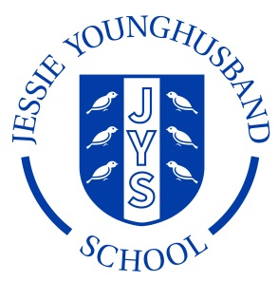

**School Council Agenda 3**

**Aspire ~ Respect ~ Enjoy**

|  |
| --- |
| Meeting of: JYS School Council |
| Place: Year 5 classroom |
| Date: Monday 28th November |
| Time: 12.00 – 12.20pm |
| Apologies for absence: |
| Minutes of the last meeting:   * Are they agreed as an accurate record? * Matters arising from these minutes: Alice and Lucy to feedback about JYS rabbit. |
| This meeting’s business:   1. Agree a chairperson and a secretary for the next meeting. 2. Agree a Code of Conduct for behaviour. 3. Feedback from classes about playtimes. |
| Any other business:   1. A query about the functioning of the water fountains. 2. A query about the condition of the playhouse. 3. A query about the condition of the car track. |
| Date of the next meeting:  Wednesday 7th December ~ 2.30–3pm in Mrs Sadler’s Office. |