Websites/app list
You may be worried about ‘screen time’ during school closure. Here is a list of some websites/apps/videos that may be able to support your child’s learning. However, please remember that these are not a substitute for play and ‘hands on’ learning.
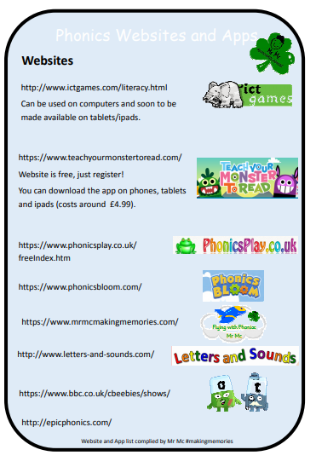

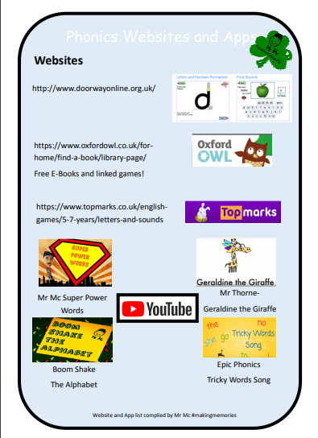

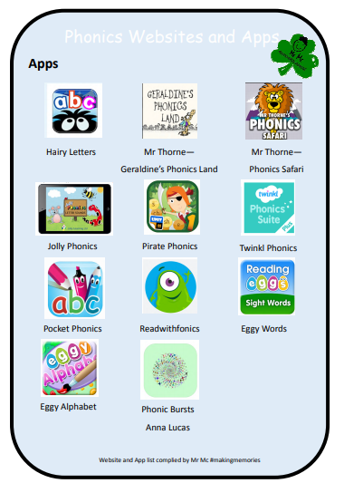
Jack Hartmann is also a firm favourite for us for brain gym, subitising and much more. Just search his videos on Youtube.

