Home learning pack (2)
These weeks would ordinarily be the Easter Holidays but I do recognise that some of you might want to maintain a teaching routine and others might have a bit of a rest from the home learning. Because of this, I have ensured the activities in this pack are fun, creative and enjoyable so that they are suitable for all.
Please refer back to the great websites that I have written in the first ‘Home learning’ pack, as these are still great resources for ‘fun’ maths and literacy.
I will be continuing to post recordings of our ‘class read’ in our closed Facebook group – ‘JYS Year 4’ over this period.
Activity 1 – Art/Writing:
Watch this clip: https://www.youtube.com/watch?v=GhFS3H2ejNA from Monsters Inc.
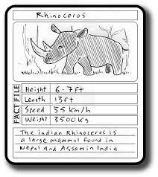
For your first activity I would like you to design and create your own monster to join the ‘Scare Floor’. Once you have designed your monster, you should create a Top Trumps card for them. You might want to use a similar layout to the template below or design your own layout. The last section of your card should include a few sentences as a summary of your monsters key skills and weaknesses.
You could make a set of different monster ‘Top Trump’ cards and then play a game with them after.
Don’t forget to include:
Capital letters and full stops
Adjectives to describe
Pronouns

Activity 2 – Music/Science:
Before the school closure, we were looking at different musical instruments and how their sounds are created. This follows our recent Science unit of sound where we investigated how different vibrations change the way we hear sounds.
For this activity, I would like you to watch the following clip and create one or more of the musical instruments shown: https://www.youtube.com/watch?v=S6gBYYxvizs
If you do not have the equipment to make the musical instruments in the video, perhaps you could write about what happens to the sound when the holes are covered and then uncovered on the recorder.

Activity 3 – Science project:
This activity might require you to pick a flower from your garden or look for one on a walk with your family. Having a physical flower to look at and dissect will really help this activity however, if this is not possible, it can be done without.
I would like you to look at and match the correct label to the defintion. I have added the flower labels and their definition mixed up below :
Petals | Absorbs water and minerals from the soil.
Leaves | Make food for the plant from CO2 sunlight.
Roots | Transports water around the plant.
Stems | These attract insects such as bee’s to the plant.
This website might help you to match the correct definitions: https://www.dkfindout.com/uk/animals-and-nature/plants/parts-flower/
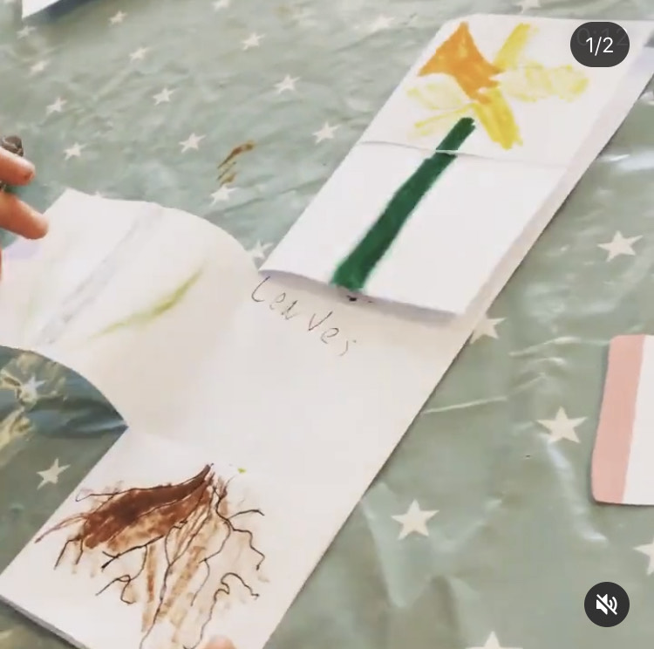
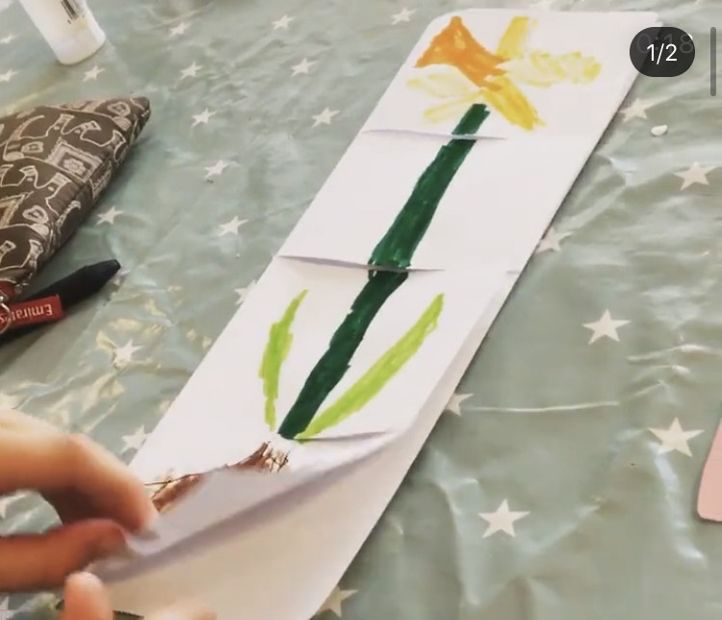
I would like you to show your findings by laying it out in a similar way to the layout below:

Activity 4 – Maths:
The next time you get your groceries, keep hold of the receipt for this activity.
Look at the receipt, write down how much each item cost and do the following:
- Find out how much you saved on ‘buy one get one free’ or ‘multi-buy’ savings.
- How many different combinations of coins could you use to pay? (You might want to draw these)
- How much change would you get from a £5, £10 or £20 note?
Activity 5 – Reading/Writing:
Re-read your favourite book, or read a new book. Write a review for that book and send it to me via email. I will post your reviews on Amazon for you to read your work published on the internet.
Remember to include:
Capital letters and full stops
The authors name/Book title
Your favourite part of the story
Summary of the story
Rate it out of 5 stars

Activity 6 – Music:
Listen to some music on the radio/online or a CD of your favourite band/group. Write down a list of different instruments you can hear being used.
Now listen to music from a different genre – what instruments can you hear? Compare the differences and similarities in the music.

Activity 7 – Maths:
For this activity you might want to use a tape measure. If you do not have one, find a unit of measure and stick with it throughout (for example, a ruler or a piece of masking tape or a DVD case).
Walk around your home and look at each room one by one. Predict which room has the greatest perimeter. Remember the perimeter is the measurement around the outside of the room or the walls.
Now use your unit of measuring to measure around the room – for example if you have used a ruler then one wall might be measured at 15 rulers. Work out the perimeter of each room.
Was your original prediction correct?
Activity 8 – Design and Technology project:
Build a robot out of empty boxes, bottles and other recycled materials.
Design your robot, labelling the materials you will use in your design.
Note to parents/carers: encourage children to see if their robot can include any movable parts.

Activity 9 – PSHE:
Note to parents/carers: I understand that for many children, this might pose a difficult time. Worry and anxiety from the news, being off school and the change in daily routine can be unsettling for anyone. I have added this PSHE activity so that parents/carers can talk through children’s concerns with them and help to come up with practical solutions to support them.
For this activity, I would like you to take 5 minutes to sit in total silence. During this time you might want to think about your day so far, focus on your breathing and calm your mind. Music might help you to do this.
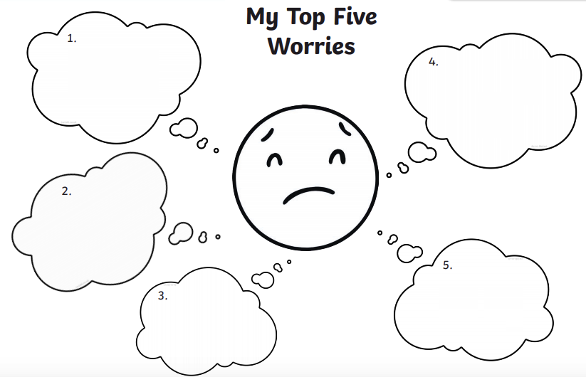
After 5 minutes quiet time, I want to you think about anything you might feel worried or anxious about. Write these down in the clouds below or re-design your own sheet to do it.
Share these worries with your grown up and discuss different practical solutions to help. These might include daily exercise, walking around the garden, quiet time etc.
Activity 9 – Maths practical activity/writing task:
Ask a grown up to help you to bake something, this might be bread, cookies, cake or anything else that you can bake easily. Take photos of you completing this activity and write each step next to the photo as if writing instructions for a recipe in your Literacy book.
Weigh out all the ingredients and write these weights down as a list.
Once you have done this, work out how much more of each ingredient you would need to make 4 of your finished product, then 8, then 10. Write each weight down in your math’s book.
Activity 10 – Arts and Crafts:
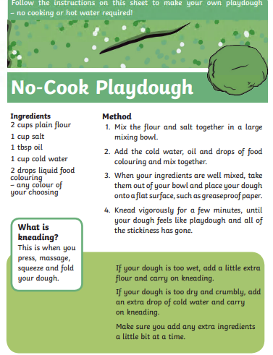
Below is a recipe for playdough, spend some time creating your own playdough figures. You might want to come up with a story about the figures you have created. You could write this story down or tell it to someone else in your house.
Activity 11 – Physical Education (game) Adult led:
For this activity you need to find yourself a safe open area – maybe a garden or a field or even a room in your house (where you can reach all 4 corners).
Game name: Corners.
- Name the corners i.e. red, blue, green and yellow.
- Explain that when you say the word “corners” children must run to any four corners of the room. You will choose a corner and all those in that corner are out. The aim is to be the last person standing.
- Go to one side of the room and turn your back on the players – call out the word “corners”. Players have to run to their chosen corners.
- With your back STILL turned on the players say e.g. “I chose red corner!” and then turn around quickly. Anyone who hasn’t reached red corner in time, is out.
- Repeat until all one player left.
Activity 12 – Design and Technology Project/Writing/Drama:
Task a: Cast your minds back to last half term, where we dived into learning all about the Titanic. Remember how we talked about the different activities you could do on board and the different foods you would eat, depending on your class (1st, 2nd or 3rd).
For this activity I would like you to draw and design your very own modern day cruise ship. You need to come up with a name for your cruise ship, decide what activities will be available on what days and decide what different rooms will be available for which passengers, for example:
- Cinema;
- Theatre;
- Hairdressers;
- Gym;
- Spa;
- Shops.
Task b: Think of the entertainment that the passengers on board your ship might enjoy. Come up with a puppet show, theatre performance, dance, singing (whatever you like) which could entertain your passengers.
Task c: Create a dinner menu for your passengers. Will they have the 10 courses available on the Titanic or will they have 3 courses? Will the menu for your 1st class passengers be the same as your 3rd class passengers? Will you have a class system for your passengers at all?
Extension: Build your cruise ship. Don’t forget to include the colours you want your ship to be, the name of your ship and any windows for passengers to see out of. You might want to include lifeboats (as we all know what went wrong on the Titanic).
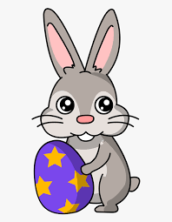
I hope you all have a fantastic next two weeks of learning. Please feel free to share any work with me or any other activities you have been doing during the school closure. I really enjoy seeing all the fun learning – bweir@jys.org.uk
For now – Happy Easter!

