Home Learning Grid- Anglo-Saxons and Vikings
Draw and colour a picture of an Anglo-Saxon. What is he/she wearing? (You will need to research this first).  Make it a full-page drawing with labels showing what clothes and accessories he/she has. | Create your own Sutton Hoo helmet/mask using whatever materials you have. You could use cardboard or paper Mache for example. You could also decorate it using tin foil or buttons. Look at the one found at Sutton Hoo for an example. (It can be any size). You will need to research Sutton Hoo helmets on the internet. | Think of what you do on  a normal day. Mark these events  on a timeline. Make it in  chronological (time) order.  You can make it more interesting by drawing little diagrams along with the activities.  Then do one for your whole life so far…  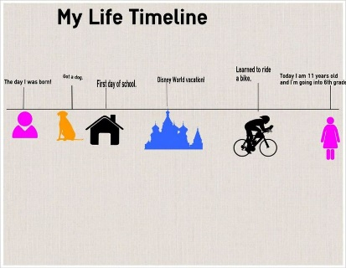 | Research an AngloSaxon artifact and  explain what it  was used for.  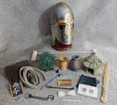
Ask a family member about  an important event in their  lives. Draw a comic strip to  show the story.  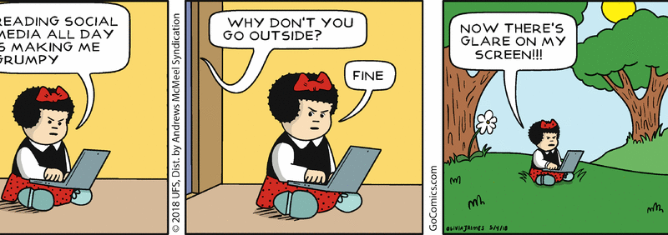 | Research the Anglo-Saxons.  Find out about their homes,  Villages, food,  Family, punishments, religion etc. | Create a timeline of key events that happened between the start of the Anglo-Saxon era and the end of the Vikings. Remember to use your understanding of ordering numbers to help you! | Draw or print out a picture of yourself and find a picture of a Viking child. Write about the similarities and differences between you both. Include information about their day, school, family, toys, pets, work.
Make a model of a Viking house or an Anglo-Saxon house. Use recycled goods where possible, card, paper, yogurt pots etc. Paint it and take a photo of it.  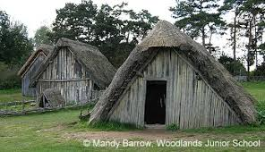 | Research Viking shields and draw or paint your own one.  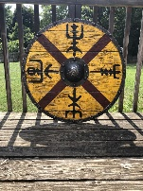 | Bake and decorate some AngloSaxon/Viking food. Write down your recipe and some facts about food of the period. You Take photographs and stick it in your book.  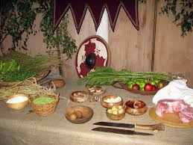 | Select a famous figure from the AngloSaxon or Viking era. Draw/paint/collage a picture of them. It could be a king, soldier, God or someone else.  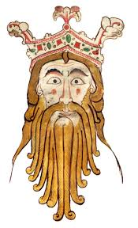
Design a Viking longboat and add the measurements of the boat to your picture. Now convert units of measurement for example metres to centimetres.  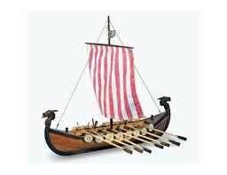 | Write a biography about King Alfred the Great. Think about all the things that happened in his life and why he is related to our topic. | Create a map of Britain showing the Anglo-Saxon kingdoms and how they changed when the Vikings invaded.  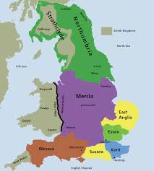 | Look on the internet and in books to find out what the Vikings thought about death. Where did they believe they went when they died? What rituals did they practice?  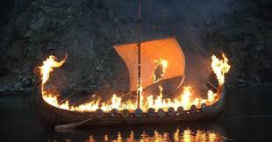
Write a fact file about Viking life.  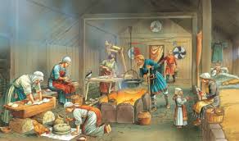 | Design a Viking board game. How many players can play? What is the purpose of the game and how do you win? | Design a Viking meal. It could be fun to have a go at making a recipe or two!! Take pictures of you making it and stick it into your book.  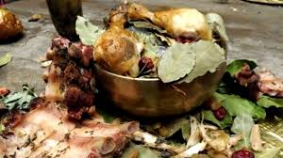 | Write a diary entry for a Viking warrior or an Anglo-Saxon settler. How would a diary entry be written long ago?
Make a piece of Anglo-Saxon or Viking jewellery. You can use clay, dough (flour & water), cardboard, paper, wool etc. Photograph it and stick the photo in your book.  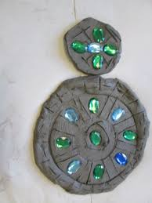 | Write a secret message in Viking runes.  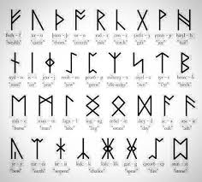 | Write a poem about the Vikings.  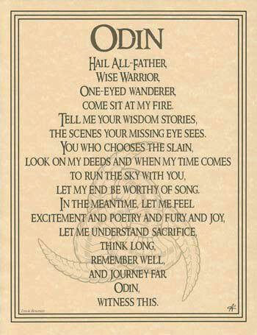 | Research the famous viking, Harald Hardrada.  Who was he?  What was he famous for?  Find out about him and write about him.  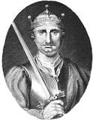
Research the Northern Lights.  What are they?  Where are they?  What causes them?  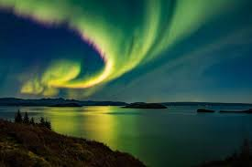 | What Gods did the Vikings believe in? Research and make a fact file. Then find out about what Gods the Anglo- Saxons believed in. Are they similar, the same or completely different? | Write a newspaper report about a Viking invasion. You can do this on the computer if you like, or use the template provided. | Create an informative PowerPoint presentation about a famous Viking myth or legend which you have researched.  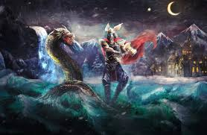
Design your own (realistic!) Anglo Saxon coin. Look on http://www.bbc.co.uk/history/trail/conquest/wessex_kings/coins_intro.shtml for ideas and designs.

Create a ‘Wanted Poster, which includes a description of the criminal, states what crime has been committed and what the punishment is. Look at this website for ideas. http://topicbox.net/geography/anglo_saxons/5655/

