Name Date
The Book of Butterflies
WALT: tell the story using sentences that describe

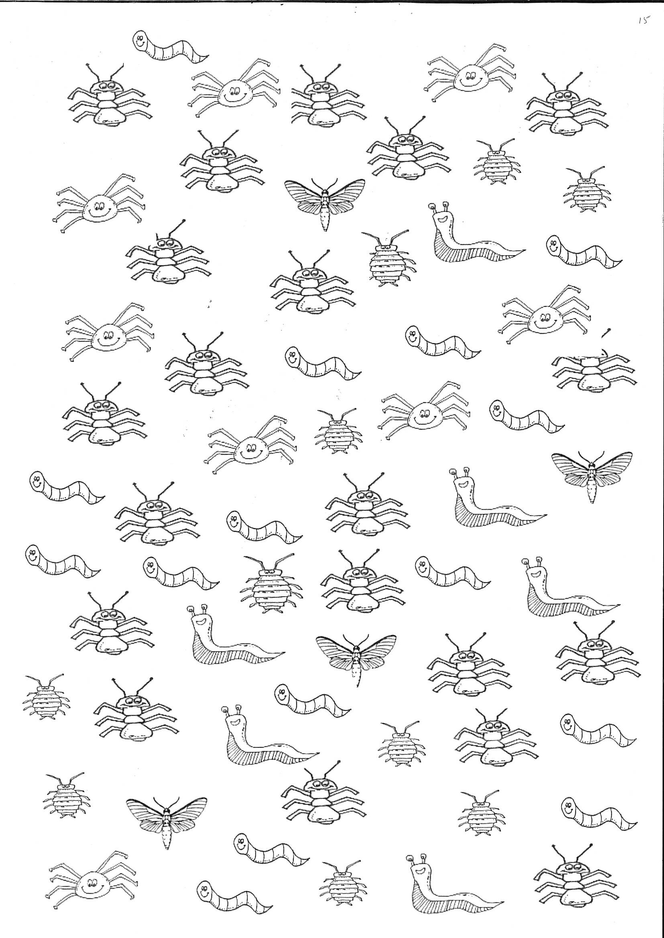

WALT: create a tally chart, pictogram and bar chart of the minibeasts found in the grounds of JYS.

J

Name Date
The Book of Butterflies
WALT: tell the story using sentences that describe

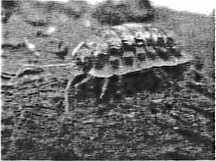
WALT: solve number problems—
write the number sentence and draw a picture to show the problem (part whole, bar diagram, number line)
1 .How many more spider legs than dragonfly legs did you count?
2. There are 10 woodlice. I counted all their legs and there were 140. How many legs did each woodlouse have?
3. How many minibeasts did you count on the sheet altogether?
4. A Woodlouse has 7 pairs of legs. How many legs would 25 woodlice have?
5. If all the spiders laid 6 eggs how many eggs would the spiders lay?
6. Beth counted 137 woodlice. Ben counted 114 woodlice. What's the difference?
7. Ruby counted 37 slugs. Louise counted 28. How many slugs altogether?
8. Jack counted 56 worms. Henry counted 28 more. How many did Henry count?

