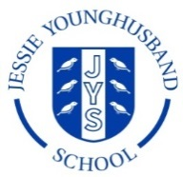
Year 1 Home Learning Activity Pack – 19th March 2020
Dear Year 1 Families,
Welcome to our activity pack for you to use to support your child with their learning at home, whilst the school is closed.
Firstly, I want to say how proud I am of all the children in our class. As I mentioned at our recent parent meetings, they are so lovely and they work so hard to demonstrate our school values of ‘Aspire ~ Respect ~ Enjoy’ on a daily basis. It is because of this that Mrs Ayers and I both find it such a pleasure to come to school every day. We love working with your children and we are feeling incredibly sad at the moment, knowing that we won’t get the chance to keep working together as a class over the coming weeks.
However, the most important priority now is for everyone to keep as safe, healthy and happy as possible and I know that the children’s learning journey will continue at home in valuable and enriching ways. P{ease remember that there will be so many ‘natural’ learning opportunities every day: helping you to write a list of jobs to do; helping to weigh out ingredients for making supper; counting out the cutlery needed to set the table etc.
When thinking about your child’s academic learning, this is a good time to focus on consolidating the skills that they have already covered at school. At least initially, give your child activities that they can do confidently so that their ‘learning task time’ is fun and enjoyable. It is so important that the children have a really strong grasp of the core skills (like being able to say their number bonds to ten immediately and without hesitation; and being able to write each letter using the correct handwriting joins) before they move on. Hopefully the activities in this booklet will give you some suggestions of where to start. However, please don’t feel that you need to cover everything! Be led by your child’s interests and questions. What do they want to learn about?
Help your child to record their work in whichever format works best for you. They may complete some tasks on individual pieces of paper but you may also like to use a notebook or to take photos of achievements. Please do save the things that your child produces as this will provide valuable evidence of their learning journey. I will really look forward to seeing what they have been up to when we return to school. I have also told the children that I would love to see any pieces of work that they are especially proud of via email, if it is possible for you to upload a photo of what they have done! My email address is: sarah.peart@jys.org.uk.
You can find all of the resource sheets and files that are mentioned in this pack on the Year 1 section of our school website, as well as a few other useful things! Go to https://www.jys.org.uk/website, click on the ‘Classes’ tab and scroll down to Year 1. Please note, I will not be posting any new ‘school closure’ resources on our Virtual Learning Environment (VLE) page after Friday evening (20th March). However, you might still want to check the VLE occasionally as I may post the odd item just for our class, rather than sharing it on the publicly accessible school website.
I will really miss seeing all of you over the coming weeks. Please do keep in touch by email. I will be checking my emails regularly.
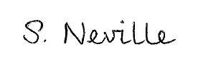
With very best wishes to you and your families during this time.

Mrs Neville

Literacy
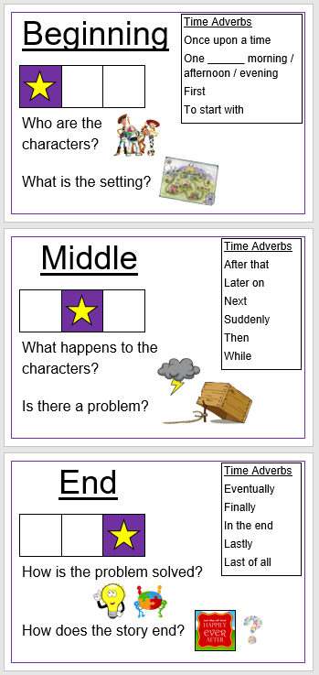
Traditional Tales
In Literacy, our current unit is all about reading and retelling traditional tales. We started by reading ‘The Tale of the Three Billy Goats Gruff’ and we then had a go at retelling the story in our own words, which the children really enjoyed! In school, our main focus text is ‘The Tale of the Three Little Pigs’ which links to our ‘Home, Sweet Home!’ topic. We have read three different versions of the story, including an ‘alternative’ to the original! Copies of these stories are on the website.
The children always enjoy seeing how authors play around with a familiar story to make it even more exciting and fun! Roald Dahl’s ‘Revolting Rhymes’ is a favourite example of this.

Reading Traditional Tales
At home, please read some traditional tales together. When you are sharing the stories, focus on the following:
- Picking out time adverbs (such as ‘Once upon a time’, ‘Next’ and ‘Some time later’);
- Identifying the adjectives used to describe the characters and settings (the big, bad wolf; the brave billy goat);
- Joining in with repeated phrases such as ‘Who’s that trip-trapping over my bridge?’ or ‘I’ll huff and I’ll puff and I’ll blow your house down’;
- Summarising the key events that happen in the beginning, middle and end sections of the story.

Retelling Traditional Tales
Help your child to have a go at retelling different traditional tales verbally first. You could take it in turns to say one event each until you reach the end of the story. Encourage your child to use some different time adverbs as they retell the story (‘Then . . .’, ‘After a few hours . . .’) and to use some adjectives to describe the characters and settings.
If your child enjoys it, encourage them to have a go at retelling a traditional tale in writing too. Alternatively, they could make up their own traditional tale!
Our key objectives for story writing are:
- To write a story that has a clear beginning, middle and end which are sequenced in order;
- To use different time adverbs to sequence events (see the prompt poster above for ideas);
- To proof-read our writing once we are finished, checking that capital letters and full stops are in the right places.
Please focus on these aspects when discussing your child’s writing with them. Remember, writing should be fun! Praise your child for whatever independent efforts they produce and pick only 1 or 2 elements to review with them, otherwise the joy of writing is quickly lost!
If you would like your child to watch some animated versions of different fairy tales, it is worth looking at the ‘oxbridge baby’ channel on YouTube. If you click on their ‘playlists’ section, there is an ‘Animated Fairy Tales’ playlist containing 21 videos. Please be aware that I have obviously not been able to watch all of the episodes, so please do check the content of the videos before allowing your child to watch them. Adverts also appear along the bottom of the screen during the animations, which will need to be ‘clicked off’.

Other Writing Ideas
In addition to story writing, your child might like to write a description of a character from a traditional tale (or any other story!). They could include what the character looks like, their personality and how they behave.
For less confident writers, getting them to write one-word or two-word labels to describe different parts of a photograph or illustration can be a more enjoyable and manageable task.

Daily Reading
Continue reading daily with your child. It is vital that they keep practising using their phonic skills! Please encourage them to read lots of different types of text with you - fiction and non-fiction books, poems, magazines and comics. Please note, we have collected the school reading scheme books back in, in preparation for the closure.
Here are some useful strategies to help your child if they get stuck when decoding a word or making sense of what it means:
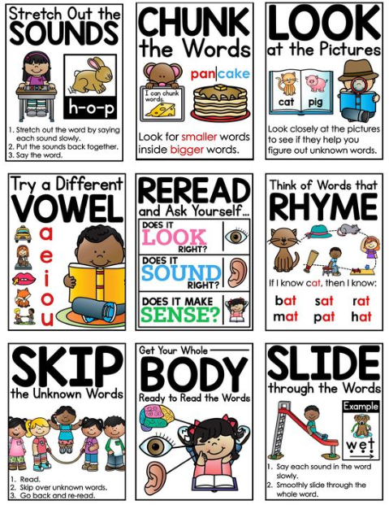

Handwriting and Spelling Practice
Please see the attached sheets that show the letter formation of all 26 letters of the alphabet. As you will see, on the lowercase letters sheet, each letter has a ‘formation rhyme’ with it, which helps to remind the children of how to write the letter correctly. You may also find it useful to look at the ‘PowerPoint to support children with cursive letter formation’. If you run a slide show of this file and then click on the pencil on each page, you can watch the pencil write your chosen letter in the correct way.
Every day, please encourage your child to practise forming a few individual letters, especially any that they are still finding tricky to write properly! Then ask them to write out a few short, simple words and to practise joining all the letters within the word properly. You could use some of the words given in your child’s spelling book each day, which would also help them to revise over the Year 1 common exception words and phonic patterns whilst practising their handwriting.

Phonics
If your child was in school for the full day on Tuesday (17th March) then I have been able to complete the 2019 Phonics Screening Check with them to assess how their decoding and blending skills have developed since the end of the autumn term.
If you would like to email me, I will be able to reply and give you personalised information about how your child is getting on and any specific sounds or skills to work on at home.
However, even if your child hasn’t done the assessment this week, there are a number of common things that many of the children are still finding tricky and so it is worth focusing on these points with your child if you can:
- Not surprisingly, most of the children are more confident with reading real words! The ‘monster’ words can be more daunting for them, so please regularly practise decoding a mixture of real and monster words together. You can find some example words to get started with in the ‘Phonics Real and Monster Word Lists’ document.

- Some children are still getting confused between the letters ‘b’ and ‘d’. Here are some visual ways to help them remember which is which:

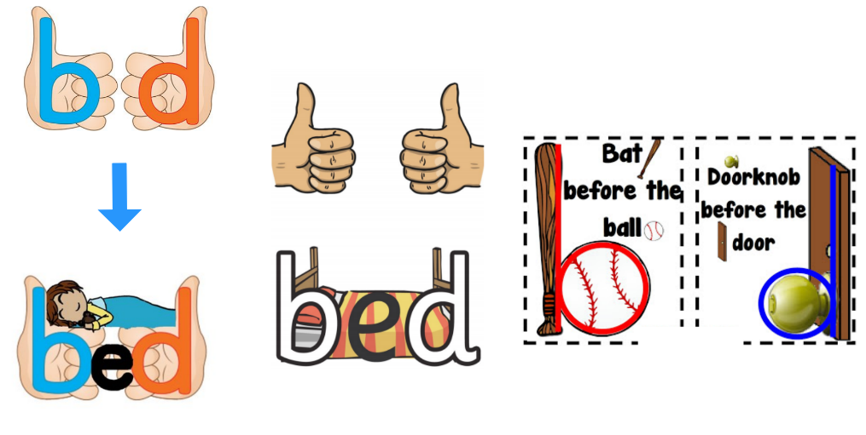

- Many children are getting confused between the ‘aw’/‘au’ and ‘ow’/‘ou’ sounds. Here are a few example words to use with your child:
Aw | au | ow | Ou
hawk | autumn | vow | Out
saw | August | cow | Loud
draw | launch | clown | Cloud
straw | author | towel | Shout
fawn | haunted | how | About
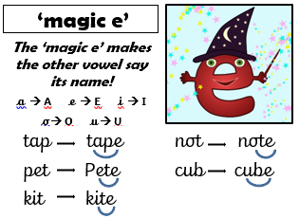
- Split digraphs (the ‘magic e’) are hard to spot when the ‘magic e’ doesn’t come at the very end of the word and is instead hidden within the word!

You can find some examples of these words in the ‘Phonics Magic e words’ document.

Remember: the ‘magic e’ works with the vowels (a, e, i, o, u) to make them ‘say their name’. The ‘magic e’ itself is a silent letter.
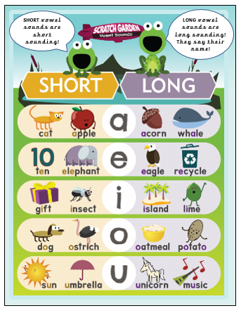
If your child is getting confused about the vowels, this reminder poster might be helpful.

Also, some children still need to consolidate their recall of the whole alphabet and recognising the ‘pairs’ of uppercase and lowercase letters which go together. If your child needs help with this, make individual letter cards and spread them out. Then ask your child to put them in the correct order. Can they spot if a letter is missing? Get them to pair up the uppercase and lowercase letter cards too.

There are lots of alphabet songs available online so have a look!

Supporting your child with phonics at home
Please use the ‘Phonics Mat’ which I gave out at our parent meetings a couple of weeks ago. This contains all of the sounds that your child will need to recognise.
You might find it useful to make flashcards of the sounds which your child still finds tricky to recognise. Each day, ask your child to say the sound (phoneme) made on each card, reminding them if necessary by saying the sound together several times.
Next, write down two or three words containing some of the target sounds and ask your child to read each one to you. When you are doing this, encourage your child to sound out each phoneme and to then independently blend the word to say it as a whole word. This is really important! For example, for the word ‘treats’, they can say ‘t – r – ea – t – s’ but then they must say ‘treats’ fluently and without hesitation by themselves. Write a mixture of ‘real’ and ‘monster’ words for them to practise with.

Generating word lists
As an extra challenge, it can be fun to start generating lists of words that all share a particular letter and sound pattern.
For example, you might write down ‘train’ and then ask your child to think of other words that have the same ‘ai’ sound in them, like ‘snail’, ‘tail’, ‘painting’ and ‘chain’. You can also encourage your child to start looking for these words in their reading books and then add to your lists together, over time.

The following websites have helpful phonics audio guides and videos to support phonics learning at home:
https://www.oxfordowl.co.uk/for-home/reading/phonics-made-easy/
‘Mr T’s Phonics’ channel on YouTube is great – it is Mr Thorne and Geraldine the giraffe teaching different sounds in an engaging and fun way!
All of the previous years’ Phonics Screening Check materials are available online for you to download if you wish.

Maths
Mental Maths Skills
Keep playing the maths games from our ‘Stay and Learn’ session to help develop your child’s mental maths skills.

Adding and Subtracting
Practise adding and subtracting numbers up to 20 (and beyond if your child is confident). Generate your own numbers by rolling dice or make your own set of number cards which you can shuffle and then pick randomly from.
Encourage your child to use practical resources (such as cubes) or the 100 Square to help them with their adding and taking away if they need to. When working with bigger numbers, help your child to add and subtract efficiently by partitioning the smaller number into ‘tens’ and ‘ones’.
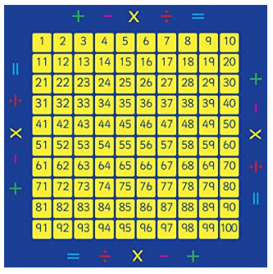
Add 10
jump down one row

Take away 10
jump up one row

Add 1
jump ‘on’ (right) one space

Take away 1
jump ‘back’ (left) one space

Example question: 48 + 25
Start by finding the biggest number (48) on the 100 Square.
Partition the smaller number (25) into ‘tens’ and ‘ones’. In this case, 25 is made up of two ‘tens’ and five ‘ones’. On the 100 Square, count on the two ‘tens’ of the ‘25’ by ‘jumping down’ two rows from the start number:
48
58
68

Then count on the five ‘ones’ by ‘jumping to the right’ five times along the row on the 100 Square:

68 69 70 71 72 73
The answer is 73.

Measuring
We are currently doing a unit on measuring length and height. Please find different items around the home to practise measuring with your child. Please measure using a ruler and remind your child to line up one end of the object with 0 cm. They need to know that there are 100cm in 1 metre.
You can also practise measuring with non-standard units (such as cubes, 10p coins, hand spans, hair clips).
Example questions:
How many coins long is your favourite cuddly toy?
How many hand spans high is the kitchen table?

You can practise comparing the length and height of different items once you have measured them. Try and encourage your child to use the following language when they are describing:
short, shorter, shortest, shorter than, long, longer, longest, longer than, tall, taller, tallest, taller than etc.
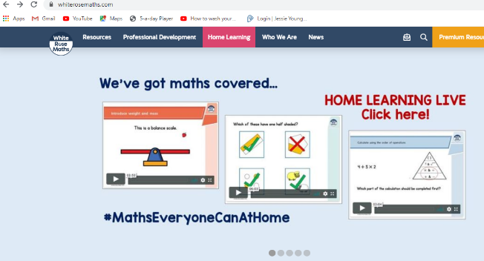
Before Easter, we were also due to cover a unit on measuring mass and capacity. We base our planning and resources around the White Rose Maths scheme and they have helpfully produced a series of five maths lessons specifically for parents to use at home with their children during the closure. The Year 1 lesson videos and worksheets about mass, capacity and volume can be found at:
https://whiterosemaths.com/homelearning/year-1/

Other Online Resources
Make use of online interactive maths resources, including:
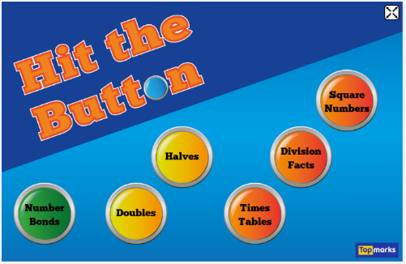
- TT Rocks Stars

- Sumdog

- Hit The Button – access through
https://www.topmarks.co.uk/maths-games/hit-the-button

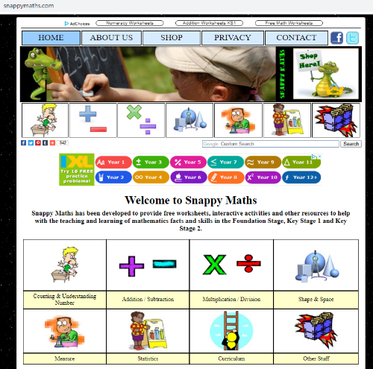
- Snappy Maths
http://www.snappymaths.com/
There are downloadable worksheets and lots of interactive games and activities on this site. The resources are divided into sections according to the area of maths. Perhaps start by exploring the ‘counting and understanding number’ and ‘addition and subtraction’ sections. Talk with your child about which types of calculations and activities they feel will give them a nice level of challenge, without over-stretching them. Please note, in Year 1 we do not cover any of the ‘formal’ calculation methods like column addition and subtraction.

Home, Sweet Home!
Science
I have included some practical science investigation activities based around our ‘Everyday Materials and their Uses’ topic. We have only just started exploring this in school so the children may not have too much prior knowledge! The activities are saved in two separate ‘Science Materials Tasks’ documents.

Geography
If you are able to use the internet for research or to communicate with family and friends in other countries . . . choose a country and investigate what traditional homes are like there. What materials are these homes and shelters made from and why are these materials traditionally used? Is it because they are found locally or is there another reason? How does the climate and weather in your chosen country affect what type of homes people need? How are the homes similar to, or different from, the type of home you live in?

Art
Design your own dream home! Where would it be? What would it look like? Try and add as much detail as you can to your designs and drawings. You could write a description of your dream home too!

Design and Technology
If you have the relevant craft resources and equipment at home, could you try making a small model of a house out of cardboard boxes and paper etc? Practise using your measuring skills to help you create things the right size. Which features will you include and how will you decorate your house? Who would like to live there?

Keeping Active
Search for the ‘Cosmic Kids Yoga’ and ‘Jack Hartmann Kids Music Channel’ channels on YouTube for activities and songs to help your child to keep active and to relax and be calm too.
The National Trust have produced a list of ‘50 things to do before you’re 11¾’ which has some great ideas that you could use or adapt for use at home in your garden or outside space, if you have one.
Mr Neaves has also added a ‘Physical Education Support’ document to the ‘Keeping Active’ section of our resources so have a look at the suggested websites listed there as well.

Computing
We have been using different computing programs in school to develop our programming skills. This involves the children writing electronic algorithms (sets of instructions) to make different things happen on-screen. If your child has enjoyed this learning, you might like to check out the ‘Lego Mindstorms Fix the Factory’ app!

