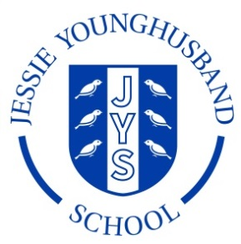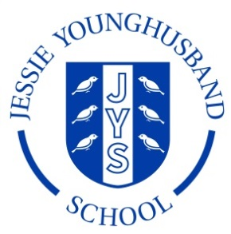

**School Council Agenda 6**

**Aspire ~ Respect ~ Enjoy**

|  |
| --- |
| Meeting of: JYS School Council |
| Place: ICT Suite |
| Date: Wednesday 3rd April 2019 |
| Time: 14.15-14.45 |
| Apologies for absence: |
| Agree the minutes of the last meeting: |
| This meeting’s business:  Chairperson: Sam Secretary: Ines   1. Welcome the Council 2. Review the minutes from the last meeting 3. New projects 4. Are there any further projects the council would like to tackle? 5. AOB 6. Arrange date and roles for the next meeting. |