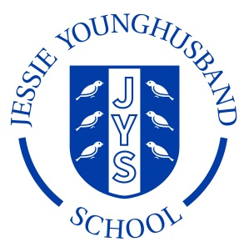

**School Council Agenda 5**

**Aspire ~ Respect ~ Enjoy**

|  |
| --- |
| Meeting of: JYS School Council |
| Place: ICT Suite |
| Date: Wednesday 4th January |
| Time: 12.00-12.30pm |
| Apologies for absence: |
| Minutes of the last meeting:   * Are they agreed as an accurate record? * Matters arising from these minutes: * Agree completed action plan. |
| This meeting’s business:   1. Look at catalogues and agree a shopping list for new equipment. 2. Sort out who is saying what during the first school council run assembly. |
| Any other business:  N/A |
| Date of the next meeting:  Monday 16th January at 12 – 12.30pm in the ICT suite |