w/b 22.4.19 AD
We are learning to write sentences.
We are learning that information can be retrieved from books.

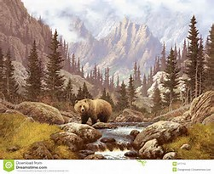

Brown Bears live in

