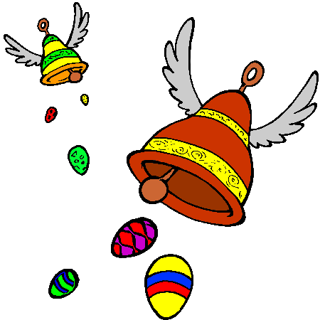French Easter Y5/6 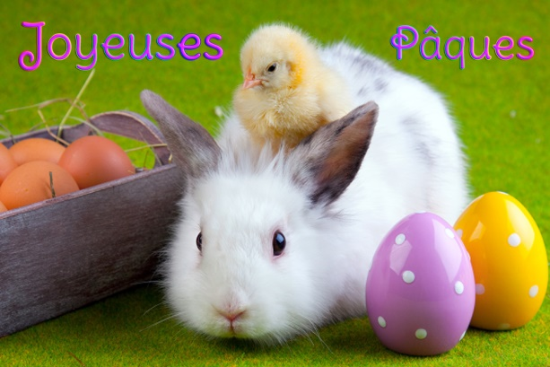

I hope you’ve had fun trying some of the activities in the home learning pack and the Lumen awards. If you’d like to send me pictures of what you’ve done, or anything you’ve made on the computer, I’d love to hear from you on rachel.ritchie@jys.org.uk.
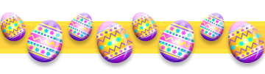
Easter in France is a very big deal. You can find out more about how Easter is celebrated by going to the Easter Zone on https://www.euroclub-schools.org/easter-zone and trying some of the activities there, including the quiz. The song is fun, but very fast and you’ll have to listen a few times to pick out what’s being sung!

Your next task is to write a poem in French, about Easter eggs. The idea is to use a simile to compare colours.

For example:

C’était Pâques le matin.
This morning it’s Easter.
J’ai trouvé dans mon jardin
I found in my garden
Un oeuf vert comme l’herbe,
An egg as green as the grass,
Un oeuf jaune comme le soleil,
An egg as yellow as the sun,
Un oeuf rouge comme une tulipe
An egg as red as a tulip.

Have a go, using the format on the next page. Use a dictionary to help, either a physical one if you’ve got one at home, or an online one: https://www.collinsdictionary.com/dictionary/english-french is useful, and a really good dictionary that gives you language in context is https://www.linguee.com/english-french which also has sound buttons.

Remember, if you want to use ‘the’ (the sun, the grass), use le (masculine noun), la (feminine noun), l’ (if the noun starts with a vowel or silent letter) or les for plurals.
If you want to say ‘a’ (a tulip, a sausage), use un/ une or des for plurals.

You could illustrate your poem when you’ve finished, and do send me a copy!

Mon Poème de Pâques

C’était Pâques le matin.
J’ai trouvé dans mon jardin
Un oeuf vert comme ______ ______________________________,
Un oeuf jaune comme ______ _______________________________,
Un oeuf rouge comme ______ ______________________________,
Un oeuf bleu comme ______ _______________________________,
Un oeuf blanc comme ______ _______________________________,
Un oeuf noir comme ______ _______________________________,
Un oeuf rose comme ______ _______________________________,
Un oeuf violet comme ______ _______________________________,
Un oeuf gris comme ______ _______________________________,
Un oeuf marron comme ______ _____________________________,
Un oeuf orange comme ______ _____________________________.

