Home Learning Packs – Weeks 4-6:
Much like the previous home learning pack, I have opted for a mixture of learning, including writing, mathematics and more physical activities, to keep children engaged by learning through play. I have also included some fun challenges for you all to do and share via the JYS Year 4 Facebook group!
I would very much recommend White Rose Home Learning, which is now live on their website and includes video tutorials, questions and answers for you to check work at home. The link to this is: https://whiterosemaths.com/homelearning/year-4/
Each lesson provides a step-by-step progression for learning, a video tutorial for children to watch and an activity for them to test their new learning. I have included a suggested grid of learning for White Rose Maths underneath:
Week 1 – 20th – 24th April | Lesson Heading | Activity | Extension
Lesson 1 | Recognise tenths and hundredths | Test booklet - online | Extension can be found in Home Learning pack (Activity 3)
Lesson 2 | Tenths as decimals | Test booklet – online | Extension can be found in Home Learning pack (Activity 9)
Lesson 3 | Tenths on a place value grid | Test booklet - online | Extension can be found in Home Learning pack (Activity 11)
Lesson 4 | Tenths on a number line | Test booklet - online | No extension.
Lesson 5 | Dividing 1 digit by 10 | Test booklet - online | Grown-ups could write questions for children to divide by 10.
WEEKEND
WEEKEND
Week 2 – 27th April – 1st May | Lesson Heading | Activity | Extension
Lesson 1 | Divide 2-digits by 10 | Test booklet - online | Grown-ups could write questions for children to divide by 10.
Lesson 2 | Hundredths | Test booklet - online | No extension.
Lesson 3 | Hundredths as decimals | Test booklet - online | No extension.
Lesson 4 | Hundredths on a place value grid. | Test booklet - online | No extension.
Lesson 5 | Divide 1 or 2-digits by 100 | Test booklet - online | No extension.

You do not need to print a booklet out for each activity, you might want to write your answers under the appropriate heading in your maths books. I will be using this resource, moving forward, to teach the majority of mathematics from home.

Activity 1 – CHALLENGE (Art/Hand-eye Co-ordination):
Your challenge is to draw a dinosaur!
Sounds easy, right? WRONG! You need to do it blindfolded or with your eyes closed. No peeking!
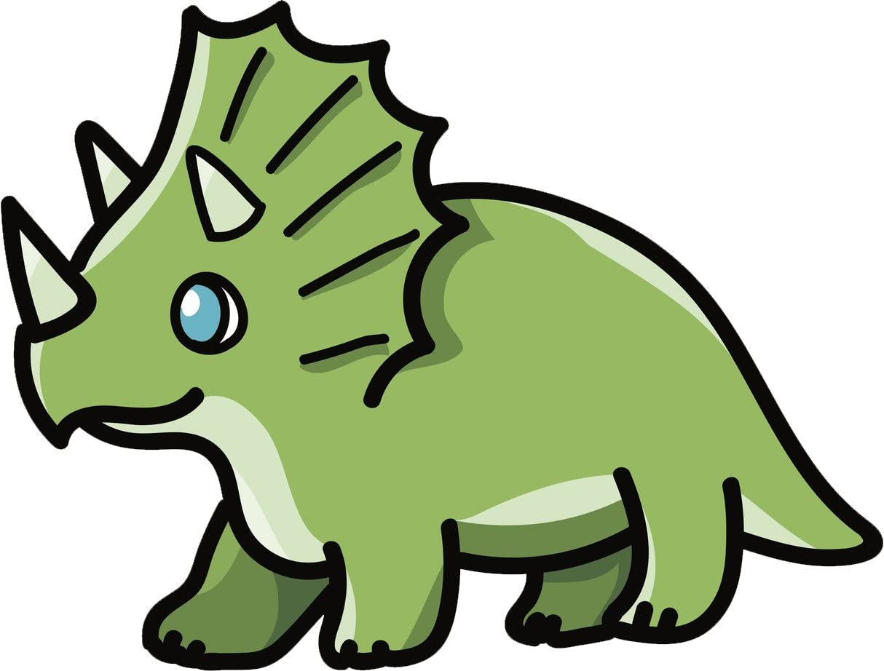
Once you’ve drawn it, you are allowed to open your eyes and colour it in – but no changing the outline.
Post a picture of your results in JYS Year 4 Facebook group for Miss Weir to see.
Extension – (Writing):
Can you write a short story about your dinosaur? For example, if he has a wonky back in your drawing, why is that? Did he have a huge battle with a neighbouring dinosaur leaving him/her without an even amount of spikes? Does your dinosaur live in an icy climate or a hot climate? What food does he/she eat? Why are they not extinct? Did they survive to live in the present day?
YOU DECIDE!

Activity 2 – Spelling/Writing:
For this activity, I am going to provide you with a ‘word of the week’ for both this week and next week. You can repeat this activity in next weeks’ lesson:
This week: dwindle
Next week: perish
For your activity, I would like you to research your ‘word of the week’ and fill in the grid below:
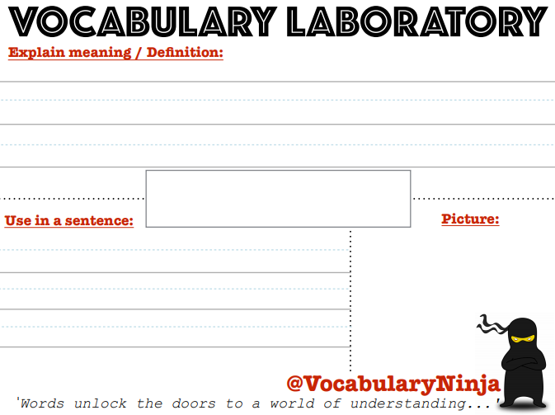
To fill this in, you could print it out or even draw the grid yourself. Your ‘word of the week’ should go in the middle. I want you to explain/define the word in a full sentence, use the word in a sentence and draw a picture to represent that word (for example, if the word is measure, you might draw a picture of a ruler or one item bigger than another item).
Extension: If you have completed that easily, I want you to write sentences modifying the word. For example, use the word in the past tense (I measured the glass), present tense (I am measuring the glass), and future tense (I will measure the glass).
SECRET CHALLENGE: How many times can you use that word in your work or in a sentence without anyone realising? Give yourself a point every time you use it and get away with it. Keep a secret scoring sheet and see if you beat your high score on the word you research next week!

Activity 3 – Mathematics:
Before leaving school, we were beginning to learn all about fractions and identifying different fractions in our work.
For this lesson, I would like you to watch the video for ‘Lesson 1’ on White Rose: https://whiterosemaths.com/homelearning/year-4/
Once you have watched the lesson, answer the questions in the worksheet. If you do not have a printer – write your answers down in your maths books and ask a grown up to mark it for you using the ‘answer’ sheet.
Extension: I want you to find fractions around your home, representing these using objects or colours. For example, this picture shows me 10 objects that are all the same but different colours:
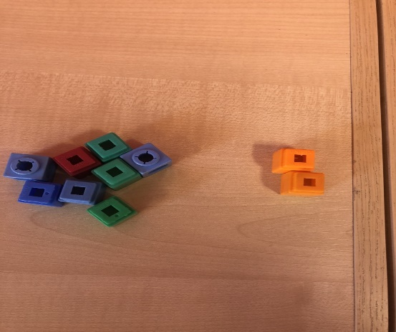
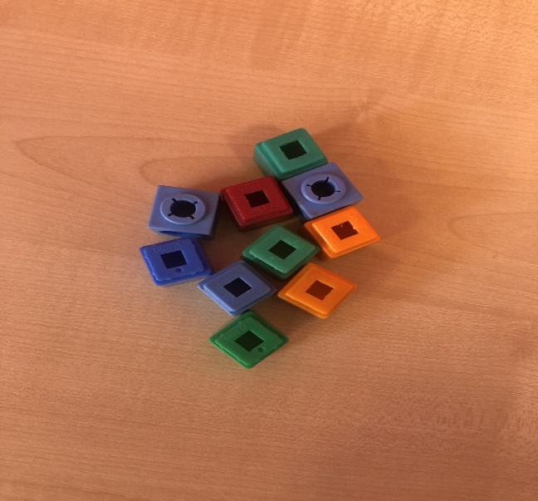
Now I have found the fraction of orange multilink is 2/10:

I could then go on to find the fraction of the blue multilink, green or red.
I would like you to find tenths (/10) in your home too!

Activity 4 – Science:
I want you to think back to our very first topic of the year ‘The Circle of Life’ where we investigated animals, food chains and different habitats.
Today I would like you to try and remember (or research if you cannot) what it means if an animal is an ‘Herbivore’, ‘Carnivore’ or ‘Omnivore’.
- Firstly, write definitions for each of the three headings.
- Then, I would like you to research different animals and put them into the correct category of Herbivore, Carnivore or Omnivore.
- Finally, I would like you to choose one animal in particular and write a fact file about your animal. Tell me everything you know and have found out through research about it. Can you make a poster or leaflet to display your findings.
Send your work/photos of your work to Miss Weir so that she can learn new facts all about animals too!

Activity 5 – Guided Reading:
I want you to become a QUIZ MASTER! Today, you are going to test the grown-ups or siblings in your house and YOU are going to become the TEACHER!
Firstly, read the next chapter of your book to yourself. Once you have read it, think of some really tricky questions you could ask grown-ups about your book. Remember – the answers have to be in the chapter you read.
- If this is a little tricky, use the chapter of Boy at the Back of the Class that I have read and recorded on our Facebook group and write questions about that.
After that, chose 5 questions about the chapter you have read, to ask grown-ups later. It might be questions like this: “What dinner was he eating?” “Who told him to get in the car?”
Then, like the teacher, read a chapter of a book aloud to the grown-ups in your home. Remind them that they need to listen carefully as you will be quizzing them on what they have heard.
- Give your grown-ups a mark out of 5, maybe as a group you could come up with a forfeit. Lowest point scorer does the washing up??

Activity 6 – CHALLENGE (Hand-eye Co-ordination):
This challenge is called CHEEKY CHOPSTICKS!
Find some chopsticks (or something you can use as chopsticks like pencils, pens, the end of a spoon!).
Then, use something small and round like beads, peas or beans.
Your challenge? To use your ‘chopsticks’ to pick up 10 of your object in a row without dropping them!
Post a video of your attempt on JYS Year 4 Facebook Group.
Extension: Can you challenge other members of your household to beat your score? Can you beat your own score? Record your highest score and see if you can beat it in another attempt next week.

Activity 7 – Guided Reading:
Before school closure, children have been learning all about teeth in humans.
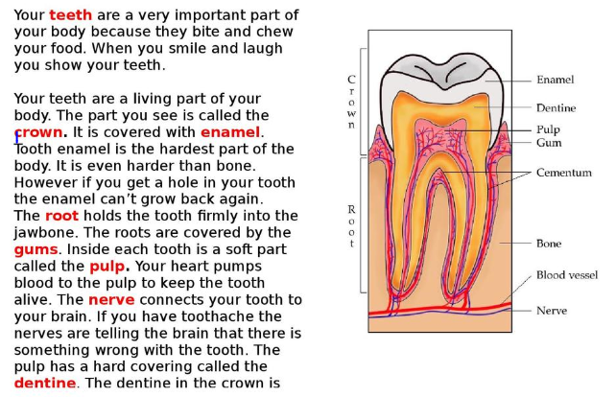

Read this extract all about teeth – ask someone to help if you need it. Once you have read it, answer the following questions in your literacy books:
- Why are the teeth an important part of your body?
- Your teeth are not living, true or false?
- What holds the tooth into the jawbone?
- What is the job or the nerve?
- Which part is the hardest part of the body?
Extension (Science and Art): Can you remember the names of the different teeth in humans? Create a diagram to show this! You could use play dough, make a drawing or a 3D diagram of teeth using cardboard or paper - you might want to use the internet to help you.
Send me photos of your diagram if you like!

Activity 8 – Writing/Art:
This project might take a week to create, and that is fine. You should take your time and enjoy this project.
I would like you to come up with, write and design a puppet show.
- Firstly, I would like you to write a puppet show story. What happens in your show? Who are the characters? Is it a story of good vs evil? Maybe you would like to write a show similar to a story you have already read.
- Next, I would like you to create and design a puppet show theatre. Use recyclable materials such as cardboard, paper or toilet roll holders – get creative, use whatever you have available. MAYBE you could build it out of duvets and blankets?
- Finally, I would like you to design and make your puppets. Again, get creative – use what is available to you. You might already have puppets, perhaps you could create clothing for them to fit with the theme of your play.
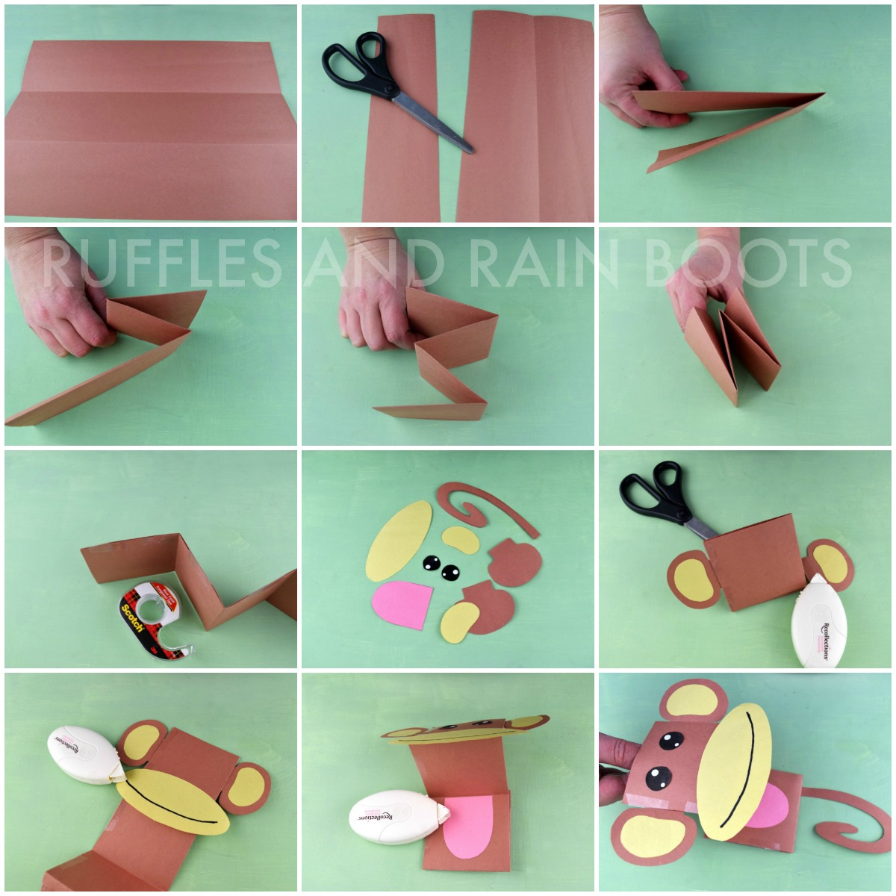
I have attached below instructions and YouTube links on making a puppet and a puppet theatre:
https://www.youtube.com/watch?v=ayFG5Ow4wXI
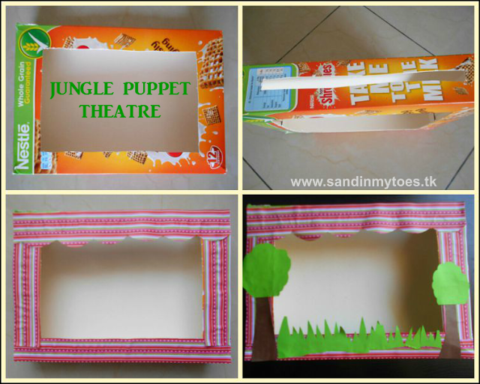
https://www.youtube.com/watch?v=N4kTNLmAhnk

But here is the fun part!! When you have completed your project, ask a grown-up to record your puppet show to share on the JYS Year 4 Facebook group. If lots of people do this, there will be potentially 30 different puppet shows for you to watch. This might inspire you to create another show.

Activity 9 – Mathematics:
Access White Rose here: https://whiterosemaths.com/homelearning/year-4/ and begin lesson 2. There is a video tutorial to help you to find tenths as decimals. Watch the video lesson provided and then answer the questions attached. Ask a grown up to mark your work using the ‘answer sheet’.
Extension: Look at the fractions you found around the house and wrote down in your maths book from the previous lesson. Can you show how you would re-write these fractions as decimals?

Activity 10 – Art and Writing:
“In Billy’s garden, behind the old peach tree is a massive and unusual egg. Billy couldn’t believe his eyes. It shone as bright as a star with golds and ruby stones all over it. This could only be the egg of a ginormous magical creature, but what…?”
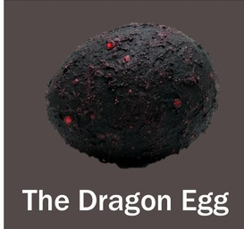
Firstly, I would like you to make or design your very own egg. It could be a dragons (like the one in the photo) or it might be another magical creature. It is up to YOU!
- Think of the colours you might want to include,
- Think of the shape of the egg,
- Is it smooth or bumpy?
- Can you make a 3D sculpture of it? Or design it on paper?
Next, I would like you to write finish the story. Maybe you would like to talk about what happens when Billy finds the egg? How is he feeling? Is he scared or excited? What happens when the egg hatches? What creature is inside?
Extension: You might want to create a play to show this new story. Perhaps you could give lines to others in your house to help you act it out, or even use your puppets and puppet theatre to perform your play?

Activity 11 – Maths:
Follow the link to White Rose and complete Lesson 3: https://whiterosemaths.com/homelearning/year-4/
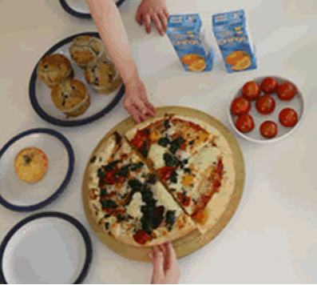
Watch the video tutorial to help you and then complete the questions attached to the activity. Ask a grown up to help you mark your work using the ‘answer sheet’.
Extension: Here is picnic that Petros and Michael are going to share equally. Can you tell me what each of them will have? Look for all the fractions in this photograph:

Activity 12 – Geography:
In class, we have been using Atlas’s to explore different mountain ranges around the world. In today’s Geography lesson, I would like you to use an Atlas or the internet to find the missing mountain ranges on this sheet.
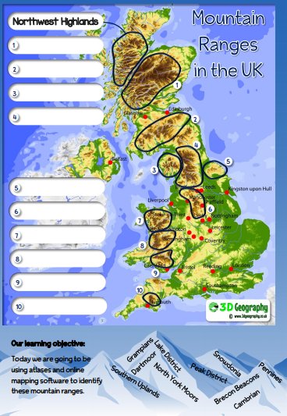
If you cannot print this sheet, please write the number and the mountain range on a page in your literacy books, with heading – ‘Geography: week 4-6 Mountain Ranges UK’
Activity 13 – Science/Writing:
We have been looking at the teeth of humans lots this half term, now it’s time to start looking at the teeth of animals. I would like you to start thinking about the different teeth animals have and how they are different or similar to our own teeth.
- You might want to look at the teeth of a pet you have, although ask a grown up if you can do this as your pet might find it a bit scary.
- You can look at different animal teeth on the internet.
Write a couple of sentences that explain the differences and similarities between our teeth and animals teeth.
Extension: I want you to have a look at these images of animal skulls. Which animal do you think the teeth and skulls belong to? Share your ideas with others in your household. Write a couple of sentences explaining your answer.
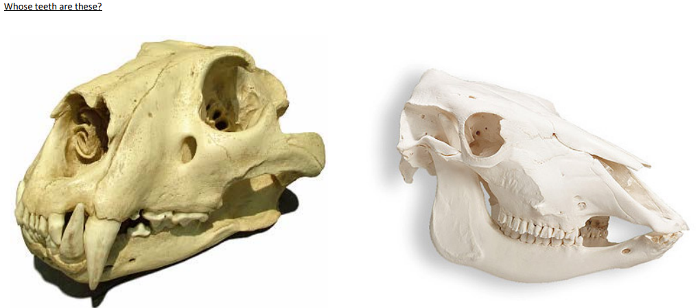

Activity 14 – CHALLENGE
Your challenge today is to spend half an hour doing simple tasks that you’d normally do.. without using your thumbs!
How tricky is it? Here’s some ideas for you to start with!
- Make (and eat!) your breakfast,
- Play a game of noughts and crosses,
- Brush your teeth.
ALL WITHOUT USING YOUR THUMBS! Good luck!

