Math’s lesson pack.
In a bid to continue to keep the pace of learning as fluid as possible, amid the school closure, I have composed a mathematics pack to maintain children’s learning.
Rather than adding new learning (which might be difficult for children to understand without teaching input) I have designed this pack as a revision of all the topics we have covered in mathematics so far. The idea is that once completed the children will be up to date with their learning and we can continue the pace of learning from where we left off.

As well as our daily mathematics lessons, children have been studying in class for the upcoming Multiplication Check. As ongoing learning, I recommend children to regularly (3 times a week) practice on Hit the Button, Times Table Rock stars and The Maths Factor.
I have included links to each of these below:
Hit the Button: https://www.topmarks.co.uk/maths-games/hit-the-button
Times Table Rock stars: https://ttrockstars.com/
The Maths Factor: https://www.themathsfactor.com/times-tables-check/#/
My recommendation for practicing times tables, would be to use The Math’s Factor more frequently, as this is a very accurate representation of how the test will be carried out.

Below are a selection of activities that you might want to carry out with your children over the closure period. Work will also be added to the VLE to support learning.

Thank you for your continued support at home.
Miss Weir

Ordering numbers:
Activity 1:
Make number cards from 0 – 9. Turn them upside down and pick four cards at random – that is your first number.
Write this number down.
- Repeat this twice times to make 2 four-digit numbers.
Can you use the ‘<’ ‘>’ greater than, less than symbols to put your numbers in order?
Play this with another person, see who can get the first ten numbers which are ‘greater than’. They are the first to win.

Extension: If you are really confident, you might want to try ordering numbers with a decimal.
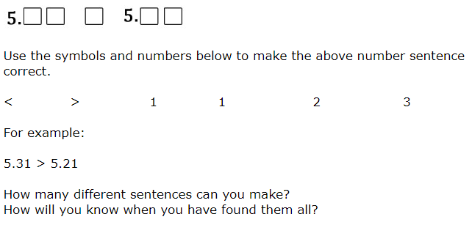
Activity 2:
These are the numbers of spectators at each team’s first five matches. Write them in order, smallest to largest:
 | Portsmouth | Real Madrid | Manchester United
Match 1 | 32,567 | 86,540 | 72,564
Match 2 | 30,482 | 83,460 | 71,936
Match 3 | 33,291 | 79,280 | 74,285
Match 4 | 29,576 | 83,540 | 72,049
Match 5 | 33,910 | 83,490 | 74,036

Positive and Negative numbers:
Activity 1:
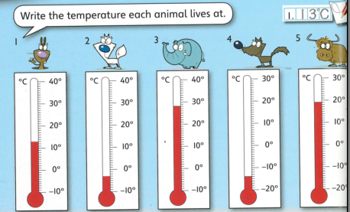

- _________ 2. __________ 3. __________ 4 __________
5. _________
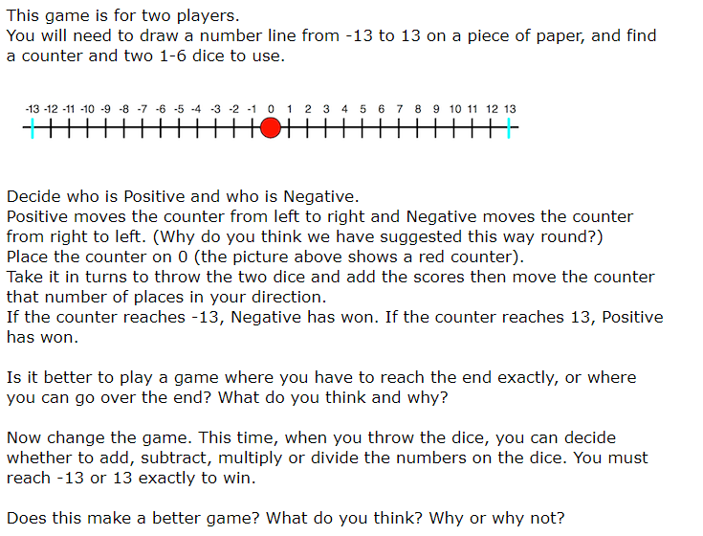
Activity 2:
Activity 3:
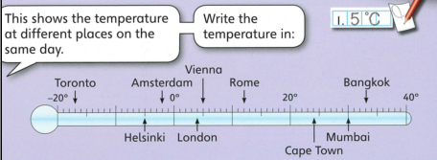
I would like you to write how much warmer or colder it is in:
- Vienna than London 2. Rome than Toronto 3. Mumbai than Amsterdam
Extension: Watch or find the weather report online or on the television. Chose two areas of the UK and find the difference between their temperatures.
Now find or watch a weather report for another country or around the world. Can you compare your findings from the UK? Which country has the greatest temperature? What is the difference in degrees Celsius between the hottest country and the coldest country in the world?
Activity 4:
Write the new temperatures:
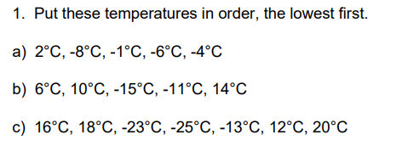
Extension: Use the ‘greater than’ and ‘less than’ ‘<’ ‘>’ symbols to organise the following temperatures:
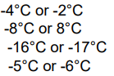

Shape and Perimeter:
Remember perimeter is around the OUTSIDE of the shape.
Activity 1:
A farmer wants to put a fence around his field. Can you work out how many meters of fence he would need to buy?
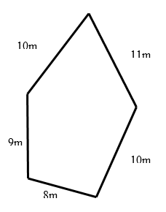

Activity 2:
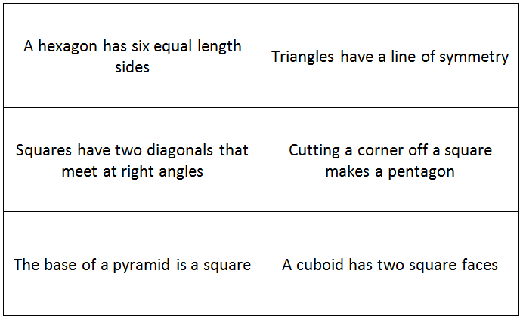
Try investigating with cut out shapes from paper. See if you can answer these statements with either always, sometimes or never.

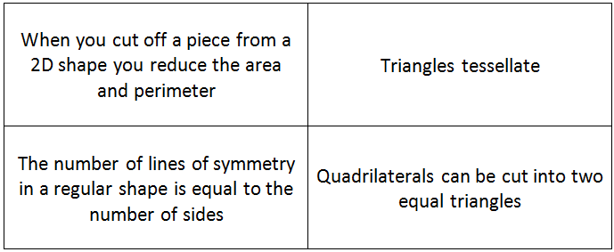
Extension: try investigating the answers to these statements.

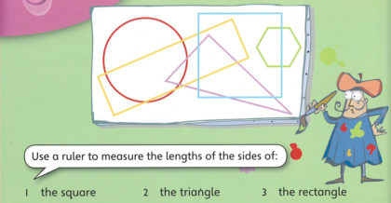
Activity 3:
Write the perimeters for each of these shapes.

Addition and Subtraction:
Activity 1:
Use formal written method to answer the following questions:
- 3424 + 2435 =
- 2700 + 6232 =
- 4321 + 2712 =
- 1590 + 2873 =

Activity 2:
Roll a dice 4 times (5 or 6 times if you are more confident). Write that down each digit you roll to create a 4 digit number.
Repeat this and add the two numbers together.
Extension: if you are feeling confident, repeat this 4 times and add all 4 four-digit numbers together.

Activity 3:
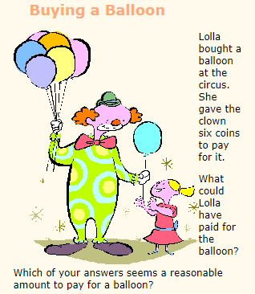
Investigate this problem – you might need physical money to help you.

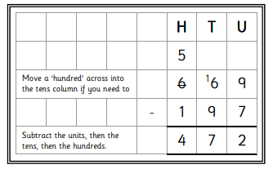
Activity 4:
Use formal written method to work out these calculations:
Remember: you might need to exchange – like this:
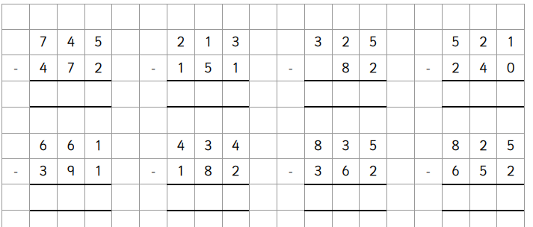
Activity 5:
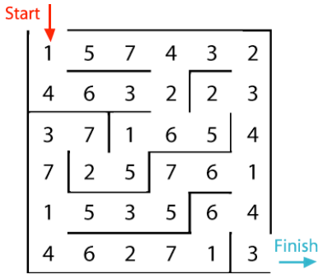
In this maze there are numbers in each of the cells. You go through adding all the numbers that you pass. You may not go through any cell more than once.
Can you find a way through in which the numbers add to exactly 100?
What is the lowest number you can make going through the maze?
What is the highest number you can make going through the maze? (Remember you may not go through any cell more than once.)
Activity 6:
You might want to collect together some pennies to help you with this task.
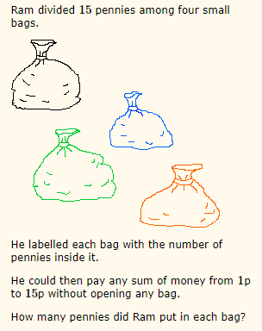

Multiplication and Division:
Activity 1:
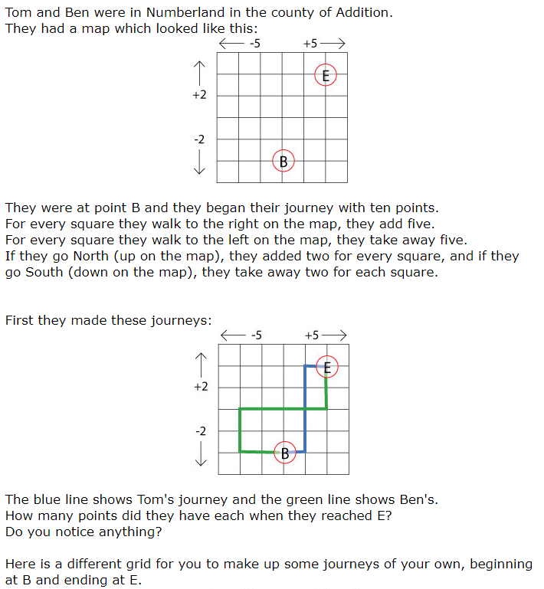

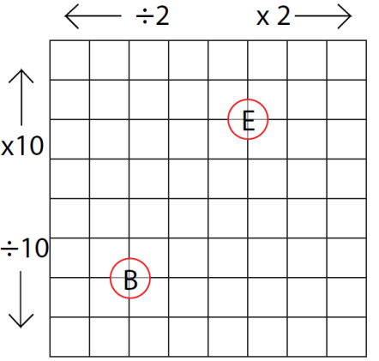

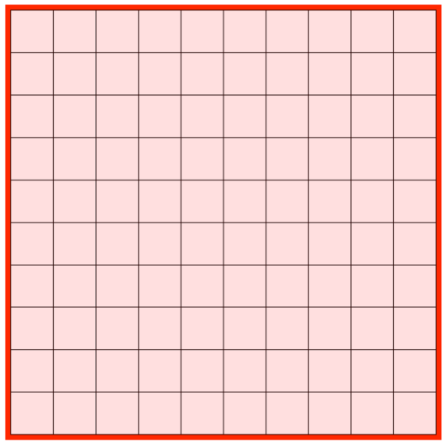
Activity 2:
Below is a multiplication square and pieces of a jigsaw to fit onto it. You may cut this out and create the jigsaw showing the correct multiplications on the square.

