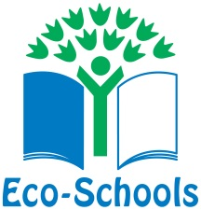
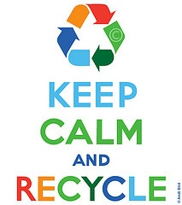
The JYS Eco Code

September 2018

We will respect and take care of all living things in our school grounds - humans, animals and plants.

We will ‘take a minute before we bin it’ by:
- reusing and recycling as much as we can;
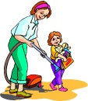
- composting fruit and vegetable waste as much as we can.

We will create a clean and tidy school by:
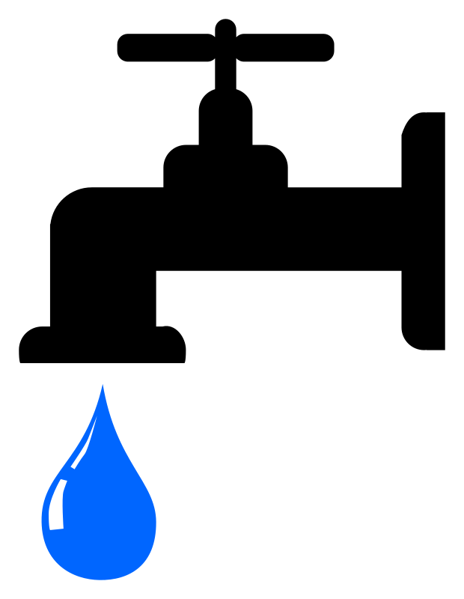
- always putting the correct rubbish in the right bins.

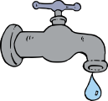
We will save water and energy by:
- turning off lights and taps when they’re not needed;
- closing doors and windows to keep the heat in during cold times.

We will keep healthy by:
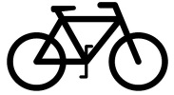
- walking, cycling and scooting to school as much as possible;
- exercising regularly;
- being healthy in our food choices and drinking plenty of water;
- growing our own fruit and vegetables.

Make a small change ~ create a big difference!
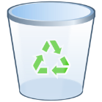
By everyone making small changes, together we will protect our planet!
Designed by Amy and Liam – Y3

