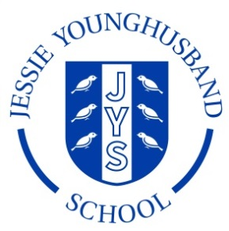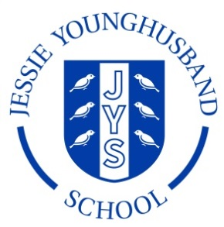

**School Council Agenda 4**

**Aspire ~ Respect ~ Enjoy**

|  |
| --- |
| Meeting of: JYS School Council |
| Place: ICT Suite |
| Date: Friday 25th January 2018 |
| Time: 13.00-13.30 |
| Apologies for absence: |
| Agree the minutes of the last meeting: |
| This meeting’s business:  Chairperson: Vincent Secretary: Ava   1. Welcome the Council 2. Review the minutes from the last meeting 3. Feedback from Council re playground markings 4. Plan for an assembly by the Council 5. Are there any further projects the council would like to tackle? 6. AOB 7. Arrange date and roles for the next meeting. |