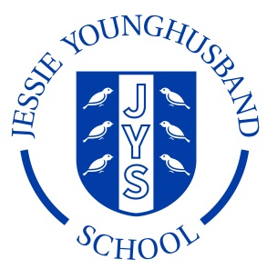

**School Council Agenda 1**

**Aspire ~ Respect ~ Enjoy**

|  |
| --- |
| Meeting of: JYS School Council |
| Place: Rainbow Room |
| Date: Thursday 10th November |
| Time: 12.45 – 1pm |
| Apologies for absence: None |
| Minutes of the last meeting:   * Are they agreed as an accurate record? **Not applicable** * Matters arising from these minutes: **Not applicable** |
| This meeting’s business:  1. Why do we need a school council?  2. What do school councillors do?  3. Inside the brain of a school councillor.  4. Meetings and communication.  5. Discuss ground rules ready for next meeting. |
| Any other business:  Discuss agenda for next meeting. |
| Date of the next meetings:  Wednesday 16th November ~ 12.40–1.00pm in the Rainbow room  Monday 21st November ~ 12–12.15pm in the outdoor classroom |