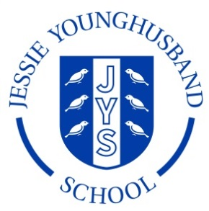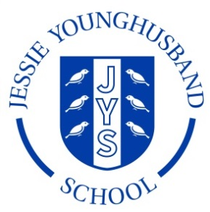

**School Council Minutes 3**

**Aspire ~ Respect ~ Enjoy**

|  |  |  |  |
| --- | --- | --- | --- |
| Minutes of meeting held on: **Friday 30th November 2018** | | | |
| Chairperson: Hannah | Secretary: Edward | | |
| School councillors present:   |  |  |  |  |  |  |  |  | | --- | --- | --- | --- | --- | --- | --- | --- | | Lucia | ✓ | Sam | ✓ | Bea | ✓ | Leo | ✓ | | Ines | ✓ | Ralph | ✓ | Seb | ✓ | Amy | ✓ | | Lola | ✓ | Matthew | ✓ | Ava | ✓ | Edward | ✓ | | Vincent | ✓ | Hannah | ✓ |  | | | |   + Mr Neaves | | | |
| Apologies for absence: **None** | | | |
|  | | Action | By whom |
| 1. Welcome the council | | **The Council was welcomed and were delighted to have jammie dodgers!** | All councillors. |
| 2. Review the minutes from the last meeting. | | **The Council looked at the minutes of the last meeting and agreed they were an accurate record.** | All councillors |
| 3. Review and discuss the Behaviour Policy. | | **The Council thought the Policy made expectations very clear. Lucia asked if we could have a copy of the flowchart in each of the classrooms so that the teachers and pupils would all know what they are and refer to them.** | DHT to report back to HT. |



**Aspire ~ Respect ~ Enjoy**

|  |  |  |
| --- | --- | --- |
| 4. Discuss songs that the children would like to be learning on a Wednesday morning. | **The Council said that some of the songs that they learn were “old” and “boring”. They’d like to learn some “new” and suggested ABBA and Coldplay. They would also like those that play instruments to have the chance to play.** | DHT to discuss with HT and KS2 / KS1 teachers |
| 5. Plan an e-Safety newsletter to parents. | **As this will take some time to collate, the Council suggested that it is delegated to the Digital Leaders to create with the IT Co-ordinator.** | PN and Digital Leaders |
| 6. NEW playground markings | **The Council are pleased to hear that the playground is to be resurfaced and are going to speak to their classes about what sort of markings they would like to see – so this can be shared with the HT.** | All councillors |
| 7, Are there any other projects the council would like to tackle? | **Can we look in to replacing the coat pegs in the classrooms?**  **Better markings on the field? Somewhere to change after football?** | DHT to discuss with HT |
| 8. AOB | **Chocolate digestives next time, please.** | All councillors |
| Items for the next agenda:  Chairperson: Vincent Secretary: Ava  See item 7. | | |



