Cress seed growing instructions

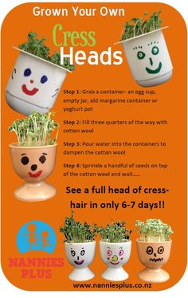
Some ideas to support learning around growing cress:
- Add a face and give it name
- Give it a hair cut!
- Give it a personality e.g. He likes playing lego. He is grumpy. He eats likes eating broccoli.
- Write an adventure about your cress head
- Make a simple pictorial diary to track the growth of the cress head.

Ice-cream in a bag instructions

1 tablespoon | Sugar
½ cup | Milk (Or Half and Half, or Cream, According to Richness Desired)
¼ teaspoon | Vanilla
6 tablespoons | Rock Salt
1 pint | Ziploc Storage Bag (small)
1 gallon | Ziploc Storage Bag (large)
add | Ice Cubes

Step 1: Measure Ingredients
Combine the milk/cream, sugar and vanilla extract in the pint-size bag. Seal the bag tightly, so that none of the liquid will leak out.

Step 2: Prep Ice Bag
Fill the gallon-size ziplock bag halfway with ice cubes. Sprinkle salt over the ice cubes.

Step 3: Zipping Bags
Insert the pint-size bag filled with ingredients into the bag of ice and salt. Seal the gallon-size ziplock bag. If the bag begins to leak, don't hesitate double bagging it to reduce the mess.

Step 4: Shake It Up!
Shake the bag for 5-10 minutes until the ice cream mixture begins to harden. Feel the small bag to determine the consistency of your ice cream. Once satisfied with the consistency, remove the small bag from the bag of ice.

Step 5: Enjoy
Open the small ziplock bag and add any desired mixins that you want. I added raspberries to mine. Feel free to eat the ice cream right out of the bag or, if you prefer, scoop it into a bowl. Enjoy!

