Home Learning – Week 2
PLEASE READ:
This is your final home learning pack for Spring 2. We really look forward to seeing everyone back at school, next week!
This home learning pack does not include Thursday and Friday as we are celebrating World Book Day across these two days. An exciting activity pack for Thursday and Friday activities will be uploaded to the school website (under Year 4) on Thursday morning.
We hope you will join us in dressing in pyjamas on Thursday 4th March! Please send us your photos of how you have enjoyed your World Book Days on Thursday and Friday. We will be sharing them in our classroom!
Please feel free to email me any completed work. You could also send your work via Google Slides and I will provide in the moment marking and feedback on these pieces. Please can I remind everyone that I will be in class teaching every day and therefore might not be available to reply although I will work incredibly hard to reply as soon as possible to every email. You may email me on: bweir@jys.org.uk.
If your child is finding any Math’s and Literacy activities particularly challenging please email Mrs McGurk on: alice.mcgurk@jys.org.uk and one of us will get back to you as soon as we are able to do so.

This week’s spellings to learn are:
Miss Weir’s Group: | Mrs McGurk’s Group:
naughty caught  cause fraught  astronaut automatic  taught author  audience applaud | build describe  imagine library  natural ordinary  promise recent  suppose weight

Day one – Monday 1st March:
Literacy – Day one – Monday 1st:
Video input
Activity:
Can you write your own short advertisement for your own chocolate using repetition?

Guided Reading – Day one – Monday 1st:
Video input
Activity:
Answer this question after the chapter. Do you think it is a good idea for our narrator and their friend to travel to London? Was it a safe decision? Why/why not?

Maths – Day one – Monday 1st:
There are two re-cap lessons for today. This will cover missed lessons from Year 3 fractions and will get the children ready for new, Year 4 learning. I have allowed some time to continue this lesson over the next session.
White Rose maths lesson one link: https://vimeo.com/504472462
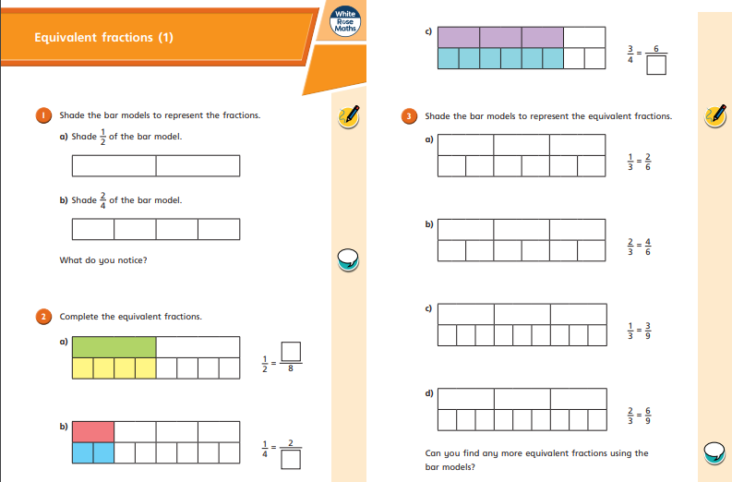
Re-cap lesson 1 sheets:
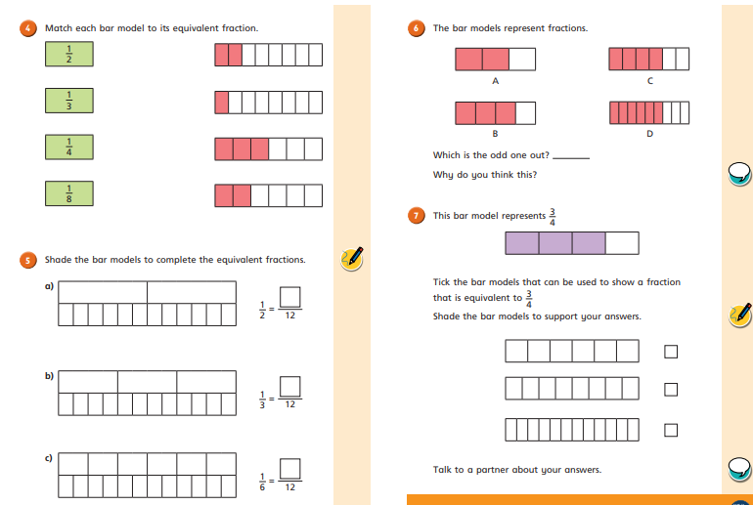

White Rose lesson 2 link: https://vimeo.com/504316253
Re-cap lesson 2 sheets:
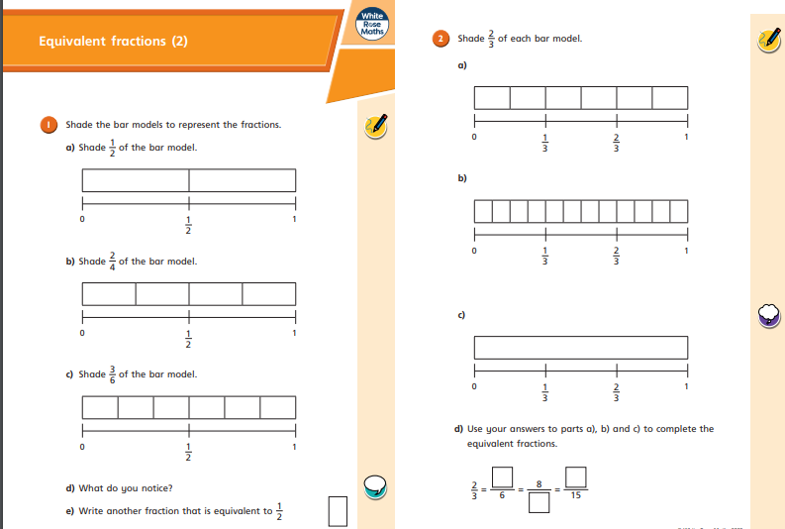
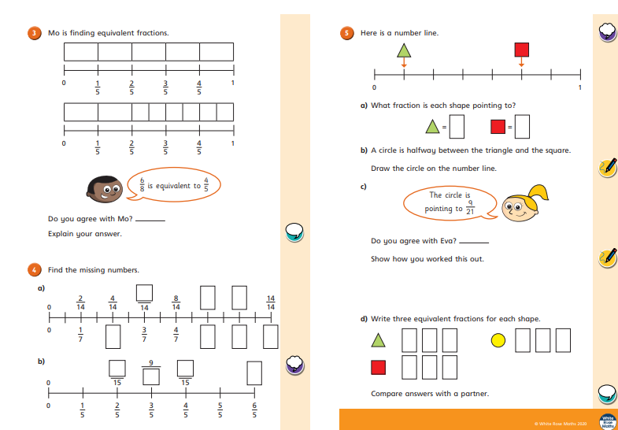
Geography – Day one – Monday 1st:
Video input
Activity:

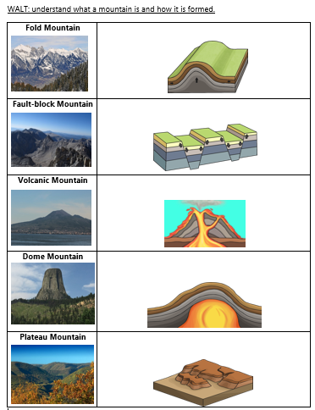
Day two – Tuesday 2nd March:
PE – Day two –
I have attached a link to the Joe Wick PE lessons live on YouTube: https://www.youtube.com/user/thebodycoach1
If you are wanting to challenge yourself, Mrs Dutton and Mr Harman have created a weekly PE challenge on our JYS YouTube page. This is attached to the ‘Year 4 Home Learning with Miss Weir’ playlist every week.
Times Tables – Day two – Tuesday 2nd:
It is important that we keep practising our times tables to help with our overall maths learning. I would like you to complete the attached sheet below:
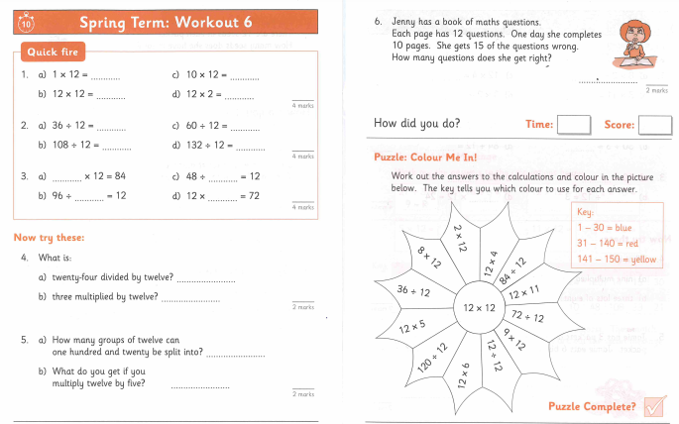

Maths –
Video input
Activity:
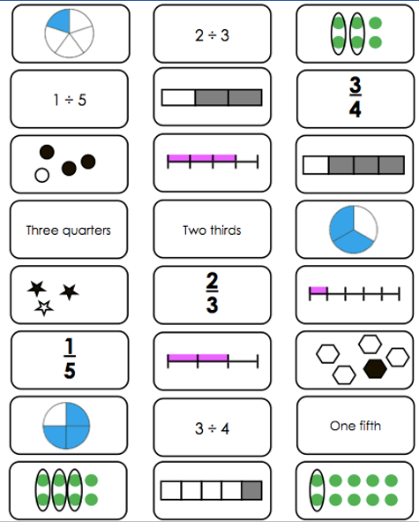
Science – Day two – Tuesday 2nd:
Video input
Activity 1:
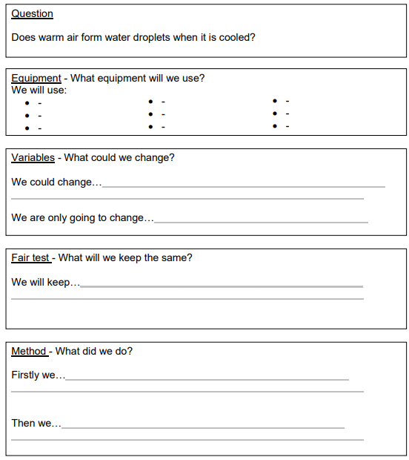
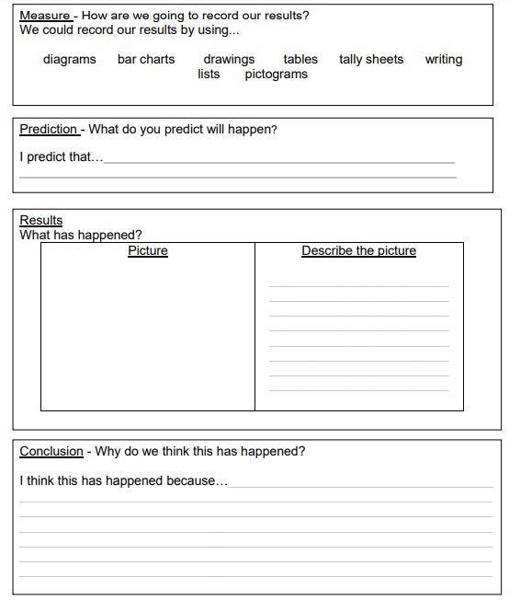SPAG – Day two – Tuesday 2nd:
Video input
Activity:
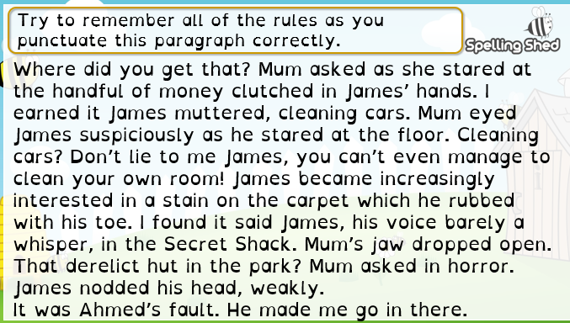
Independent reading – Day two – Tuesday 2nd:
Use this time to quietly read a book of your choice. You might have some book band books to read, ready to return to school next week. If someone in your house is free, perhaps ask if you can read to them.
Day three – Wednesday 3rd March:
Guided Reading – Day three – Wednesday 3rd:
Video input
Activity:
What do you think happened to the narrator at the end of the chapter? Can you make a prediction? Back up your answers with evidence.

Literacy – Day three – Wednesday 3rd:
Video input
Activity:
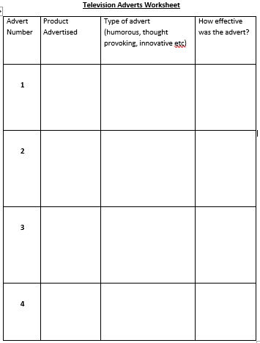

PSHCE –
Work from Mrs Potter

French –
Video input by Mrs Ritchie

