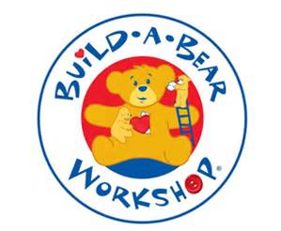

Dear Families,
You may be aware that during the summer term we usually hold a Build-a-Bear Stay and Play session kindly funded by The Friend’s Association. Sadly we were unable to do that this year but I didn’t want the children to miss out on the opportunity to create their own bear. With this is mind, I am asking you to create your own Build-a-Bear factory at home for home learning the week commencing 13.7.20!
You will each have in your ‘kit’:
- a bear,
- some stuffing
- thread
- some material
- a piece of red card
- some decorations

- Make a heart for your bear from the red card. Make a wish and place it inside your bear;
- Stuff your bear and sew up the back;
- Make some clothes for your bear (remember if sewing isn’t your talent, stapling, tying and wrapping work just as well!)
- Give your bear a name and fill in his/her adoption certificate;

There will be some activities in the normal format on the website inspired by real and imaginary experiences with our special bears hopefully fuelled by the excitement of building their own at home.
Finally, I’d like as many of you as possible to join me for a Zoom Teddy Bear’s picnic on Wednesday 15th July at 4.30pm (the invitation will be sent via ParentMail to ensure it is a secure room). This includes home school children and children attending school both in Reception class and Key Worker groups. Please bring your teddy with you to show to your friends (we’ll have an opportunity for each child to share their bear) and a ‘snack’ (this needs only to be small- just to go with the idea that it’s a picnic. Try and sit outside if the technology and weather allows!) They’ll be a few games and an opportunity to see all their friend’s faces. I hope that this will be a nice end to the year as one whole group.
Best wishes,
Mrs Appleby

