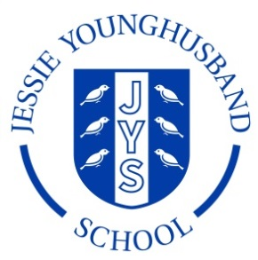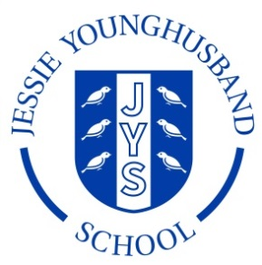

**School Council Minutes 6**

**Aspire ~ Respect ~ Enjoy**

|  |  |  |  |
| --- | --- | --- | --- |
| Minutes of meeting held on: **Wednesday 3rd April 2019** | | | |
| Chairperson: Sam | Secretary: Ines | | |
| School councillors present:   |  |  |  |  |  |  |  |  | | --- | --- | --- | --- | --- | --- | --- | --- | | Lucia | ✓ | Sam | ✓ | Bea |  | Leo | ✓ | | Ines | ✓ | Ralph | ✓ | Seb | ✓ | Amy | ✓ | | Lola | ✓ | Matthew | ✓ | Ava | ✓ | Edward | ✓ | | Vincent | ✓ | Hannah | ✓ |  | | | |   + Mr Neaves | | | |
| Apologies for absence: Bea | | | |
|  | | Action | By whom |
| 1. Welcome the council | | **The Council was welcomed and were delighted to finally have caramel wafers!** | All councillors. |
| 2. Review the minutes from the last meeting. | | **The Council looked at the minutes of the last meeting and agreed they were an accurate record.** | All councillors |
| 3. New projects | | **New coat pegs are to be installed in Y6 to see if they are better than existing ones. Y6 councillors then to write a report on the benefits to see whether or not they should be rolled out across KS2.** | All councillors |



**Aspire ~ Respect ~ Enjoy**

|  |  |  |
| --- | --- | --- |
| 4. Are there any other projects the council would like to tackle? | **The school received a lovely hardback book – we would like some councillors to write a thank you letter.** | Ines and Ralph (supported by Edward and Lucia) |
| 5. AOB | **We went out to look at where we could place the dragonflies and butterflies in the grounds.**  **We also looked at the placement of the new school rules signs within the school grounds.**  **Vincent asked if the school would consider allowing a small Yu-Gi-Oh club to be held in the school library on a Wednesday lunchtime.**  **The School Council is grateful for the biscuits each session and don’t mind what they get next time!** | All councillors |
| Items for the next agenda:  Chairperson: Lola Secretary: Matthew  Next meeting: Friday May 10th 2019 13:00 – 13:30 | | |



