Geography Projects:
I have put together two projects that should take a week each to carry out. These are centred on our current geography topic ‘Misty Mountains’ and should allow children to present all they have learnt so far, in a creative and physical way.

Project 1 – build a mountain:
We have investigated the different types of mountains and how they are formed, for example; volcanic; plateau; fold; fault-block and dome mountains.
Chose a particular mountain that you would like to investigate further and create your own physical mountain. Below is an example of a student using modelling clay to build a volcanic mountain.
I would like you to label how the mountain is formed in a similar way.
You might want to use paper-mache to build this or junk modelling.

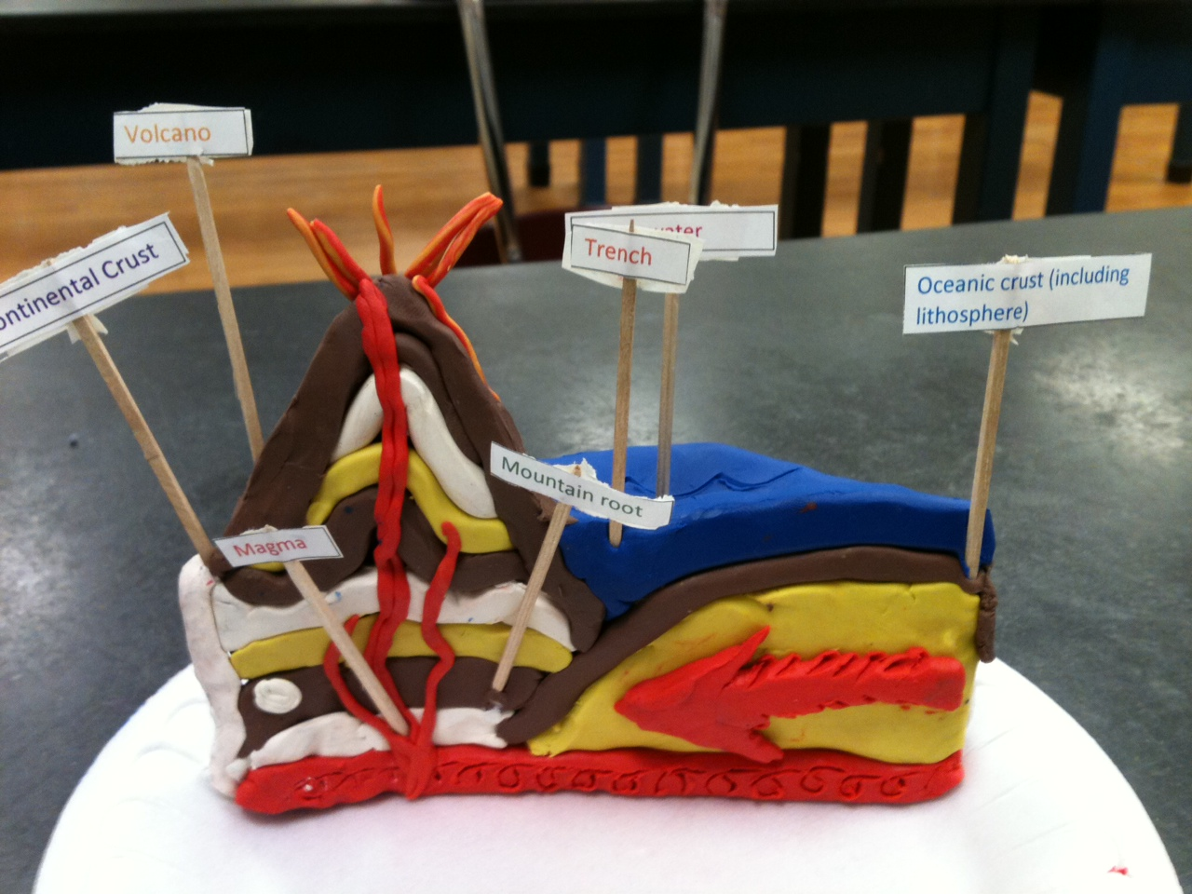

Project 2 – 3D map of the World:
During our geography unit, we have been exploring the different continents and key mountains on these continents. To embed this learning further, I have set a project on creating and building continents out of 3D materials.
For your project, I would like you to develop your own 3D continents. You might want to look at one continent in particular (with a key mountain). I would like you to create a 3D map of this continent on cardboard. You will need to create a key to show where the mountains are as well as other key features such as, water, low land, hills and peaks.
I have attached an image of a good example below:
