Home Learning pack: Weeks 6-8:
Firstly, I would just like to say that I have really enjoyed some of the challenges you have been posting on our JYS Year 4 Facebook groups (I hope you have enjoyed completing them too). Because of this, I have continued to include these in this Home Learning pack.

The timetable for White Rose Math’s online lessons can be found below. Please remember that this is a suggested timetable, if you want to complete more/less on any given day then that it completely fine.
- These Activities are ‘Summer Term – Week 1’ and ‘Summer Term – Week 2’.

Date | Title | Activity | Support/Extensions?
Monday 4th May | Lesson 1 – Make a whole | Activity sheet on website | Yes
Tuesday 5th May | Lesson 2 – Write decimals | Activity sheet on website | Yes
Wednesday 6th May | Lesson 3 – Compare decimals | Activity sheet on website | Yes
Thursday 7th May | Lesson 4 – Order decimals | Activity sheet on website | No extension.
Friday 8th May  (Bank Holiday) | Lesson 5 – Maths Challenge | White Rose Friday Challenge | N/A
WEEKEND
WEEKEND
Monday 11th May | Lesson 1 – Round decimals | Activity sheet on website | Yes
Tuesday 12th May | Lesson 2 – Halves and quarters | Activity sheet on website | No extension.
Wednesday 13th May | Lesson 3 – Pounds and pence | Activity sheet on website | Yes
Thursday 14th May | Lesson 4 – Ordering money | Activity sheet on website | Yes
Friday 15th May | Lesson 5 – Maths Challenge | White Rose Friday Challenge | N/A

Following from my phone conversations – I have created a new grid below which will provide an extension activity and a support activity to those who need it.
- The extension activity is to extend children who find this task relatively easy and want something a little more challenging.
- The support activity is for children who found this concept hard to understand and need something to try can help them to understand. You might want to try my activity first and then move on to the White Rose lesson after.
Date | Title | Support activity | Extension
4th May | Lesson 1 – Make a whole | Draw a hundred square – colour in rows of 10 at a time. How many rows of ten (tenths) can you shade in to fill in the whole grid?  Draw 12 triangles of pizza and cut them out (make sure you have used a ruler and made each slice the same size).  - Each triangle should be a quarter of a circle  How many whole pizzas can you make with 16 slices? | Here is a link to Nrich Website to create a game called Matching Fractions.  You could print the cards of write your own.  Link: https://nrich.maths.org/8283/note
5th May | Lesson 2 – Write decimals | Draw a place value grid (as shown at 1:07 on White Rose lesson 2 video).  Draw or counters, or write numbers to show me where the following decimals sit on that place value grid:  - 0.3  - 4.5  - 3.2  - 0.7  - 0.1  - 1.0  Discuss: Do we need to put a 0 at the end of 1.0?  How could we also write it?  1.0 is considered a whole number, why? | Discussion with a grown up:  - What does 0.05 mean?  - How is it different to 0.5?  - Is it even less of a whole number than 0.5?  - Which is the greater amount, 0.5 or 0.05?  - How do you know?
6th May | Lesson 3 – Compare decimals | Draw 10 squares and shade in 3 to show the fraction 3/10. Do the same thing next to it, but this time shade in 5 squares making the fraction 5/10.  - Make these into decimals.  (You should end up with 0.3 and 0.5).  Which is the greater decimal? Show your more than/less than symbols to show this ‘>’ ‘<’  Now make your own two fractions – make them into decimals and show me which is greater. | Write numbers from 1 whole down to as small as you can go.  Is there an end?  What does the end look like?  Is there such a number as 0.0003?  Why are you adding an extra 0 as your numbers get even smaller?
7th May | Lesson 4 – Order decimals | Measure members of your households height (this could be in cm, m or ft – whatever you have available). Record each person’s height – including yours.  After that, put these people in a line starting with the tallest person and ending with the shortest person – as you do write your decimals (height numbers) in the same order on your sheet.  Discussion with a grown up:  Look at the pattern – what do you notice about the decimals of the tallest people compared to the decimals of the shortest people? | Here is a link to the Nrich website.  You will need two players to play this game.  Link: https://nrich.maths.org/10326
8th May  (Bank Holiday) | Lesson 5 – Maths Challenge | N/A | N/A
WEEKEND
WEEKEND
11th May | Lesson 1 – Round decimals | Remember our magic rule when rounding, if the number on the right is 5 or greater then we round the number on the left up, if its smaller than 5 the number on the left stays the same and the number on the right changes to 0.  - Worksheet found on fig.1 under this grid. | Worksheet found on fig.2 under this grid.
12th May | Lesson 2 – Halves and quarters | Draw a hundred square (you can do this easily by drawing a line 10 squares down and 10 squares across).  - Colour in 25 squares on one side:  This shows one quarter.  Discussion with a grown up:  Discuss why this shows one quarter. How could you show 3 quarters?  How many squares (hundredths) would you need to colour in? | This is an open ended task – you could begin to think about what one shape is compared to another. Is the orange shape a quarter of the blue shape? Is the blue shape half of the green shape?
13th May | Lesson 3 – Pounds and pence | Ask a grown up if you could look at any coins they have in the house.  Explore these coins, what amount do you think each coin represents?  How do you know?  Discussion with a grown up:  What is the difference between £1 and 1p? £1 = 100p. So how many pennies would you need to make £2? | Here is a link to the Nrich website.  This activity asks you to use all your problem solving skills to work out how much Dan has paid for a packet of crisps and an ice cream.  Link: https://nrich.maths.org/5949
14th May | Lesson 4 – Ordering money | Ask a grown up if you could look at any coins they have in the house.  Explore these coins, which do you think is the smallest amount and which do you think is the greatest amount? Why?  Order these coins from smallest to greatest. Copy your work into your math’s book.  - Check with a grown up after. | Here is a link to the Nrich website for an activity entitled Money Bags.  Link: https://nrich.maths.org/1116
15th May | Lesson 5 – Maths Challenge | N/A | N/A

Fig.1 (Support): Print this sheet and colour in the decimals which round to odd whole numbers. Start at the ‘Start’ space and see if you can navigate to the ‘Finish’ space.

Fig.2 (Extension): Print this sheet and colour in the decimals which round to odd whole numbers. Start at the ‘Start’ space and see if you can navigate to the ‘Finish’ space.

Multiple activities – History:
Once you have completed your first history lesson on BBC Bitesize, you may go on to investigate some of the ideas on this ‘Activity Map’. Some work through these activities one at a time. Others refer back to them as extra work when all other work is completed. It is completely up to you.

In this map there are activities from most areas of the curriculum. This should be an ongoing activity that might span further than the length of this home learning pack:

HOUSE OF CARDS - CHALLENGE:
This challenge is called ‘House of Cards’.
Find a pack of cards (doesn’t matter what cards they are!)
Can you build a house of cards from them? How many tiers can you make it?

Take a picture and share your creation!

Activity 1 – History:
As we have entered into Summer term, I thought it would be appropriate to introduce you to a new topic – Stones, Bones and Thrones, all about the Stone and Iron ages. I have created a video input which will go live on our JYS Year 4 Facebook group on Monday 4th May. This will explain what we are covering in this historical topic.

So – WELCOME TO THE STONE AGE!
BBC have released fantastic engaging lessons on all areas of learning. They have created a brilliant lesson all about the Stone and Iron Ages.

Follow this link to complete the lesson and to find out more about our brand new topic: https://www.bbc.co.uk/bitesize/articles/z7t72sg

I have also attached a link to a compilation of videos from Horrible Histories, all about the Stone Age. Horrible Histories is a really engaging and fun way to learn new and interesting facts from history: https://www.youtube.com/watch?v=fDDlhCtIdQ4

Activity 2 – Writing:
For our literacy over the next two weeks, we will be building up to writing an information book all about the Stone Age. Each lesson will help you to write your final piece at the end of the two weeks.

Firstly, watch ‘The Owl Babies’ animation with a grown up: https://www.youtube.com/watch?v=TPQRiSTYFHo&t=1s

Next, I want you to have a discussion with your grown up:
Was the animation you watched fiction (imaginary) or non-fiction (factual?
How do you know?
What would you need to change to make the information factual about Owl babies?

Remember: an information text needs a title, introduction, main description and a conclusion. For example:

TITLE: | Owls
INTRODUCTION: | Owls are carnivores, which means that they eat meat. They hunt insects, small mammals and other small birds during the night.
Description: | Owls most commonly lay between three and four eggs. They are white and round. The eggs do not hatch at the same time.
CONCLUSION: | There are more than 200 different species of owls. Owls can be found all over the world, except in Antarctica.

Pick your favourite animal, do a little research on them then create a small piece of information writing about that animal.

You might want to lay it out in a grid like I have done first and then when you are ready, write it up neat in your Literacy book.

Extension: can you draw a picture of your animal just like a real information book?

Catch the ball – CHALLENGE:
For today’s challenge, I would like you to find a partner and sit opposite them (with some distance) with a cup/mug in front of you both.

Find an object which is small enough to act as a ball.

Throw the ball into your opponents cup. Every time your ball lands in your opponent’s cup, you win a point!

Activity 3 – Science:
I have attached a sheet on how to make ‘Invisible Ink’ using Lemons or Onions. (One might be a little stinker than the other – sorry grown-ups!)

Message for Spies…
Your mission – should you choose to accept it:
Make your own secret language. You might need to write down a key (or it could get a little confusing).
For example, I have had to write your mission in code – to avoid interception:

)nxz +, )ih 0nnc /I %z1/n x :f1n0fn 5xf/ 10 1091:1d4n 10p.

Here is my key:
a=x b=d c=f d=c e=n f=5 g=2 h=s i=1 j=l k=p l=4 m=8 n=0 o=i p=g q=e r=z s=: t=/ u=h v=9 w=% x=u y=) z=- 4=+

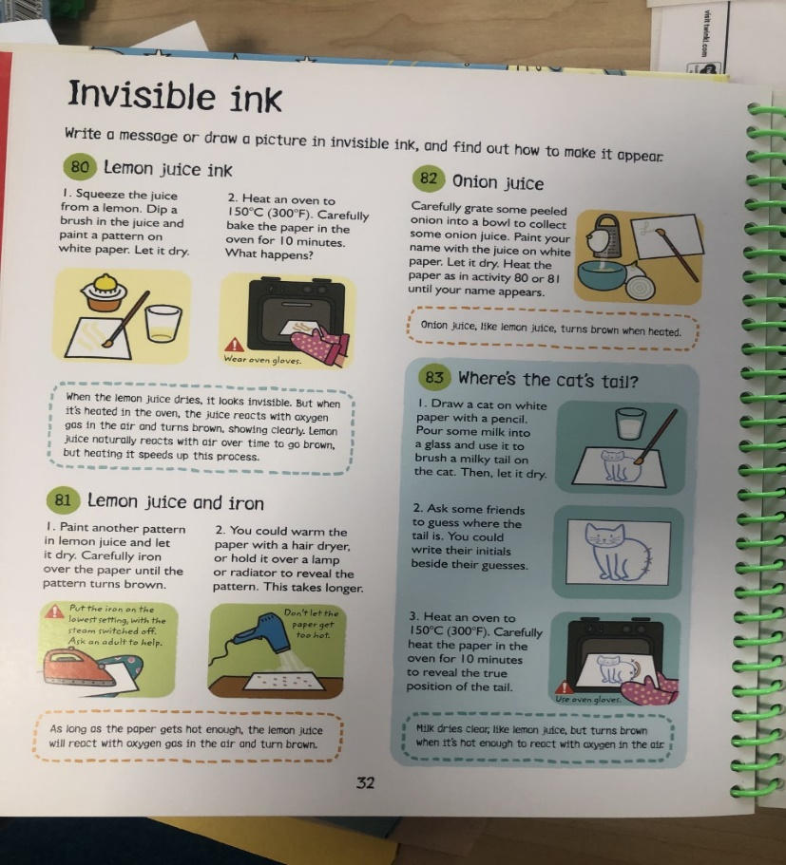
Write your own secret message in invisible ink and see if someone else can crack the code!

Activity 4 – Writing:
Authorfy is a fantastic website filled with inspiring and engaging creative writing opportunities. They have teamed up with bestselling authors who have recorded videos setting you 10 minute challenges. I was particularly inspired by this challenge and want you to give it a go yourself.

Watch the video with bestselling author Abi Elphinstone to find out your task: https://authorfy.com/10minutechallenges/

Once you have written your 10 minute challenge, I would love to hear it – email me at bweir@jys.org.uk

Activity 5- PSHE:
We are in some very unusual times. Learning from home is not something we are all used too and some of you might be feeling a little uneasy about this. My task for you is to write it all down. Create or (if you have one already) use a journal to write down how you are feeling each day. You do not have to write lots and lots, just a couple of sentences to show how you are feeling.
I would then like you to share this with a grown up in your house. This will mean you can talk to them about how you are feeling. And talking about how we feel always helps us to begin feeling a little better.

Domino’s – CHALLENGE:
If you have a set of dominos at home, this is the challenge for you.

Stack your dominos to make a shape. Remember: they need to be close enough to each other to cause a ripple effect when they knock down.

Extension: can you make your pattern more tricky? Going up the stairs or around objects?

Activity 6 – Science/Maths/Art/PSHE:
Whilst looking out your window, going on your daily walk or being in your garden, you might have noticed the sound of LOTS of birds. Whilst we stay in to protect others and ourselves, we are seeing more and more different types of birds around our homes.

PSHE – Firstly, I would like you to go outside (on your daily walk) or garden. If you do not have a garden and are shielding, just open a window. Then I want you to just take a few moments to listen – close your eyes and listen.
- What sounds can you hear?
- Are there different birds outside? How do you know?
- Does every birds song sound the same?
- Can you try and copy a birdsong?
Here is a link to a website, which will help you to learn birdsong: https://www.rspb.org.uk/get-involved/campaigning/let-nature-sing/birdsong-radio/

Science – Then, I would like you to try and spot the different birds. You might want to take a photograph of them when you see them. Do a bit of research into the birds around your house.
- What breed is the bird?
- What is their birdsong?
- Do they ever migrate?
- Is there a particular time of year we see them most?
- What foods do they eat?
- Where would they be if you put them in a food chain?

Maths – Now, I would like you to keep a tally chart of the bird or birds you researched. How many times do you see them? Or maybe you’ve learnt their birdsong in which case, how many times do you hear them?
- Show your workings out as a bar graph.
Art – To finish off this project, collect items from outside (if possible). Can you create a nature collage of that bird?
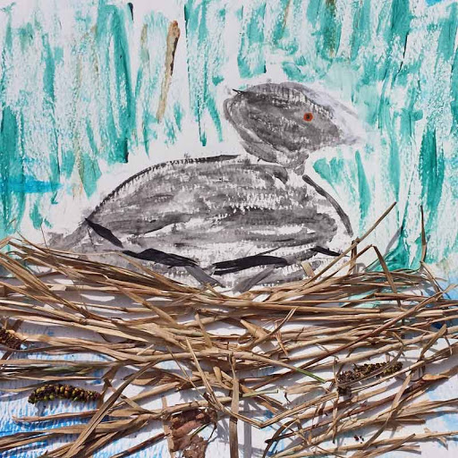
I have attached some photograph examples to inspire you:
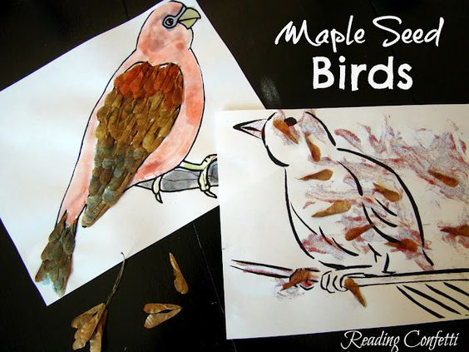

IT’S THE WRONG HAND! - CHALLENGE:
In this challenge, I want you to write three sentences about yourself. EASY right??
WRONG!
You need to do it using the WRONG hand. Good luck!

Activity 7 – History:
For your task this week, I would like you to create an ongoing fact file all about the Stone Age. Collect together as much information as you can and create an information book.

Remember, your information book needs:
- A front cover,
- A contents page,
- Headings,
- Pictures (drawn or printed).

Here are some great sites to get you started with your research:
https://www.bbc.co.uk/bitesize/topics/z82hsbk
https://www.youtube.com/watch?v=VyilGaQl6RU

