Jessie Younghusband School

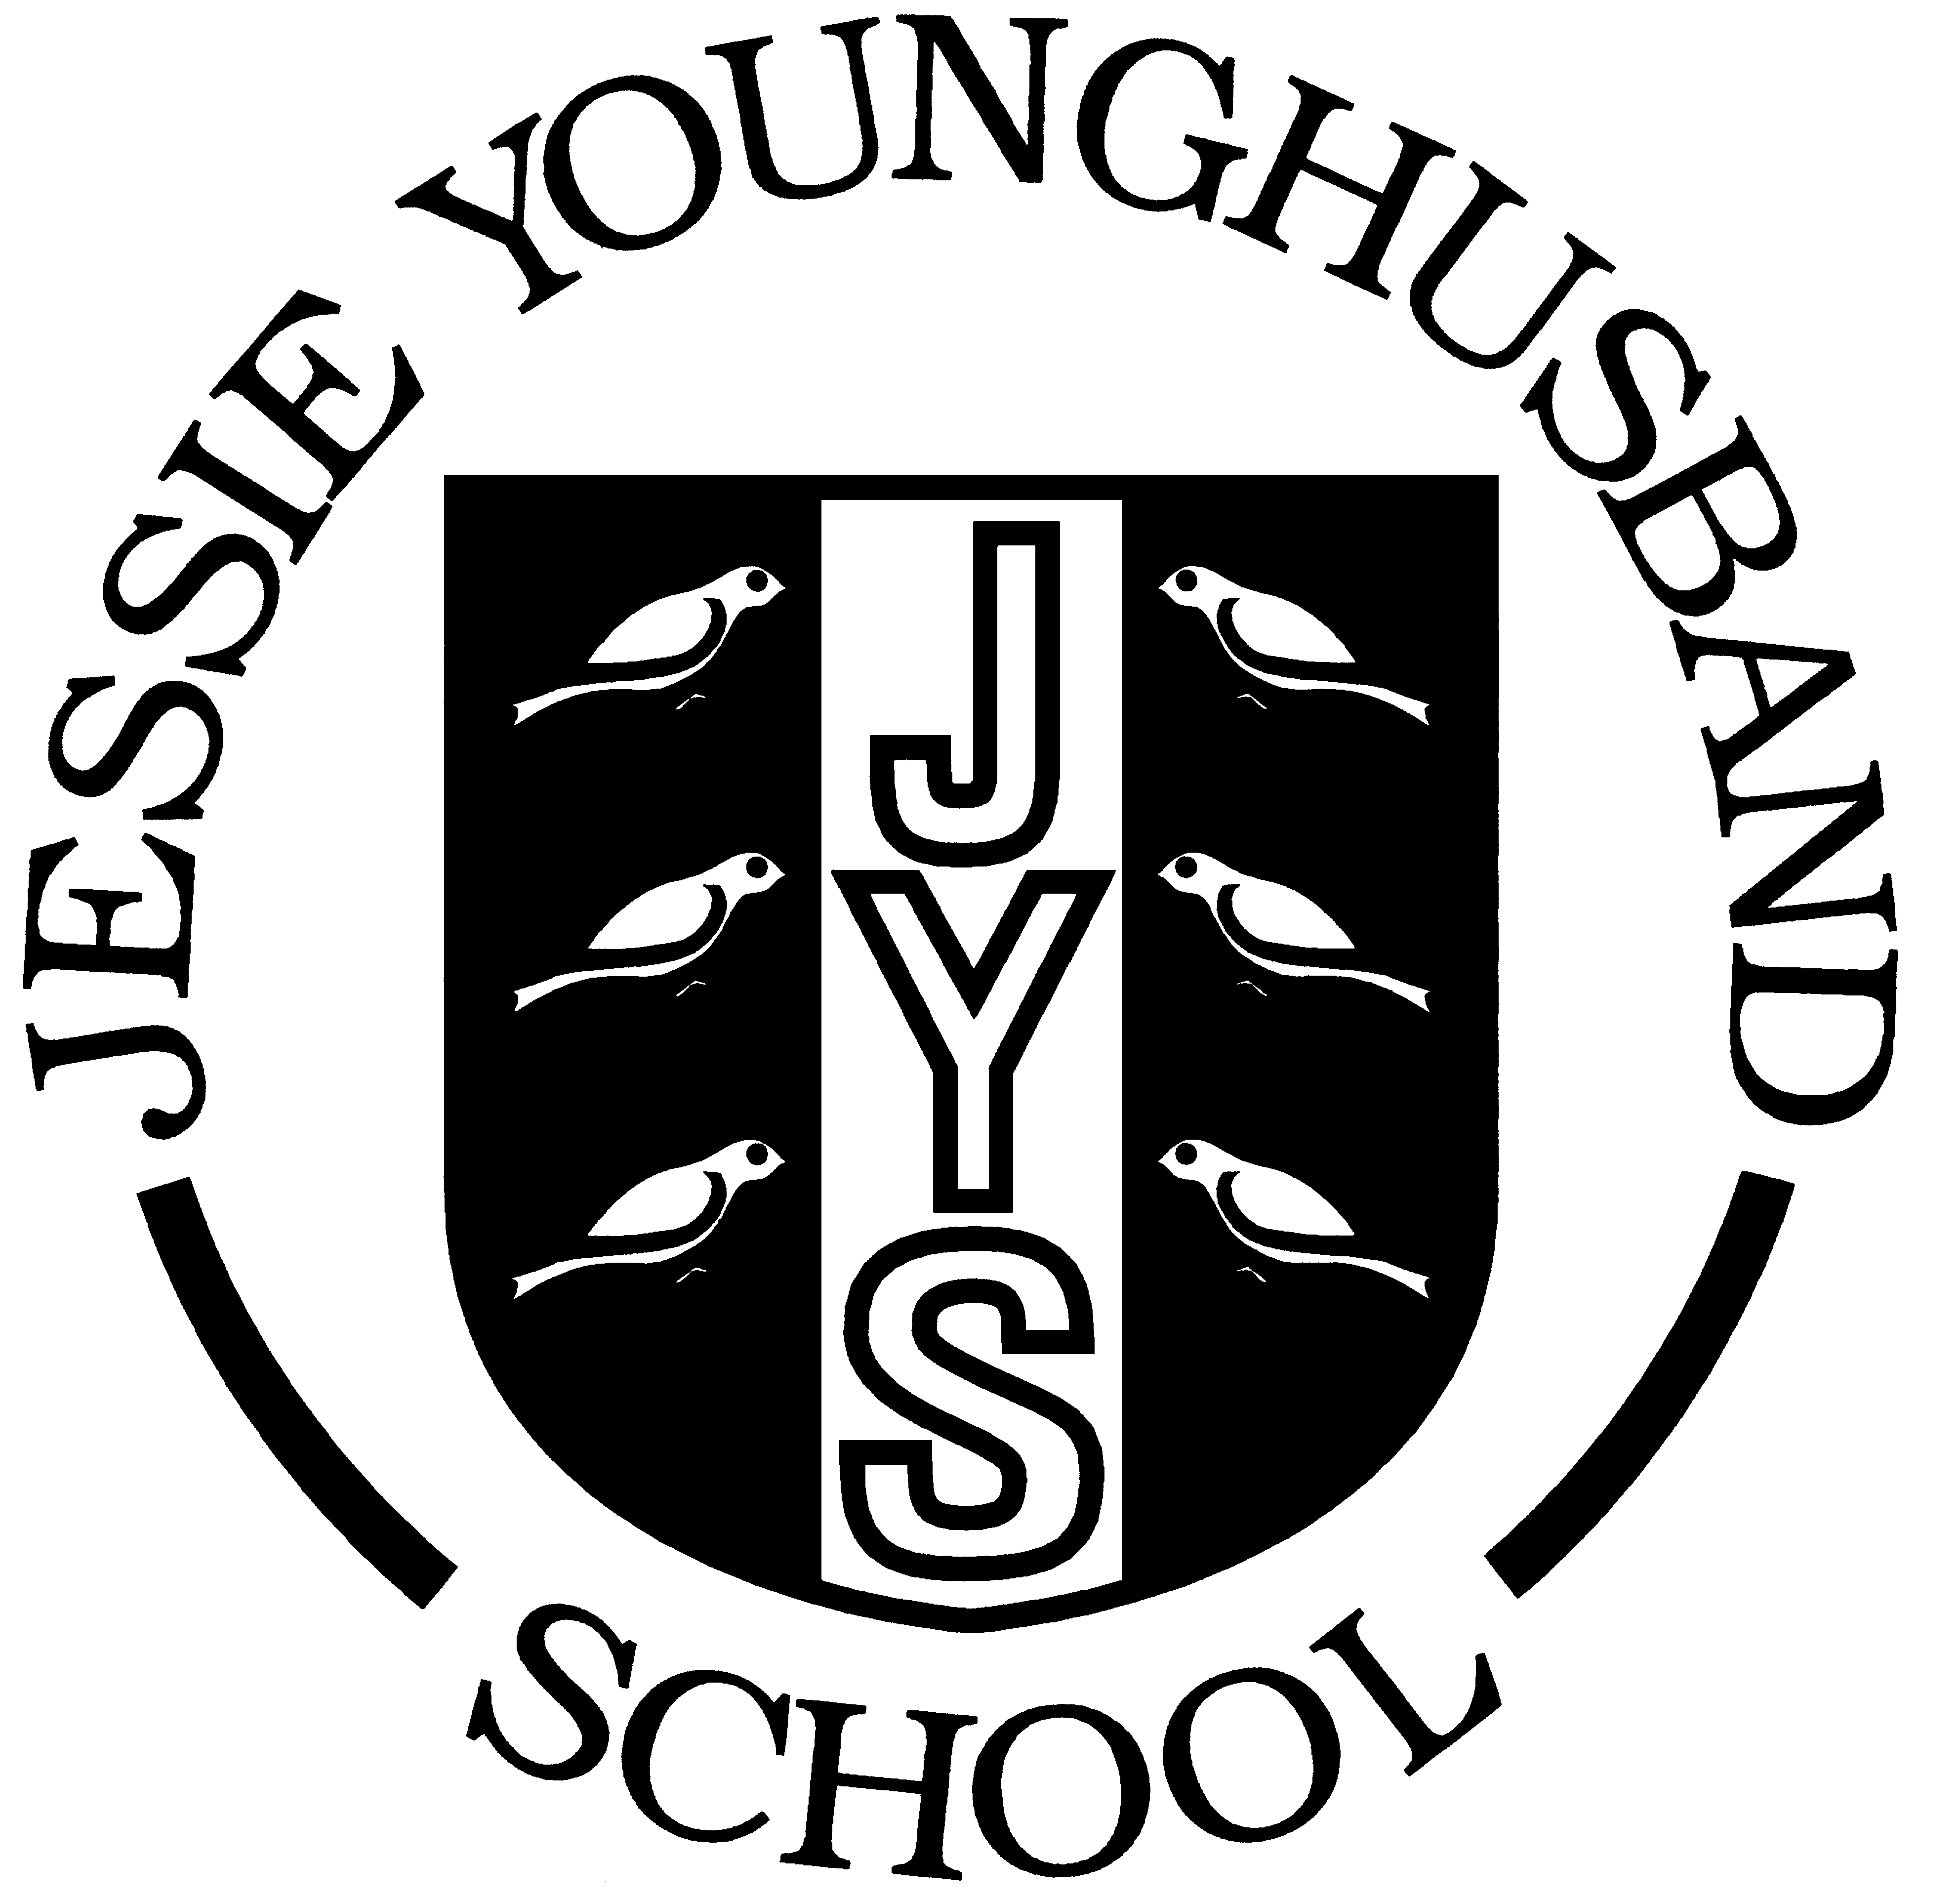

Teaching and Learning Policy

Updated Summer 2018
Review Summer 2021

Aspire ~ Respect ~ Enjoy

Introduction:

At Jessie Younghusband School (JYS), we thread our school values – Aspire, Respect, Enjoy – throughout our curriculum. We believe that learning should be a rewarding and enjoyable experience for everyone. Through our teaching we collectively create a stimulating environment which fosters excitement and enthusiasm for learning. We constantly strive to improve our provision for children at JYS and in doing so encourage everyone to aim high and try to achieve their full potential. High importance is also placed upon the children developing skills to reflect upon their learning, thus enabling them to make good progress in all areas of learning – academically, physically, socially and emotionally. Pupils gain high levels of confidence, have pride in their achievements and really enjoy their learning. We recognise that the personal development of children - spiritually, morally, socially and culturally (SMSC) - plays a significant role in their ability to learn, achieve and be happy individuals.

Aims and Objectives:

This learning and teaching policy is intended to promote consistency and high standards and the achievement of the school aims. Through our teaching we aim to:

- enable children to become confident, co-operative and independent learners who are able to live safe, healthy and fulfilling lives;
- develop children who have a thirst for learning, developing their knowledge and understanding of the world;
- enable children to become successful learners who enjoy learning, make progress and succeed;
- foster a sense of identity within the school and the wider community, helping them feel a valued part of it;
- enable the children to become responsible citizens who are tolerant and respectful of others’ values and make a positive contribution to the school and wider community and society;
- foster and promote an awareness of fundamental British Values such as democracy, the rule of law, individual liberty, mutual respect and tolerance of those with different faiths and beliefs;
- provide a safe, secure and supportive environment that promotes self-worth and self-confidence;
- develop children who are articulate communicators and good listeners; preparing them very well for the next steps in their education;
- encourage perseverance and a willingness to take risks and ‘have a go’.

Effective Learning:

We acknowledge that people learn in many different ways and we recognise the need to develop strategies that allow all children to learn in ways that best suit them. At JYS we offer opportunities for all children to succeed in learning new knowledge, skills and understanding by:

- Developing a positive environment where they feel safe and feel they belong, they enjoy being challenged and stimulated;
- Providing a vibrant, exciting and stimulating curriculum which delivers the National Curriculum (2014) and is enriched further with trips, outside visitors, themed days/weeks;
- Delivering teaching using a variety of techniques to match children’s learning styles therefore catering for visual, auditory and kinaesthetic learners;
- Providing hands-on participative learning where children explore materials; learning to design, make and evaluate;
- Using a range of visual aids and stimuli in classroom resources, such as the use of ICT, dance, drama, role play, creative activities and music;
- Collaborating effectively, exploring and sharing ideas together and with each other;
- Enabling the children to be actively involved and engaged in their learning through self-initiated tasks and by giving them an input into their termly topic;
- Providing an environment which is organised, well resourced, appreciative, well managed and conducive to learning;
- Fostering an appreciation of human creativity and achievement;
- Offering an outstanding range of extra-curricular activities which considerably enhance their learning;
- Including age appropriate learning opportunities to enable children to understand how to keep themselves safe in different situations.

We believe in making appropriate links in children’s learning both through teaching cross-curricular topics and linking discrete subjects with purposeful contexts. This enables them to see the bigger picture with connections to previous work being made explicit; the children knowing why each and every lesson is important. It also helps to develop interconnected knowledge and skills for lifelong learning. The children are provided with opportunities to recognise and develop key aspects of learning such as enquiry, problem solving, reasoning, evaluation and empathy.

The children at JYS are given opportunities to work alongside others in group work, paired work, independent work and whole class activities and investigations. Each term, each class is provided with an opportunity to pursue their own line of enquiry which enables the children to follow new pathways linked to their current learning/topic. They get to apply their knowledge, skills and understanding, develop high levels of independence and become experts on a chosen aspect linked to their topic. The children take ownership about how to present their findings before celebrating their achievements in front of their peers. During the autumn and spring terms, this work is completed in school. In the summer term, the children are given an outline of their ‘Line of Enquiry’ task for homework with clear expectations and a deadline for completion. The children are then given time and the opportunity to apply their skills, knowledge and understanding and present their findings in a format chosen by them.

More information on our principles for a curriculum for learning are set out in Appendix 1.

Effective Teaching:

We have high expectations of all children, and believe that all children should be included in the full range of educational opportunities and that their work here at JYS should be of the highest possible standard. We base our teaching on our knowledge of each child, responding to the needs of the children in our classes and overcoming any potential barriers to learning. Our teaching is inclusive and ensures that all tasks set are appropriate. When planning work for children with specific educational needs (e.g. SEND or G&T) we use information and targets contained in the children’s Learning Passports/G&T Pupil Sheets.

We believe children learn effectively when the teacher provides:

- Thorough preparation which is based on good subject knowledge and a clear understanding of the Early Year Foundation Stage Curriculum (Year R and 1) and the National Curriculum (2014) requirements;
- Lessons where children’s previous learning and interests are built upon, through purposeful application of knowledge to different situations;
- Lessons where children’s understanding is developed through active, practical and first hand experiences, involving individual and collaborative talk, exploration, questioning, prediction and investigation, so that the lesson makes a difference;
- Clear expectations of what pupils are expected to achieve by the end of the session;
- Shared learning objectives which are understood by the pupils;
- Work which is differentiated appropriately to cater for the needs of all pupils;
- An atmosphere where the children are prepared to take risks;
- Opportunities to review and reflect on the learning and feedback marking/comments from the teacher. This is integrated into the on-going learning process, with time set aside for the children to respond;
- Good quality targeted intervention with many opportunities for children to be challenged;
- Developmental feedback of pupil’s work;
- Praise for the children’s successes and ‘personal bests’.

Learning and teaching are effective because teachers show flair, creativity and imagination in their planning to make learning relevant and fun for all. Good subject knowledge gives them confidence to be adventurous in the classroom. Teachers have high expectations of what children can achieve; they are knowledgeable, share learning intentions, use new technologies and questioning skills most successfully and make learning fun.

Our classroom environments set the climate for learning with vibrant and attractive displays which ask questions, display challenging learning prompts, celebrate high quality work and are exciting and relevant to our current topics. We believe our classrooms are stimulating, engaging and enable high quality learning to take place. They are enhanced with resources such as interactive whiteboards, VCOP word lists, number lines, clocks, 100 squares and timelines. At JYS there is a genuine celebration of pupil’s learning, as evident in the termly topic books which indicate the children’s research, excellent presentation skills and in-depth knowledge of a wealth of historical periods and scientific and geographical concepts. They are quality collections of work which illustrate our creative approach, rich learning experiences and strong cross-curricular links.

Working walls in classrooms illustrate the learning journey taking place; they are interactive and are used to record, visualise and assist learning. Working walls are used at various points in the day, week or term, such as for objective setting, sharing progress towards goals/targets, displaying new vocabulary or topic review. Children can refer to the working wall as a prompt or reminder (if they are unsure about applying a concept). Seeing the work of their peers and ‘magpie-ing ideas’ can be an effective way to move a child’s learning forward.

Children at JYS have opportunities to review and reflect on their learning. They participate in self- and peer-review strategies as well as plenaries to review key learning objectives and to assess levels of understanding. Children make evaluations against the learning intention or success criteria, for example using traffic light assessments or ticking a list of criteria to be met. Teachers work alongside children to increase their understanding of their successes and areas for development. Verbal feedback given to the children will be indicated with the code: VF next to a piece of work. More information on marking and feedback can be found in our Marking Guidelines.

Assessment:

Assessment ensures more effective teaching by providing the evidence for closer matching of tasks to the child’s needs. It assists the children by providing them with an indication of what stage they have reached in the learning process. It helps to identify future planning and teaching strategies. It also helps us to recognise and move on from success. We believe assessment is a rigorous and inclusive process involving teachers, children and parents in partnership. Please refer to the Assessment, Recording and Reporting policy for further information.

Assessment:

- Is part of effective planning for progress in learning;
- Promotes commitment to learning objectives and assessment criteria, for example using WALT, success criteria lists.
- Focuses on how children learn;
- Encourages self-assessment, for example using traffic lights, thumbs up/down;
- Helps learners know how to improve;
- Recognises progress from a child’s previous best work and effort.

Children’s opinions are valued and respected being represented through our school council, eco-team, use of pupil questionnaires and collaborative work in class. They are given opportunities to communicate appropriately to a variety of audiences. Children’s achievements and work is celebrated in a variety of ways including:

- Class and whole school rewards systems including House Points
- Class assemblies to parents;
- Celebration assemblies;
- Celebrating work on display in classrooms and in shared areas in the school.

Teachers motivate and challenge children by planning for continuity and progression across units of work, between classes and year groups and meeting the requirements of the Early Years Foundation Stage Curriculum and National Curriculum (2014). This creates secure foundations for subsequent learning.

Through our provision we also encourage a sense of pride in, responsibility for and ownership of the environment. This is enhanced through our use of classroom and playtime monitors and school council/eco-team members. Our teaching encourages pupil involvement and interest in charity fundraising which helps the children to understand community, environmental and global issues while teaching them to respect differing beliefs, opinions and values.

We constantly seek to enhance our links with other schools and communities. This enables children to become confident and responsible citizens, and have a better understanding of their place in the wider world, thereby promoting British Values, community cohesion and SMSC (Social, Moral, Spiritual and Cultural) development effectively.

Teachers establish positive working relationships with the children that they are teaching. All are treated fairly, respectfully and given equal opportunity to take part in class activities. We foster good relationships, building and developing positive attitudes reflected in the children’s engagement in lessons and enthusiasm in learning. All teachers follow the school policy with regard to discipline and behaviour. We praise and reward children for good effort and, by so doing, help to build positive attitudes towards school life and learning in general. We do this through our school values – Aspire ~ Respect ~ Enjoy. This is further developed through our approach to ‘Growth Mindset’ which is a vital part of our school ethos and is put into practice through the promotion of our learning attitudes and behaviours – Determination; Resilience; Effort; Perseverance; Positivity and Focus.

Teachers make effective use of TAs and other adults in the classroom however they are involved: leading an activity, providing general classroom support and/or working with individuals.

Safeguarding and Safety:

We fully recognise the contribution the school makes to safeguarding children. We follow the current guidance in ‘Keeping Children safe in Education (DfE). We recognise that the safety and protection of all pupils is of paramount importance and that all staff, including volunteers, have a full and active part to play in protecting pupils from harm. An important aspect of our curriculum is the need to develop the children's awareness of working safely and with due regard to the health and safety of themselves and others, the environment and the resources they use. This is in addition to teaching the children to keep themselves safe and is achieved through much of our day to day practice such as:
- Units in our PSHE scheme of work on SRE and (Sex and Relationships Education) and keeping themselves fit and healthy.
- Regularly reinforcing the risk assessments (generated by the children) regarding the safe use of the trim-trails, playground and Jolly Jess boat;
- Working within the guidelines laid out in the West Sussex Local Authority document "Be Safe" in D&T, P.E. and science and otgher recommended guidance;
- Ensuring that children and staff adhere to the Acceptable Use in ICT policy and are fully aware of the need to follow e-safety guideleines and those which relate to GDPR;
- Teachers keeping children safe and secure by setting clear expectations of them – from outlining positive behaviours to sharing risk assessments before educational and residential visits;
- Clarifying routines through the use of visual timetables, labelled resources and signs.

More information is available in the following policies: Health and Safety; Safeguarding; Acceptable Use in ICT; D&T; P.E.; Science; SRE. And the PSHE Scheme of Work.

Governors:

Our governors determine, support, monitor and review the school’s policies on learning and teaching. In particular they:

- Monitor how effective learning and teaching strategies are in terms of raising pupil attainment;
- Support the use of appropriate teaching strategies by allocating resources effectively;
- Ensure that the school buildings and premises are effective in supporting successful learning and teaching;
- Monitor teaching strategies in the light of health and safety regulations;
- Ensure that staff development and appraisal policies promote good quality teaching;
- Monitor the effectiveness of learning and teaching policies through the school self-review processes. These include regular visits into school, the Headteacher’s reports to governors and the work of the pupils and curriculum committee;
- Keep up-to-date with developments within education.

Parents and Carers:

We believe that parents have a fundamental role to play in helping their children to learn. We inform and support parents to further their children’s learning and confidence at school:

- Parents’ consultation meetings with teachers are held to discuss progress and strategies for further improvement.
- Through our open door policy we develop outstanding links with parents and carers to discuss their child’s progress and behaviour as and when appropriate.
- The school provides curriculum information to parents on our curriculum jigsaws which detail information regarding the topic and coverage each class will be following in Literacy, Numeracy and in the Foundation subjects (in the Foundation Stage information about the seven areas of learning is included on their curriculum jigsaw). Information is also sent out in a curriculum newsletter.
- Information about homework expectations is included in the newsletter and is also available in the Homework policy so that parents know what will be given to children each week.
- We hold additional meetings for parents of children who are starting school in Reception.
- The website is kept up-to date with all statutory policies and other sources of information to keep parents and other interested parties informed about teaching and learning at JYS.

Many parents offer some of their time to help in school. These offers are always welcome and parents undertake a variety of tasks, working with individuals and groups of all ages. All school helpers are required to have DBS clearance before starting work. More information is available in the Parent/ Volunteers booklet.

Monitoring and Review

This policy is reviewed every three years through the Pupils and Curriculum Committee.

Appendix 1
Principles for a Curriculum for Learning

- A balanced curriculum

A good curriculum is balanced and wide ranging. It includes all the areas of learning for the Early Years Foundation Stage Curriculum (Year R) and all the subjects of the National Curriculum (2014), and acknowledges the relationship between them. This range cannot be achieved through the subject curriculum alone.
  - Cross-curricular themes including topic work, PSHE and citizenship are taught in all year groups.
  - Teachers and support staff use a ‘Growth Mindset’ approach to develop children’s self-esteem and self-awareness. This helps them to be effective learners and to promote the school values – Aspire ~ Respect ~ Enjoy.
  - Extra-curricular activities which enrich or extend the curriculum including sporting, musical and dramatic clubs and events, trips, special weeks, community and locality projects enhance classroom learning and build life skills in working with others.
  - Using the strengths and opportunities that being located near the centre of Chichester, and working with other locality schools enables a broad and relevant curriculum, reflecting the needs and circumstances of our community.

- Matching the needs of individuals

We are not all the same, and the different learning needs of individuals are central to the planning and implementation of our school’s curriculum. All pupils have equal rights of access to the curriculum irrespective of any disability, gender and ethnicity.
  - The principle of personalised learning and differentiation are core to ensuring the individual needs of pupils are met.
  - Many learners need help at some point in their education, and all pupils need to feel valued for their achievements at their own level with praise given for their successes and ‘personal bests’. Further information can be found about this in the Behaviour Policy.
  - The school monitors closely and carefully the effectiveness of policies and practices with regard to equal opportunities.

- Flexible approach

The different demands of each part of the curriculum and the varied learning needs of individuals require a flexibility of teaching methods and forms of organisation. Collaboration and independence are valued, and above all active engagement and personal commitment to learning are core to our curriculum.
  - Pupils gain experience of working in a variety of groups for a variety of purposes. They learn to take different roles within a team and learn to work effectively with others of all abilities and ages.
  - They experience responsibilities and learn to make choices about how they act and how they best learn.
  - They develop a capacity for independent learning, including research skills to follow lines of enquiry, and a commitment to completing a task to the best of their abilities.
  - They are provided with opportunities to ask, discover, solve problems, discuss, debate, enact, create, communicate and evaluate, using a variety of media.

- Continuity and progression

The curriculum is arranged so that individual progress is continuous and progressive, within and across key stages, so that learners can build on previous learning, and so that practices are consistent.
  - Transfer between classes, on entry and as children leave is carefully planned and managed, including detailed information about the curriculum and achievement.
  - Moderation between teachers ensures that the staff have a shared understanding of attainment and know the steps for progression and learning.
  - All subject policies and the whole school curriculum map clarify progression and allocation of subject specific learning, ensuring consistency of practice and supporting the progress of individuals through the curriculum as a whole.

- Aiming high and achieving potential

Accurate assessment is a key to individual progress. In order to set appropriate challenges, a teacher must know the children well and understand the curriculum, its development and aims.
  - On-going assessment is used to inform planning, discussion, self-review and evaluation are integral to good progress and achievement.
  - Tracking progress and monitoring the achievement of all pupils enables early intervention and support to be targeted.
  - Relevant and accurate information is shared with parents formally and informally.
  - Achievement in every aspect of learning is valued, including out of school learning.
  - Knowing what a child already knows, finding out what they wish to know, and knowing what they need to learn engages the child more closely with their own learning and achievement.

- Developing the whole child

The quality of relationships between all those at the school is central to children’s well-being and development of themselves as individuals within a community. Sensitive issues are considered in a balanced and responsible manner, in an ethos of open and honest communication, and mutual support in a safe, happy environment, where everyone is valued and respected.
  - Strong, effective partnerships with home are essential to our effective education at JYS.
  - We value the involvement of agencies, other schools, clubs, arts organisations and all community groups in enabling us to enrich the experiences of the whole child.
  - For all our pupils, learning to help and support others and to take on responsibilities and roles, builds up their experiences of working with and for others.
  - Our school promotes life-long learning and develops life skills in all aspects of the curriculum we provide.

