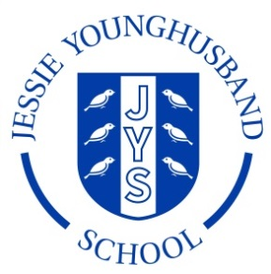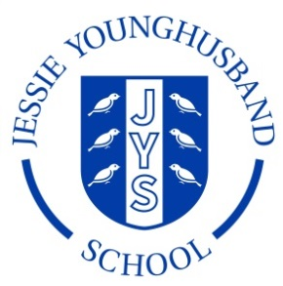

**School Council Agenda 3**

**Aspire ~ Respect ~ Enjoy**

|  |
| --- |
| Meeting of: JYS School Council |
| Place: ICT Suite |
| Date: Friday 30th October 2018 |
| Time: 11.30-12.00 |
| Apologies for absence: |
| Agree the minutes of the last meeting: |
| This meeting’s business:  Chairperson: Hannah Secretary: Edward   1. Welcome the Council 2. Review the minutes from the last meeting 3. Review and discuss the Behaviour Policy 4. Discuss songs that the children would like to be learning on a Wednesday morning. 5. Plan an e-Safety newsletter to parents. 6. Are there any further projects the council would like to tackle? 7. AOB 8. Arrange date and roles for the next meeting. |