**Year 2 Home Learning Monday 8th June – Friday 19th June 2020**

Additional Literacy activities

The Oxford Owl website has some great information about helping your child with grammar and punctuation. There are also some videos at the bottom of the page which suggest a few grammar games to play with your children.

<https://home.oxfordowl.co.uk/english/primary-grammar/grammar-year-2-age-6-7/>

If you get through your Literacy activities in the first week, continue with the lovely lessons on the story of The Firework Maker’s Daughter by Philip Pullman.

<https://www.thenational.academy/online-classroom/year-2/english#subjects> (scroll down to find more lessons)

**How to make beautiful caterpillars from straws- Design Technology**

<https://www.youtube.com/watch?v=0fg1E13eQsw>

You will need the help of an adult for this activity but the caterpillars look so cool!

**Cheesy caterpillars and snakes- Design Technology**

<https://katielovescooking.wordpress.com/2014/04/06/cooking-with-kids-cheesy-caterpillars-and-snakes/>

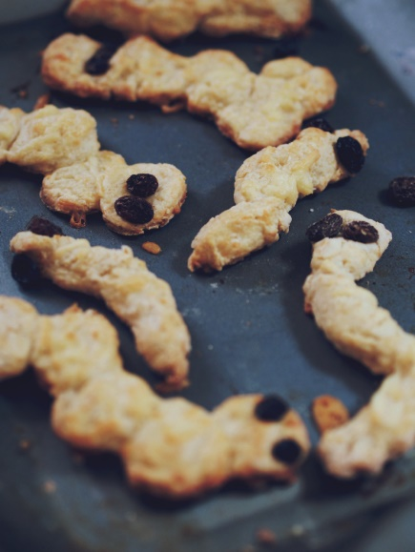 Why not make these delicious treats for yourselves?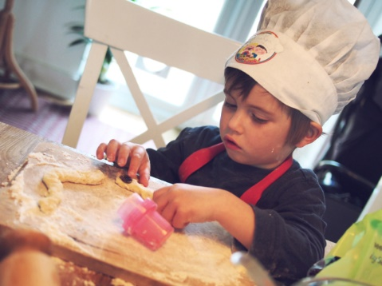

**Make your own ‘Very Hungry Caterpillar’- Design Technology**

<https://www.youtube.com/watch?v=f9Ae72l1djE>

This is a fun and easy way to make your very own caterpillar!

**How to paint a very hungry caterpillar- Art**

<https://www.youtube.com/watch?v=F_0v3l0xjZY>

You can use these potato stamps or just paint with your brush! Send Mrs Saunders a picture of your caterpillar!

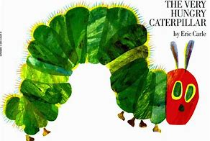

**Caterpillar shoes the video- Reading**

<https://www.youtube.com/watch?v=tYa6OLQHrEc>

This is a lovely animated version of your poem.

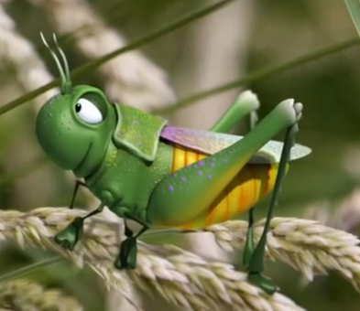

**Spelling and reading fun with the Alphablocks!- Phonics**

<https://www.youtube.com/watch?v=xrjVALwDx_Y>

You can also find our little phonics friends on CBeebies iPlayer too!

**How a caterpillar changes into a butterfly- Science**

<https://www.bbc.co.uk/teach/class-clips-video/how-caterpillars-change-into-butterflies-no-narration/zn4rkmn>

Now I’d like you to draw a beautiful picture of a caterpillar changing into a butterfly. It could look a bit like this:

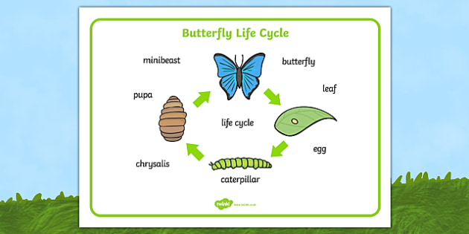

**Make a caterpillar habitat/house- DT & Gardening**

<https://www.instructables.com/id/Caterpillar-House/>

<https://www.wikihow.com/Make-a-Caterpillar-Habitat>

See if you can make a caterpillar habitat of your own. Then go out into the garden and look for some caterpillars!

<https://www.insectlore.co.uk/>

**Minibeast survey- Science**

On the sheet which is labelled ‘Minibeast Survey’ on the website, go out into your garden and maybe a nearby field (with an adult) and mark down as many minibeasts as you can find. The sheet will help you know what to look for. Just do as many as you can. If you can’t print out the sheets, copy down the information into your pink book. Have lots of fun being a nature detective!

**Minibeast Wordsearch** Name \_\_\_\_\_\_\_\_\_\_\_\_

Find the hidden minibeast words.

|  |  |  |  |  |  |  |  |  |  |  |  |
| --- | --- | --- | --- | --- | --- | --- | --- | --- | --- | --- | --- |
| m | s | b | e | e | t | l | e | i | s | b | f |
| i | x | m | d | h | e | s | n | y | d | o | t |
| n | m | h | a | n | t | p | b | p | r | d | j |
| i | r | e | r | m | v | i | r | s | i | y | e |
| b | o | a | d | b | u | d | o | a | b | f | s |
| e | w | d | x | e | a | e | b | w | y | g | u |
| a | l | b | c | e | t | r | i | n | d | s | o |
| s | g | f | l | y | q | e | q | c | a | d | l |
| t | a | c | z | m | o | t | h | v | l | y | d |
| k | w | l | e | g | s | a | p | j | u | h | o |
| w | b | u | t | t | e | r | f | l | y | z | o |
| o | l | f | i | n | s | e | c | t | p | k | w |

**Here are the words to find:**

ant minibeast

MCAN00710_0000[1]

bee moth

MCj03469250000[1]

beetle wasp

body worm

butterfly woodlouse

MCAN01328_0000[1]

fly head

MCAN00221_0000[1]

insect ladybird

legs spider

**Yoga for kids- PE**

Join Sophia Khan for some relaxing and stretchy sessions of Yoga!

<https://www.youtube.com/watch?v=X655B4ISakg>

**Choose your own musical activity- Music**

Choose one of these music activities and have fun!

<https://www.bbc.co.uk/teach/ks1-music/zbcjscw>

**Similarities and differences –RE**

<https://www.bbc.co.uk/bitesize/subjects/zxnygk7>

Have a look at some of these video clips and see what similarities (things that are the same) and differences (things that are different) there are between the way the religions are practiced. You do not have to do this all in one go, maybe do one bit each day over the two weeks? Here is a chart to help you to sort things out. Copy it out if you are not able to print it:

|  |  |  |
| --- | --- | --- |
| Religion name | Similarities | Differences |
|  |  |  |
|  |  |  |
|  |  |  |
|  |  |  |
|  |  |  |

**Make your own sprite on Scratch- Computing**

<https://scratch.mit.edu/>

Scratch is a simple computer coding application that we use at school. Good news- you can also use it at home! Why not see if you can make your own sprite? You could also see if you can give it some simple codes to make it move! Happy coding!

**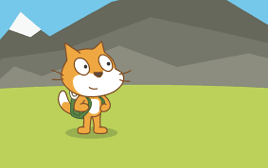**

**Design a book cover – Art/DT/Literacy**

Once you have read the poem ‘Caterpillar Shoes’, see if you can design your own book cover for it. Use these book covers to help you get some ideas. Use crayons, coloured pencils, felt tips or paint to make it nice and bright!

