Year 4 Home Learning Year 4 15th June 2020
Hello Year 4!
It’s Mrs Cooke here! I’m going to be providing your Home Learning for the next few weeks, as Miss Weir is teaching a Key Worker class at school at the moment. I hope you are all well? I’ve tried to continue the learning in a similar style to Miss Weir, with just a few touches of my own. I’ve included some fun challenges and plenty of practical activities. Please do feel free to keep putting your achievements onto the Year 4 Facebook page and you can also still email work to Miss Weir.
If you have any questions, please feel free to email me on michaela.cooke@jys.org.uk.
Don’t forget that you should just do what you can, in terms of work. Just try your best but don’t work for too many hours. Keep having breaks and have lots of exercise outside! You and your parents are doing a fantastic job and we hope to see you soon-ish!
Take care, stay safe and have fun!
Mrs Cooke

Maths WB 15th June 2020
Lessons continuing on from the White Rose website.
https://whiterosemaths.com/homelearning/year-4/
Date | Title | Activity
Monday 15th June | Lesson 1 – Week 7 – Tenths as decimals | Activity sheet on school website
Tuesday 16th June | Lesson 2 – Week 7 –  Divide 1-digit by ten | Activity sheet on school website
Wednesday 17th June | Lesson 3 – Week 7 –  Hundredths as decimals | Activity sheet on school website
Thursday 18th June | Lesson 4 – Week 7 –  Divide 1 or 2-digits by 100 | Activity sheet on school website
Friday 19th June | Lesson 5 – Maths Challenge | White Rose Friday Challenge
WEEKEND
WEEKEND
Monday 22nd June | Lesson 1 – Week 8–  Write decimals | Activity sheet on school website
Tuesday 23rd June | Lesson 2 – Week 8 –  Compare decimals | Activity sheet on school website
Wednesday 24th June | Lesson 3 – Week 8 –  Order decimals | Activity sheet on school website
Thursday 25th June | Lesson 4 – Week 8 –  Round decimals | Activity sheet on school website
Friday 26th June | Lesson 5 – Maths challenge | White Rose Friday Challenge

*Remember to keep practicing your times tables. (TT Rockstars)

Literacy- Challenge 1
This time we have M.G Leonard, (author of Beetle Boy) setting you a ten minute challenge about making your own plastic monster and then writing about it.
https://authorfy.com/10minutechallenges/

Literacy- Challenge 2
Complete the activities set by Dermot O’Leary, author of Toto the Ninja Cat.
https://authorfy.com/wp-content/uploads/2020/03/Toto-Activity-Sheets.pdf

Literacy challenges for every day.
Here are some fantastic radio programmes to listen to and then do the creative writing challenges. Choose one from the archive for each time you want a new activity.
https://radioblogging.net/index.php/category/live-shows/
It’s a different way of learning. You listen to the radio show online and stop it when Pie tells you to do a quick writing activity. Then press play again to continue listening. It keeps the ideas fun and creative! Let Miss Weir know what you’ve been doing.
Literacy- Oak National Academy
Follow the link and complete the 5 lessons on poetry. These are fun, interactive lessons which will add a bit of variety to your learning.
https://classroom.thenational.academy/subjects-by-year/year-4/subjects/english/
Spice girl turns into author!
Gerry Halliwell from the Spice Girls has a new career as a children’s author. This is a fun video that she made in order to inspire children to write stories. Give it a go!
https://www.bbc.co.uk/iplayer/episode/m000jybt/celebrity-supply-teacher-series-1-1-geri-horner-english?xtor=CS8-1000-[Discovery_Cards]-[Multi_Site]-[SL07]-[PS_IPLAYER~N~~P_CelebritySupplyTeacherS1E1]
Reading- Mrs Cooke’s Story Time on YouTube.
Lots of fun stories for younger children and chapters of a book for Years 4-6, Neil Gaiman’s ‘The Graveyard Book’. https://www.youtube.com/user/michbott1/videos

Science- Solids, liquids and gases.
This summer term, Year 4 would be learning about grouping and sorting solids, liquids and gases.
What am I?
I am white and fluffy and the children play with me in the garden. Some grown-ups are spoil-sports and throw salt at me to try to make me go away. When the sun shines strongly I warm up and run to the lowest part of the garden. If I am feeling really energetic, I may leave the path altogether and take to the skies.
Which part of this riddle refers to : a solid? a liquid? a gas?
ACTIVITY
Look at the examples of different substances. Some are solids, some are liquids and some are gases. What do think each one is? Make a table to show your ideas.
milk, oxygen, petrol, copper, wood , hydrogen, polystyrene, blood, carbon dioxide, paper, water, wool, ketchup, oil.
Material | Solid | Liquid | Gas

ACTIVITY
Make up some useful rules which could help someone pick out the solids. Then do the same for the liquids and the gases. What properties do they need to have? You could make 3 posters starting with, ‘To be a solid, a material must….’
Science- Materials
(1) Materials are the things that objects are made from. Materials can be in one of two groups.
1. Man-made- e.g. glass, plastic.
2. Natural- e.g. sand, wood, leaves.
Our homes contain different materials:- Try to find 5 examples for each!
1. Wood e.g. desk
2. glass
3. rubber
4. metal
5. plastic
6. fabric
7. paper
Now for each category, try to think of adjectives that give lots of extra information. E.g. 1. wood- hard, strong, grained, polished 2. glass- clear, strong, cold 3. Rubber 4. Metal 5. Plastic 6. Fabric 7. Paper
Solids, liquids, gases activity sheet.
Find an additional activity on making statements true about solids, liquids and gases. See which word fits best.
Reading- audio and visual
I have been reading stories for children and putting it on my YouTube channel. There are different books and also chapters of a great story by Neil Gaiman, ‘The Graveyard Book’. Check it out! https://www.youtube.com/user/michbott1/videos
Design Technology- Make a bridge.
Your challenge is to make a bridge from straws, tape and paper! The STEM learning page has instructions on how to do the bridge challenge. However, if you can’t get any straws, use the design principles and challenge yourself to make a bridge out of either paper, cardboard, recycled materials etc. Take a picture and write a paragraph on what problems you encountered and how you overcame them. Put the pictures on Facebook or email them to Miss Weir!
https://www.stem.org.uk/resources/elibrary/resource/35888/bridge-building
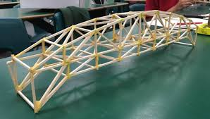

Challenge! Pick it up with your feet!
Try basic tasks such as picking things up and opening a door, but also drawing and painting. You’ll definitely enjoy seeing your own feet-art!

PE- Cricket skills
This term you would have been practicing your cricket skills. See if you can persuade your family to have a go at these easy cricket-based games. If not, practice throwing and catching with a tennis ball. You could use chalk to draw a set of wickets on an outside wall (get permission from an adult first) and then throw the ball underarm to see if you can hit the wickets.
https://www.meulemans.com.au/uncategorized/9-easy-games-play-kids-new-cricket/

Music- Exploring pulse.
Scroll down the page on the link and you will come to a section of lessons labelled ‘Creative’. Have a go at the ones called ‘Pulse’ and ‘To beatbox using rhythmic patterns’.
Have fun!

RE- Ganesh the Hindu God
Your RE topic is Hinuism at the moment. Watch this video about the Hindu God Ganesh. Then reflect on your own values. What do you think is important in life? Write down the top 10 values (eg kindness, looking after family etc) you think are important) than are most important to you.
https://www.bbc.co.uk/bitesize/clips/zt7tfg8
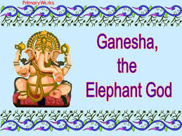

Challenge! Catch coins from your elbow!
Have your little one rest the back of their hand on the same shoulder, so their elbow should be pointed out and the underside of the arm facing up. Then they place a coin on their arm, just above the elbow. The idea is to quickly draw your elbow into your side so that the coin flies into the air, and at the same time, flip the arm over so that they can catch the coin. It’s tough to catch just one coin but you can up the ante by having them catch a stack of coins.
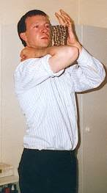
Art- How to draw a landscape.
Follow the tutorial to learn how to draw a landscape. Maybe you could put a river in it?
https://www.youtube.com/watch?v=v368l7nAltE

Theme/Topic- Rivers
Your Theme for this half term is ‘Rivers’. We will be doing a few activities on this theme over the coming weeks.
Watch these videos and read the information on rivers. Then test yourself using the quiz at the bottom of the page.
https://www.bbc.co.uk/bitesize/topics/z849q6f/articles/z7w8pg8
Next, draw a diagram of the ‘Features of a river’ and label it. I have provided a picture but if you type the title into Google, you might find a different one you’d like to copy. Colour it in, label it and give it a title. Make it a really professional job!
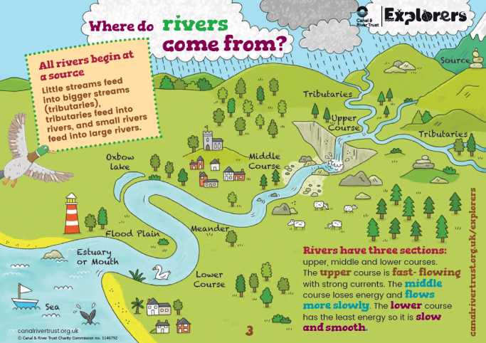

Challenge! Guess who?
One person has to imitate a person and the other players have to guess who it is. You can act out celebrities, characters or people you all know such as teachers or friends. The catch is that you can’t say anything that will give it away. This includes any popular catchphrases or descriptions of the person’s appearance. You need to use gestures and your voice to try and portray the person as best as you can. Have fun!

Cookery & Baking
Creamy Mango Lollies
https://www.littlecooksco.co.uk/recipes/creamy-mango-lollies/
Beautiful Burgers
https://www.littlecooksco.co.uk/recipes/beautiful-burgers/
Fajitas! - My kids’ favourite!
https://www.bbcgoodfood.com/recipes/cooking-kids-fajitas

