Jessie Younghusband School

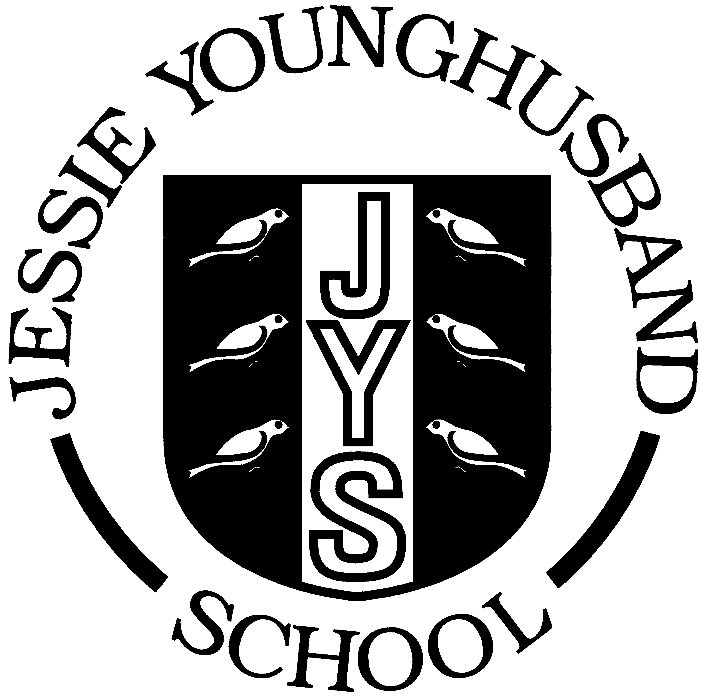

Health and Safety Policy

Updated summer 2018
Review summer 2019

Aspire ~ Respect ~ Enjoy

Statement of Intent
The governing body acknowledges West Sussex County Council’s (WSCC) Corporate Health and Safety Policy, acting as Local Education Authority and employer, and provides the following additional statement of intent to cover all school buildings, activities and undertakings for which it is responsible.

Under the Health and Safety at Work Act 1974, the governing body accepts that it has the responsibility to take all reasonably practicable steps to secure the health and safety of staff, pupils and others visiting and using the school premises.

The governing body believes that the prevention of accidents, injury or loss is essential to the efficient operation of the school and is part of the good education of its pupils. It will be the governors' policy to encourage, where practicable, the co-operation of all users of the establishment by monitoring, review, discussion and consultation to promote and develop measures which ensure health and safety at work.

Chair of Governors
THE ORGANISATION FOR HEALTH AND SAFETY

Health and safety responsibilities

The Governing Body has strategic responsibility for health and safety within all areas of the schools undertakings and is answerable to the LEA for its actions, on behalf of whom it makes decisions. The governing body is responsible for ensuring that advice from competent health and safety advisers is available on health and safety matters in order to comply with regulatory controls.

The Head Teacher has responsibility for the day-to-day operation of health and safety and welfare policies and practices, as delegated by the governing body, within all areas of the school’s undertakings. The Head Teacher is responsible for ensuring that advice from competent health and safety advisers is sought on health and safety matters in order to comply with regulatory controls.

Department Heads are responsible for ensuring that safe working conditions are maintained for all pupils, employees, visitors, members of the public and, where applicable, contractors throughout their individual work areas, as delegated by the Head Teacher or governing body and detailed in the organisation section of the policy. Department heads are responsible for ensuring that advice from competent curriculum and health & safety advisers is sought on health and safety matters in order to comply with regulatory controls.

Employees are responsible for their own health and safety, that of their colleagues and members of the public who may be affected by their work activities.

ARRANGEMENTS FOR HEALTH AND SAFETY

Accident and Incident Reporting

All accidents and incidents, to staff, visitors and contractors are reported to WSCC using the online accident reporting system. Minor incidents to pupils are recorded locally major injuries and direct visits to hospital are also reported to WSCC using the online system.
Charlotte Elkington is responsible for reporting accidents

The Head teacher will monitor accidents and incidents in order to identify trends and report to the governing body.

Administering medicines

The school’s Managing Medicines Policy details the procedures followed by the school and is based on WSCC policy and procedures. A copy of the policy is available from the school office.
The lead for the administration of medicines is Charlotte Elkington

Asbestos

The school holds an asbestos register and follows the WSCC Code of Practice regarding monitoring and record keeping. All contractors working on the building are made aware of the location of asbestos and sign the register. Staff are made aware of the location of asbestos and the procedures to follow if discovering disturbed asbestos. Ray Hellyer Premises Officer is responsible for asbestos management

Control of Substances Hazardous to Health (COSHH)

All hazardous substances stored and used within the school are to be risk assessed and the precautions identified by the risk assessment shall be communicated to staff and implemented. These assessments will be held in the school’s COSHH risk assessment file, along with the relevant data sheets and made available to all employees who are required to use these substances in their work.

Ray Hellyer is the designated person for ensuring that the COSHH risk assessment file is kept up to date and communicated to relevant staff.

Contractors

Maintenance and servicing contractors receive an induction to the school site (including asbestos), its facilities and emergency arrangements. Contractors undertaking large scale building work receive all of above and an induction pack which includes relevant school policies, procedures and risk assessments. The school adheres to WSCC self-managed process and uses only WSCC approved contractors. Contractors are monitored whilst on site although during school periods access arrangements will be negotiated to facilitate the completion of the work.
Lindy Nash is responsible for the management of contractors

Curriculum Safety
The governors recognise that some curriculum areas represent an increase in risk; these departments hold department specific health and safety arrangements, which are regularly reviewed and communicated to the relevant staff.
Sean Harman – responsible for Design and Technology
Paul Neaves– responsible for Physical Education
Laura Osborne – responsible for Science

Display Screen Equipment (DSE)

Every DSE user will have a risk assessment completed to make sure they know how to adjust and set up the workstation correctly. It is the responsibility of Lindy Nash to ensure assessments are completed by relevant staff. The risk assessment can be carried out by the workstation user through the e-Learning programme and assessment checklist. This is available on Health and Safety A-Z pages of the WSSfS.

DSE user risk assessments will be reviewed periodically by Lindy Nash at least annually, or if there have been any significant changes to the workstation. A review of the original assessment must be undertaken as soon as practicable by the line manager when an employee complains of musculoskeletal or other health issues that could be attributed to, or aggravated by, working with DSE

Electricity

All portable electrical equipment within the school is to be tested annually and records of these tests will be held at the school.

Private portable electrical equipment must not be brought into the establishment and used without the appropriate checks.

A 5 yearly check of the fixed electrical installation is completed and records kept.
Electrical safety is managed by Ray Hellyer

Emergency Provision/Business Continuity

The Emergency Plan details procedures and arrangements to be used in the event of an emergency. This includes liaison with WSCC and the emergency services, provision for the continuation of school business and arrangements to contact interested parties i.e. parents and the press. All staff are trained in the procedures contained within the emergency plan and are able to take the appropriate action if required.
The emergency plan is regularly monitored and reviewed by Lindy Nash SBM.

Fire Safety
Ray Hellyer is the designated person for fire safety within the establishment. The designated person will ensure that:

- The school’s fire risk assessment is kept up-to-date by annual review or in response to significant changes to premises or work arrangements.
- There is reasonable fire-fighting equipment in the school, it is maintained and maintenance records are kept.
- The fire safety equipment, e.g. fire alarm, emergency lighting, etc. is regularly checked, maintained and records are kept.
- There are no general fire hazards around the building, particularly near escape routes, escape routes are unobstructed and that there is access for fire fighters.
- Staff and pupils are practised in evacuating the premises by performing termly drills, monitoring their effectiveness and keeping records.
- Develop personal emergency evacuation plans (PEEP) for those staff and/or pupils who require additional assistance to evacuate the premises.

They will also ensure that the establishment has in place an up to date Emergency Fire Plan, which details the procedures to be followed in the event of a fire. The plan must be prepared to ensure that people within the establishment know the action to take if there is a fire, and to ensure the establishment can be safely evacuated.

Where necessary, the Emergency Fire Plan will include the following features:

- Action on discovering a fire and calling the fire service (these notices will also be displayed throughout the establishment)
- The location of the assembly point for roll call
- Liaison with emergency services
- Identification of key escape routes
- The type and location of fire-fighting equipment provided
- Specific responsibilities in the event of fire (adequate number of fire wardens to assist with the evacuation)
- Training (in house fire safety awareness training is carried out annually for all staff).
- Any need to co-operate or co-ordinate with other responsible persons that will be operating within the premises.

First Aid
The lead First Aider is Charlotte Elkington the following staff are trained First Aiders: Charlotte Elkington, Jo Taylor, Hannah Broughton, Alison Creasey. Details of the school’s first aid trained staff is displayed in the first aid room/area.
Lindy Nash SBM, monitors first aid training to ensure certification remains in date.

A first aid risk assessment has been completed and provision is in place,
following the findings of the risk assessment. Suitable and appropriate first aid cover is provided at all times during the working day and after hours to cover breakfast and after school clubs and all staff members are aware of the arrangements in place.

Sandra Delves is the designated person for ensuring the first aid kits are kept fully stocked and items are within date, checks of first aid kits are recorded as completed.

Food Safety

The lead for Food Safety is Lindy Nash. The Food Safety lead will ensure that there are arrangements for safely and hygienically receiving food from suppliers and preparing it for serving to pupils. The kitchen, servery and dining area are to be cleaned daily and after each use by Chartwells.

A risk assessment is in place for lunchtime meals (hot and cold). Midday Meals Supervisors must cordoned off a spillage, cleared up immediately and the floor surface left clean and dry before being opened up to pupils again.

All incidents are to be reported to the Food Safety Lead.

Glazing
The school holds an up to date Glazing Survey and regularly monitors glazing as part of the premises inspection. Ray Hellyer is responsible for glazing management.

Gas Safety
The school ensures that the gas boilers and other gas appliances are serviced and maintained regularly. Ray Hellyer is responsible for gas safety.

Induction

All new employees are informed of the school’s health and safety arrangements and procedures using the induction checklist available within the Health and Safety A-Z on the WSSfS. Staff will also complete the eLearning ‘Your Own and Others’ and records will be kept. Lindy Nash is responsible for the induction of staff.

Lone Working

Lone working is discouraged, however where employees are required to work alone, the risks should be assessed and adequate controls put in place.
Lindy Nash is responsible for risk assessing and producing lone working procedures.

Play equipment

External and internal play and physical education (P.E.) equipment is serviced by Universal. P.E. equipment is checked prior to every use by the teaching staff any defects are reported immediately to the Head teacher. Ray Hellyer regularly monitors external play equipment and defects are reported immediately to the Head teacher. Faulty equipment is immediately decommissioned.

Premises Maintenance

The internal and external premises will be inspected at regular intervals Ray Hellyer, the inspections are recorded and resulting issues reported to the Head teacher. The school is to be kept clean, tidy and free from hazardous obstacles. Staff must report any defective equipment, furniture or premises issues to Ray Hellyer using the defects log. Ray Hellyer will sign and date completed actions in the log.
Monitoring, audit and review

The Governing Body shall receive termly reports on Health and Safety and will regularly inspect and monitor the premises. Regular review of procedure shall be undertaken in the light of operational practice, new laws and new policy/directives of the Local Authority. The operational practice and procedure shall be constantly monitored by the head/local safety officer. The Governing body shall prepare an annual action plan to address deficiencies in health and safety arising from the Head teachers’ annual report.

Moving and Handling of Customers and the Manual Handling of Inanimate Loads

Manual handling is defined as the transporting or supporting of a load (including the lifting, putting down, pushing, pulling, carrying or moving thereof) by hand or bodily force. Consequently, the Manual Handling Operations Regulations apply to a wide range of operations; in this context it applies to both the moving of inanimate loads (manual handling) and the moving and handling of children where they are unable to do this unaided (moving and handling).

Where manual handling or moving and handling tasks are undertaken, The Governing body will designate suitably competent staff to undertake risk assessments of the activities, and ensure staff working in these areas receive the necessary training and instruction.
Lindy Nash is responsible for developing and reviewing moving and manual handling risk assessment.

New and Expectant Mothers

Any staff member who becomes pregnant is to inform the Head Teacher of this and an appropriate risk assessment is to be undertaken following the guidance contained within the Health and Safety A-Z on the WSSfS. The school recognises the changing nature of pregnancy and will regularly review risk assessments to ensure that working at the school will not pose any risk to their health and safety and that of their unborn child.

Off site activities

All off site activities are risk assessed using the WSCC system. The schools systems are audited by WSCC Outdoor Education Advisor. Mandy Sadler is the schools Educational Visit Co-ordinator (EVC)
Risk Assessments
Risk assessments are a legal requirement under health and safety law and the Head Teacher will assess all risks arising out of the curriculum and associated work which the school undertakes. In accordance with corporate guidance risk assessments will be recorded in writing and reviewed annually or following a significant accident and or incident.
Staff Welfare/Stress
The governing body considers staff welfare of paramount importance, and seeks to promote a work/life balance amongst their staff. The Head teacher is constantly monitoring staff workload and every effort is made to make effective changes if staff are experiencing stress either at home or work. The school also utilizes the services of Health Assured and Occupational Health.
Training
The school ensures that all staff are provided with adequate information, instruction and training to perform their roles. Training requirements are discussed during induction, professional development reviews and one to one supervision. Training records are kept and reviewed by Lindy Nash.
Water quality
Ray Hellyer is responsible for monitoring and recording water temperatures at the school to ensure water quality is maintained. A bi-annual water quality risk assessment is produced and reviewed by
Working at height
Teaching staff should avoid working at height where ever possible. Only the 3 step step-ladder should be used when this is necessary to put up displays. Staff should work in pairs in these instances. Only Ray Hellyer Premises Officer should use any other working at height equipment for access to any areas of the building including the roof. No such acitivities should be undertaken without informing the SBM and only when at least one other member of staff is present. Ladders, step stools and other access equipment are kept on a ladder register and regularly inspected and maintained.

