Year 4 Home Learning Monday 29th June – Friday 10th July 2020
Hello everyone,
How are you all? I’m well and enjoying planning the Home Learning for Years 2-6. It’s so interesting to see how differently the teachers approach their individual lessons and activities.
This week, Mrs Sadler has asked me to pop in a sample timetable, for anyone who is finding it difficult to structure their days. It is only a guideline but may be helpful for reluctant learners. The lessons are flexible and can be swapped around to fit in with your schedule. It is important that the children do some work to keep up with their year group, so that they are not hugely behind next year (please feel free to pass this information on to the children).
Day | Lesson 1 | Lesson 2 | Break/lunch | Lesson 3 | Lesson 4
Monday | Maths | Literacy |  | PE | Theme/Topic
Tuesday | Literacy | Maths |  | Science | French/Music
Wednesday | Maths | Literacy |  | Theme/Topic | Art/DT
Thursday | Literacy | Maths |  | RE/PSHE | Science
Friday | Maths | Literacy |  | Art/DT | PE

We usually get children to do Maths and Literacy in a morning, as they are more receptive at that time of day. Afternoons can be more laid back and creative. We usually give them a short break between each lesson but our lessons are longer than 40 minutes. This is just a sample suggestion of a timetable and can be adapted. Each lesson should usually be around 30-40 minutes long. Some may take less time and some may take more. Reading should be done every day and spellings/grammar once or twice a week, in an ideal world.
Of course, I realise that this is not an ideal world and you must just do what fits in well with your family timetable. This timetable is only a suggestion.
All subject objectives, spellings, grammar can be found on this website as guidance. http://www.primarycurriculum.me.uk/
Please do feel free to keep putting your achievements onto the Year 4 Facebook page and you can also still email work to Miss Weir.
If you have any further questions, please do email me on michaela.cooke@jys.org.uk and I’ll be happy to answer your queries.
Kind Regards, Mrs Cooke

*See below for activities

Maths
You can follow the White Rose Maths on their Home Learning webpage. Remember there are videos to help you and worksheets to go with them available on the JYS website. https://whiterosemaths.com/homelearning/year-4/
There is also information on what the BBC Bitesize website are providing on different dates and for different year groups here https://bam.files.bbci.co.uk/bam/live/content/zn4pyk7/pdf#sa-link_location=blocks&intlink_from_url=https%3A%2F%2Fwww.bbc.co.uk%2Fteach%2Fbitesize-daily-lessons-schedule%2Fzdtwjhv&intlink_ts=1592483499015-sa
Maths WB 29th June 2020
Lessons continuing on from the White Rose website.
https://whiterosemaths.com/homelearning/year-4/
Date | Title | Activity
Monday 29th June | Lesson 1 – Week 9 – Interpret charts | Activity sheet on school website
Tuesday 30th June | Lesson 2 – Week 9 –  Comparison, sum and difference | Activity sheet on school website
Wednesday 1st July | Lesson 3 – Week 9 –  Introducing line graphs | Activity sheet on school website
Thursday 2nd July | Lesson 4 – Week 9 –  Line graphs | Activity sheet on school website
Friday 3rd July | Lesson 5 – Maths Challenge | White Rose Friday Challenge
WEEKEND
WEEKEND
Monday 6th July | Lesson 1 – Week 10–  Identifying angles | Activity sheet on school website
Tuesday 7th July | Lesson 2 – Week 10 –  Angles, comparing and ordering | Activity sheet on school website
Wednesday 8th July | Lesson 3 – Week 10 –  Classifying triangles | Activity sheet on school website
Thursday 9th July | Lesson 4 – Week 10 –  Classifying quadrilaterals | Activity sheet on school website
Friday 10th July | Lesson 5 – Maths challenge | White Rose Friday Challenge

*Remember to keep practicing your times tables. (TT Rockstars)

Literacy- Challenge 1
This time we have Swapna Haddow, (author of Dave pigeon) setting you a ten minute challenge about writing a story from an animal’s perspective.
https://authorfy.com/10minutechallenges/
Literacy- Challenge 2
Complete the activities set by Guy Bass (author of Skeleton keys) where you make up a world which you can unlock with a skeleton key of your very own!
https://authorfy.com/10minutechallenges/

Literacy- Challenge 2
Complete the activities set by Lucy Worsley (author of children’s historical fiction books). She asks you to draw an illustration to go with her new story, The Austen Girls.
https://authorfy.com/10minutechallenges/
Literacy challenges for every day.
Here are some fantastic radio programmes to listen to and then do the creative writing challenges. Choose one from the archive for each time you want a new activity.
https://radioblogging.net/index.php/category/live-shows/
It’s a different way of learning. You listen to the radio show online and stop it when Pie tells you to do a quick writing activity. Then press play again to continue listening. It keeps the ideas fun and creative! Let Miss Weir know what you’ve been doing. (Although the live shows have now stopped, all of the previous shows are available to participate in).
Literacy- Oak National Academy
Follow the link and complete the 5 lessons on poetry. These are fun, interactive lessons which will add a bit of variety to your learning.
https://classroom.thenational.academy/subjects-by-year/year-4/subjects/english/

Reading Comprehension activity pack- Literacy Shed
Over the next 4 weeks, I would like you to work your way through these Reading Comprehension activities. Choose one each time and see how you get on. They can be downloaded and printed off, or you can read them online and write the answers in your Home Learning book.
https://www.literacyshedplus.com/en-gb/resource/stage-4-reading-packs
Reading- Mrs Cooke’s Story Time on YouTube.
Lots of fun stories for younger children and chapters of a book for Years 4-6, Neil Gaiman’s ‘The Graveyard Book’. https://www.youtube.com/user/michbott1/videos

SOLIDS, LIQUIDS AND GASES
- Can you put the sentences into the correct columns? Some sentences go in more than one column. (Please continue to scroll down, as the formatting has placed them in odd places- sorry!)

- Takes the shape of the container it is poured into.
- Keeps its own shape
- Flows easily along a pipe
- Will not flow along a pipe
- Turns into a liquid when it melts
- Turns into a gas when it boils
- Spreads out in all directions to fill a space
- Can be easily compressed
- Cannot be easily compressed
- Turns into a solid when it freezes

SOLID | LIQUID | GAS

- Add some sentences of your own.

Solids, Liquids and Gases

All things are made from . All materials are found as a , a or a . These are called physical states of matter. Choose words from the box to complete the sentences.

materials space states solid liquid gas
spread physical states of matter pattern particles tightly
force pour shape further apart

Solids are made of , which are packed together very tightly in a .

Solids keep their shape unless a is applied to them.

Liquids are made of that are not packed as as those in a and can move more quickly.
Liquids and take the of the container.

Gases are made of particles, which are not packed as tightly as those in a liquid and are .
Gases cannot usually be seen. They out to fill the around them.

These are some examples of .
SOLID | LIQUID | GAS
wood | water | helium

These are some examples of objects that exist in different .
SOLID | LIQUID | GAS
pencil | paint | inside lemonade

Solids and liquids activity
This is a fun activity. Click on the blue boxes and they will give you an option of 3 words to choose from for the answer. Choose the one which makes most sense. (Separate sheet)
Solids, liquids & gases fun facts quiz.
Complete the questions on the answer sheet and then get an adult to mark it for you? Have a good discussion with your adult about our answers. How did you do? Did you know more after you talked about it? Science is often easier to understand once you’ve had a good chat about it! (Sheet- Science fun facts quiz).
Design Technology- Bridges
This week we follow on from our previous work on bridges. First, watch this video which explains all about what makes bridges so strong. https://www.youtube.com/watch?v=oVOnRPefcno
Next, have a look at this video about the building of the Golden Gate Bridge in San Francisco, USA. Watch it from 3:45 minutes, as the narration is a bit technical. Watching the pictures of how it was built is really interesting though! https://www.youtube.com/watch?v=OC5C9a2udjo
Finally, use this video to help you to build a pasta bridge! You can use any type of dry pasta and spaghetti and glue it all together. Try to make a different type of bridge to the obe you made last time. You could even paint it, if you are happy with the result! Send your photos of your bridge to Miss Weir! https://www.youtube.com/watch?v=xN0poIrm0q8
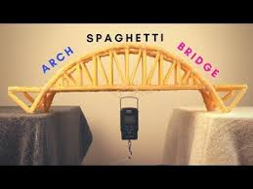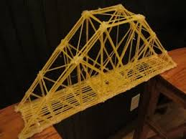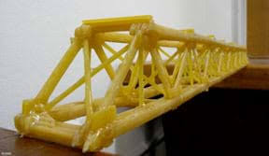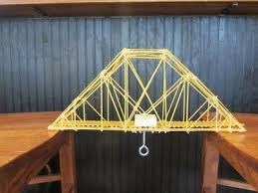
This is also an interesting programme about bridges, hosted by Richard Hammond from Top Gear. https://www.youtube.com/watch?v=dQf_vE7tOlw
PE- Cricket skills
Continue with your cricket practice in your garden or local sports ground. Get your family involved! https://www.meulemans.com.au/uncategorized/9-easy-games-play-kids-new-cricket/

Music- singing challenge!
Do you remember when Mr Neaves got all of the teachers and TAs to sing along to ‘Better when I’m dancing’? Well, it’s your turn! Can you video yourself singing and dancing to the song? Maybe someone might like to put the videos together and make a Year 4 version of the song? I’m sure Miss Weir and Mr Neaves would be blown away. If it’s not your thing, then just practice singing and dancing to the song in the comfort of your own room. See how good you can get!
https://www.youtube.com/watch?v=sgnESV_hfMs&feature=youtu.be&fbclid=IwAR1XoMWICQUM4DVwJdWBohSe9HLsWLxUTqFgWwQlT0mOqZZLo5_6eF-2mTU
https://www.google.com/search?q=better+when+im+dancing&rlz=1C1GCEU_enGB890GB890&oq=better+when+im+dancing&aqs=chrome..69i57j46j0l5.6749j0j4&sourceid=chrome&ie=UTF-8

RE- Ganesh the Hindu God
The birth of Lord Ganesha is celebrated by Hindus all over the world. Lord Ganesha is depicted with an elephant's head on a human body, and in the Hindu tradition he is the son of Lord Siva and the Goddess Parvati.
This Hindi Festival is celebrated on 22nd August 2020 and on 9th September 2021.
I’d like you to read the Powerpoint about Ganesh and then draw a colour picture of him on a piece of plain paper. Once you have coloured it in, write all the facts you have learned about him on the remaining white pieces of paper. You will then have a lovely, colourful fact file about Ganesh.
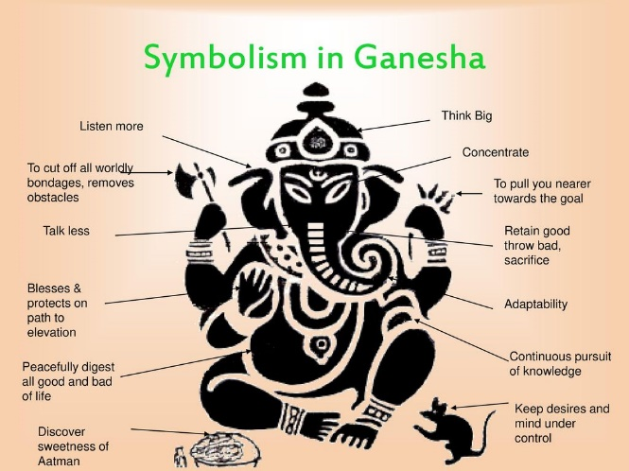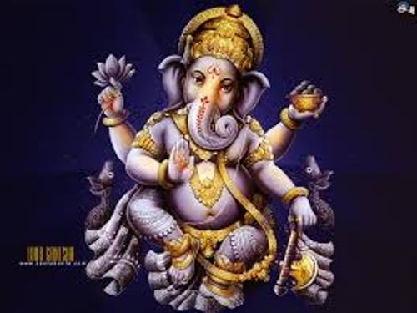

Challenge- Can you wiggle your face?
Best played in a group, have your kids see who can wiggle different parts of their face without moving the whole thing. They can try wiggling their ears, nose, eyebrows or go cross-eyed. This will get lots of laughs as they see that some people can do it and some can’t at all. It’s also interesting to see the direction in which they wiggle their features, can your nose go up and down as well as side to side?
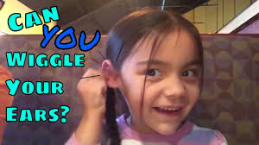

Challenge- Different accents
The rules are simple: do your best accent! Deciding the accents is half the fun; your kids could write down countries and challenge one another. They could pick the countries from a hat or even choose on a globe. If they don’t know how their chosen accent should sound, they should make it up. Alternatively, you could have them watch videos of different accents and try to imitate those. This can be fun if you want to tackle regional accents in the UK or the States for example.
https://www.google.com/search?q=how+to+speak+different+accents&rlz=1C1GCEU_enGB890GB890&oq=how+to+speak+different+accents&aqs=chrome..69i57j0l2.6394j0j9&sourceid=chrome&ie=UTF-8#kpvalbx=_qQjyXunsCa6o1fAP55OKmAQ60
Art- Rivers
Here is a tutorial on how to draw a river scene in a cartoon style. Give it a go!
https://www.youtube.com/watch?v=pEgVjfSSELs
Here’s how to draw a cool mountain and river scene. Have a try!
https://www.youtube.com/watch?v=Fp04CrVIMrI
Now try this one. How do the different videos produce different results?
https://www.youtube.com/watch?v=dyA_RFAG04k

Challenge- One Minute Games
Pretty straight forward; players have one minute to complete these challenges. You just need to time them and see how far they get in one minute. The tasks should be possible to complete in one minute, but not easy. Some ideas include having all of the picture cards in a deck shuffled and face down, and then players have to sort them into their suits in order. Or stacking chapsticks in a tower using chopsticks to pick them up. More ideas can be found here.
PE- Celebrity PE lesson with Marcus Rashford
https://www.bbc.co.uk/iplayer/episode/m000jycy/celebrity-supply-teacher-series-1-3-marcus-rashford-pe
Theme/Topic – Rivers
Watch this BBC clip on rivers. https://www.bbc.co.uk/teach/class-clips-video/geography-ks1--ks2-rivers/z6qsf4j
Then I would like you to answer the questions under the video clip.
Finally, I would like you to make a fact file or Powerpoint about rivers. It can be about one river in particular or a few different ones. They can be anywhere in the world. The only rule is that you MUST include some information on what different parts of a river are called and how they are formed, from the source, right down to the mouth of the sea (eg; using words such as; meander, stream, spring, source, mouth, tributary etc). It’s fascinating!
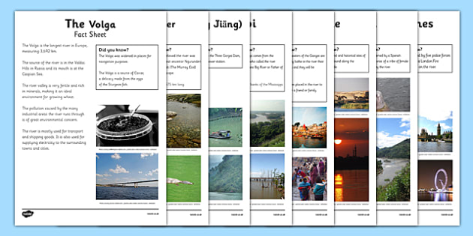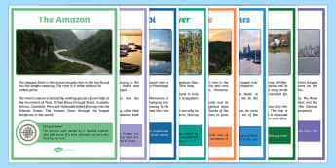

DT- Cookery and baking
Impress your family with this family meal of spaghetti and meatballs!
https://www.bbc.co.uk/food/recipes/mos_magic_meatballs_53940
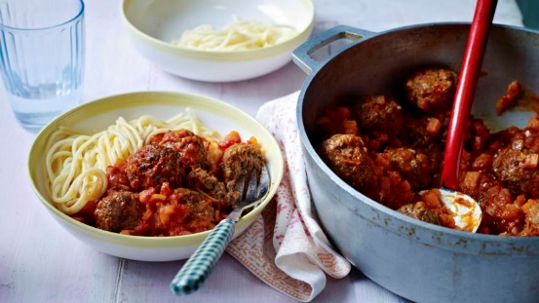
This recipe only takes a few minutes to prepare! Yum! Easy omelette!
https://www.bbc.co.uk/food/recipes/baileys_breakfast_24338
How about some bean burgers? You can make them spicy by adding some sweet chilli dip or chilli sauce!
https://www.bbc.co.uk/food/recipes/veggie_bean_burgers_for_53280
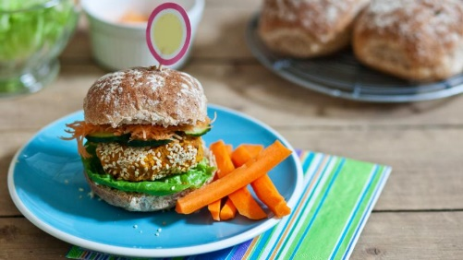
How about some Disco Pops for those hot, hot days?
https://www.bbc.co.uk/food/recipes/disco_pops_02468
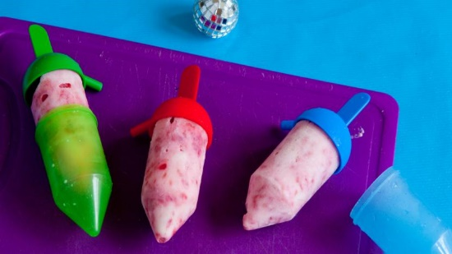
Make your own sprite on Scratch- Computing
https://scratch.mit.edu/
Scratch is a simple computer coding application that we use at school. Good news- you can also use it at home! Why not see if you can make your own sprite? You could also see if you can give it some simple codes to make it move! Happy coding!
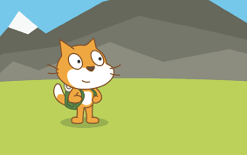
DT- Gardening
Grow a vegetable from scratch!
Take out seeds from a vegetable: tomato, pepper, squash, chilli etc and pop them in a plant pot/yogurt pot full of soil. Water it, label it and pop it on the windowsill. Watch them grow! When they are sturdy seedlings, plant them outside. If you’re lucky, you might be able to produce your own vegetables!

