Home Learning
This Home Learning pack will help by providing some lessons (on our current units), whilst your child is at home.
If you have any further questions about the contents of this pack, please feel free to email me on: Julie.saunders@jys.org.uk. I would be happy to give feedback on any work completed via email.
Literacy: Lesson 1
In our Literacy unit, taught at the end of last term, we were learnt how to write an information page. We had a list of features that we needed to include: this list is included on the writing frame sheet. Your task is to write an information page. The topic can be of your choosing. In school we were going to use the topic of our Christmas holiday. Have a look at my example: you might choose this topic for your page or you can choose something else.
Literacy: lesson 2
In our new Literacy unit, we will be revisiting our learning about writing a description of a character and adding new objectives. The key features are listed below:
- Use of capital letters and full stops to mark sentences;
- Use of finger spaces to identify individual words;
- Use of conjunctions ‘and’ and ‘because’ to join ideas together;
- Use of nouns and adjectives.
Additional learning for this unit:
- Use contractions
- Use of exclamation sentences
A full dictionary of these skills are listed below:
Skill | Definition | Example
co-ordinating conjunction  ‘and’ | ‘and’ joins words or groups of words which are of the same importance in the sentence | The green bird pecked the juicy apple and ate if noisily.
subordinating conjunction ‘ because’ | ‘because’ joins words or groups of words together which add extra meaning but which are not as important as the rest of the sentence | The boy watched the bird quietly because he didn’t want to scare it away.
nouns | words that name objects, people, places or ideas | The bird pecked the apple.
adjectives | words that describe nouns | The green bird pecked the juicy apple.
contraction | a shortened version of a word that omits some letters. An apostrophe represents the missing letters | don’t, it’s, couldn’t
exclamation sentence | a sentence that expresses great emotion | What an amazing day!  How great was that!

Literacy – Day 2 write a description of a character:
You might like to choose one of these characters, to inspire you to write a description. Plan your description carefully so that you include all the features in this unit. Or, draw a member of your family and describe them or perhaps a character from your favourite book.
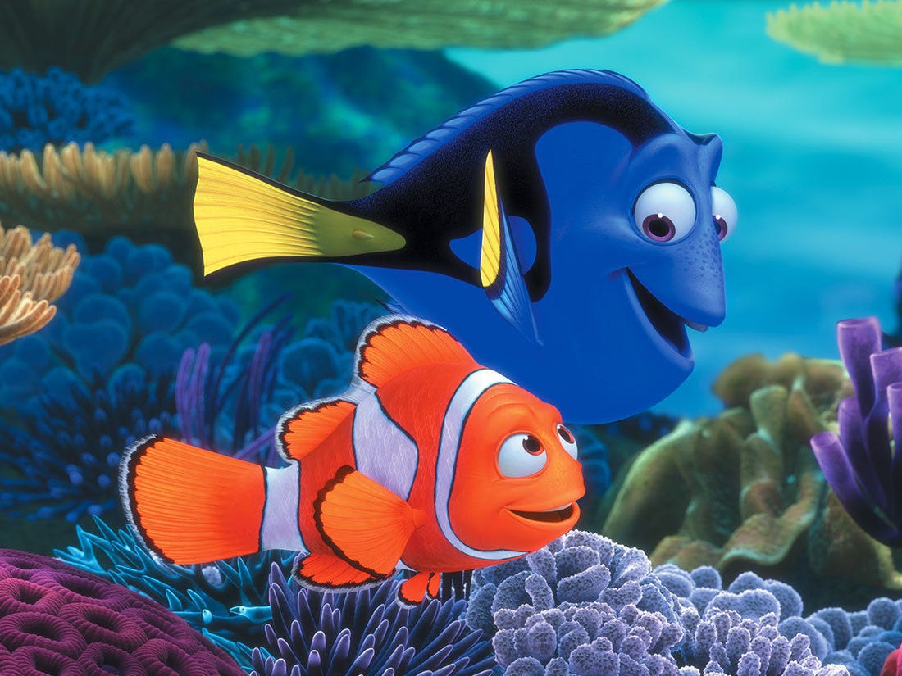

Literacy – Day 3 editing the description of your character:
Read each of your sentences. Have you included a sentence with ‘because’? Have you joined two ideas with ‘and’? Have you added an adjective to describe each of your nouns? Do you have an exclamation sentence and an example of a contraction?
Use a coloured pencil and mark your capital letters, full stops and exclamation marks, like we do in class.
Put a tick in some of your finger spaces.
Put a wiggly line underneath ‘and’ or ‘because’, as well as contraction examples.
Put a circle around your nouns and a line underneath your adjectives.

Reading
As you are reading make a note of any contractions that you read. What letters have been missed out?
Mathematics:
We have just finished the unit on addition and subtraction.
For lesson 1 have a go at the investigation on the worksheet.
How many different addition and subtraction number sentences can you find?
Choose your 4 numbers carefully to match the level of challenge. Don’t forget for some trickier number sentences you may need to use your written number line method to find the answer.
Lesson 2
We are about to start the multiplication and division unit.
At Jessie Younghusband, we follow the White Rose maths scheme, who have very helpfully made their maths available for home learning use.
Here is a link to the White Rose website, where you will find video tutorials for each element of learning that we cover in this unit: https://whiterosemaths.com/homelearning/year-2/spring term /
These videos have questions for the children to explore and answer independently.
Try week 12 from the autumn term then move to week 1 spring term.
These worksheets will support the video tutorials.
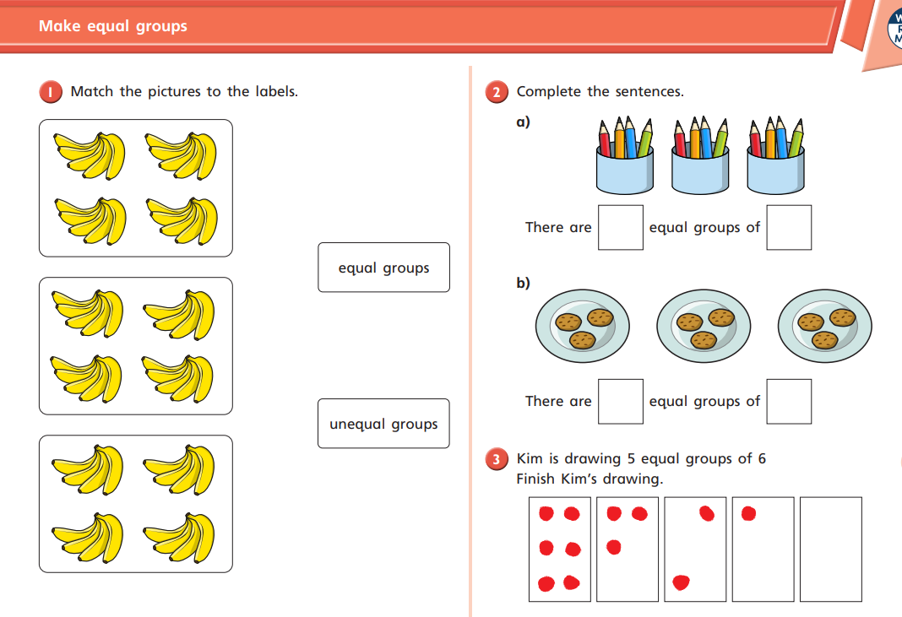

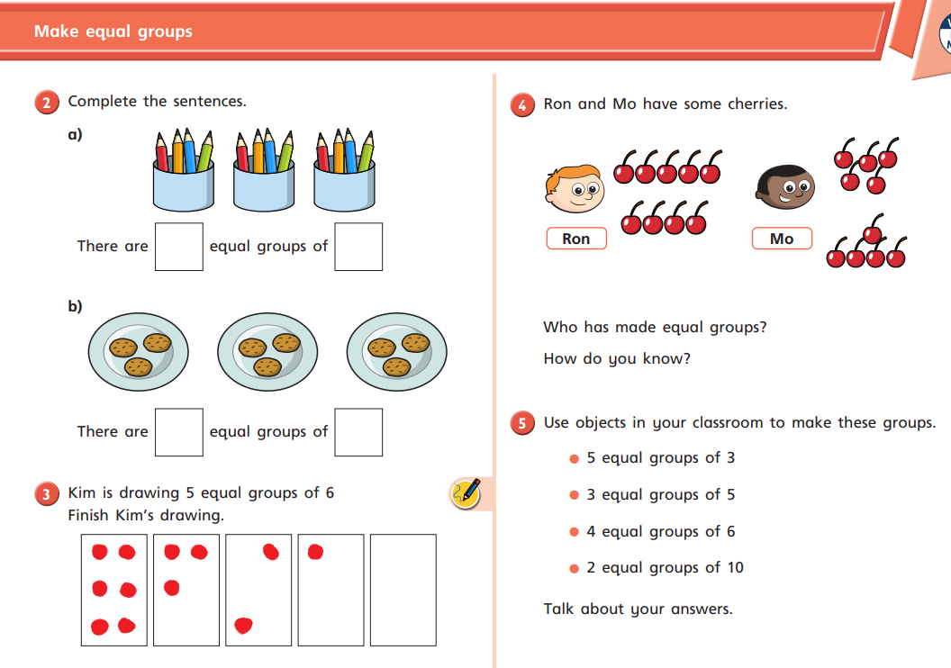
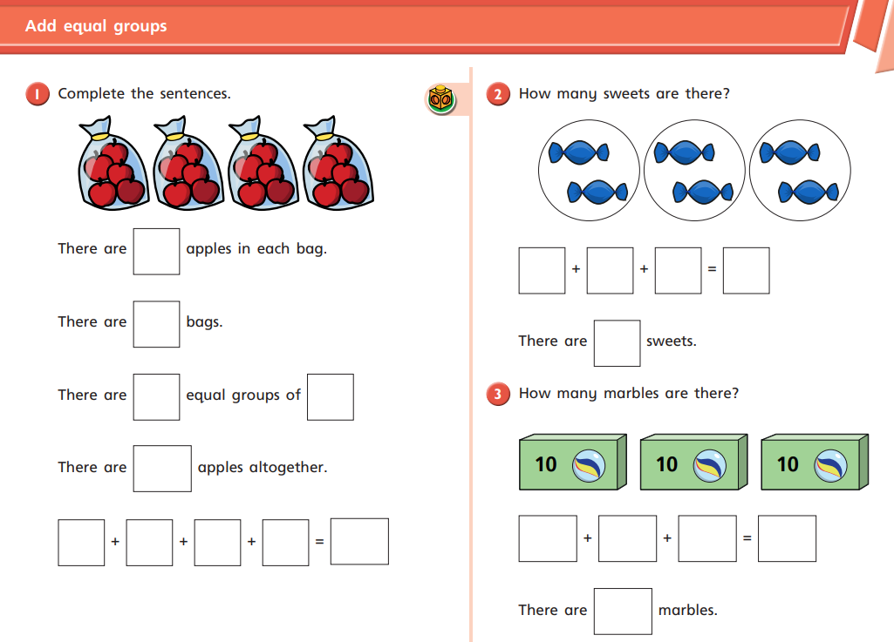

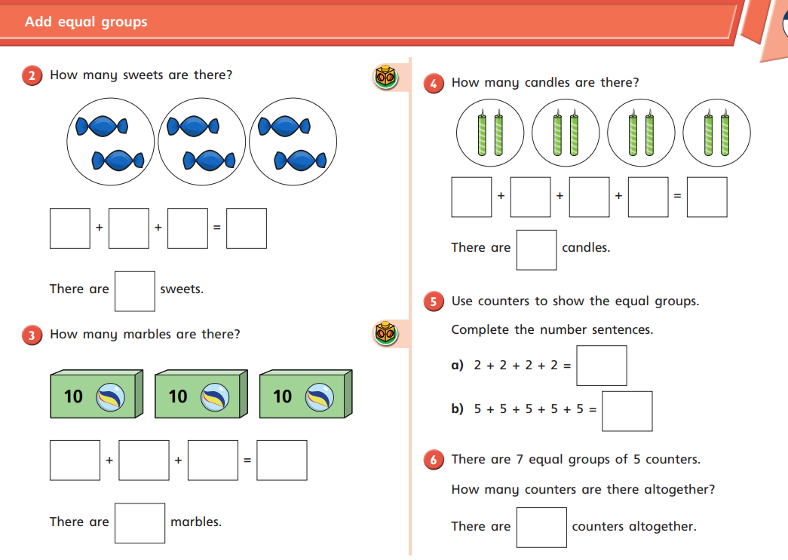
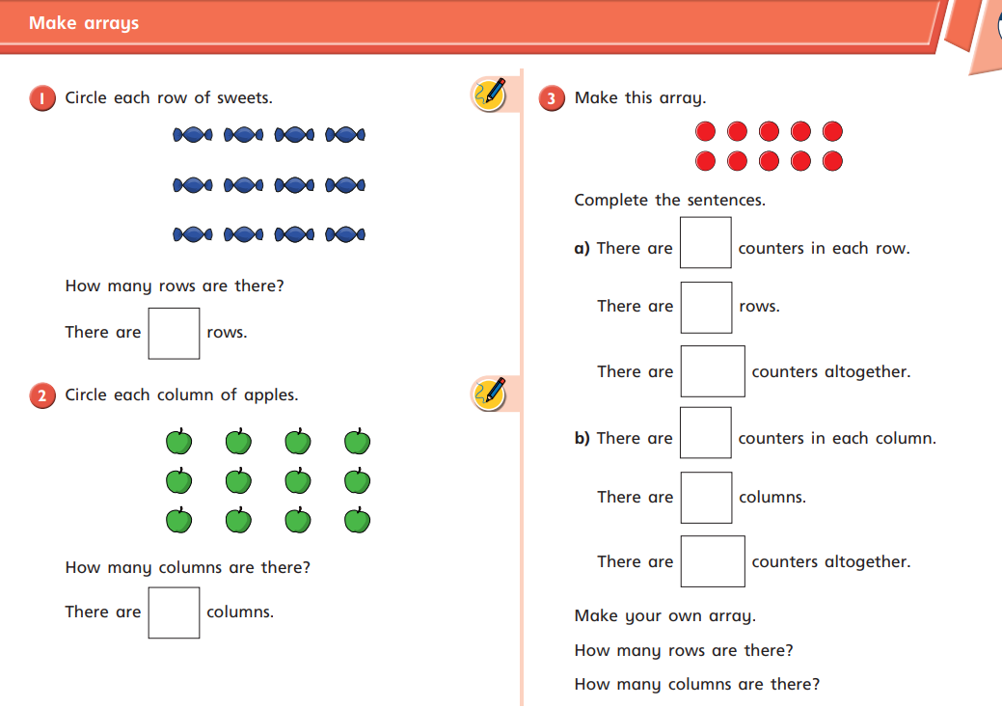

Science - Lesson 1:
Our new area of learning will be, The uses of everyday materials.
Please follow this link to the Oak Academy where they have helpfully created a series of lessons on materials for key stage 1
https://classroom.thenational.academy/units/materials-de3f
Have a look around your house and in your garden if you have one. What are objects made from, wood, plastic, glass, metal, rock
Use the chart in the pack to record your findings.

History:
Take some time to do some research about London Bridge. Why has it been rebuilt so many times? What materials were used to rebuild it each time?
Look up the nursery rhyme, London Bridge is falling down, and write it out in your best handwriting.

