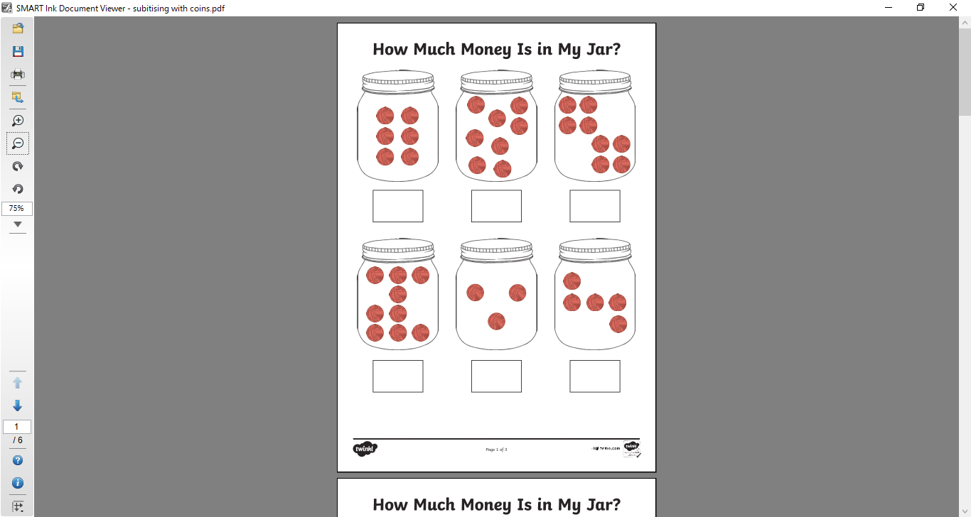

**Can you draw your own?**

**How many Evil Peas are trapped in the jar?**

**Try not to count- subitise!**