Home Learning Pack – Week 9

This home learning pack only includes week 9, as week 10 would ordinarily be May half term. I am aware that many of you would like a break over this time; however, if you would like to continue work, please refer back to my ‘Stone-Age Activity Map’ which has plenty of fun activities for complete.

Secondly, I just want to remind you all what an amazing job you are all doing! Many of you are teaching multiple children as well as working full time. I want to reassure you, that whatever your situation, you are all doing amazing and I’m sure your children have enjoyed spending time with you over this school closure. Please do not put yourself under any pressure to keep up with the home learning packs - work through them at your own pace!

Finally, just a quick thought. If there are any particular activities in a previous pack that your child has enjoyed – go back and use them again with a slightly different topic, i.e. rather than drawing a dinosaur, draw a dog blindfolded. These are here for you to refer back to and the challenges are extra fun because they can be adapted easily!

Date | Title | Activity | Support/Extensions?
Monday 18th May | Lesson 1 – Multiply 2-digit number by 1 digit number | Activity sheet on school website | Yes
Tuesday 19th May | Lesson 2 – Multiply a 3 digit number by a 1 digit number | Activity sheet on school website | Yes
Wednesday 20th May | Lesson 3 – Divide a 2-digit number by a 1-digit number | Activity sheet on school website | Yes
Thursday 21st May | Lesson 4 – Divide a 3-digit by a 1-digit number | Activity sheet on school website | Yes
Friday 22nd May | Lesson 5 – Maths Challenge | White Rose Friday Challenge | N/A
WEEKEND
WEEKEND

I have attached a grid below – this is to:
- Support any children who are finding the lessons a little tricky. Children could complete these support activities before trying the White Rose lesson again.
- To extend the knowledge of those children who are confident with the lesson. Following the White Rose lesson, try the extension activity.

Date | Title | Support activity | Extension
18th May | Lesson 1 – Multiply 2-digit number by 1 digit number | Break questions down using a number line to help you. Complete the following question and then try it yourself on the White Rose questions.  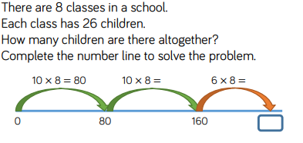 | 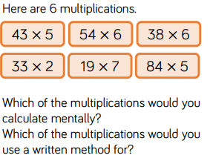
19th May | Lesson 2 – Multiply a 3 digit number by a 1 digit number | Repeat activity on number line to break down the multiplication. | Use a dice, rolling it three times to create a 3-digit number. Roll it a 4th time, this will tell you what you are multiplying by.  - Play with a partner – the closest answer to 1,000 wins the point.  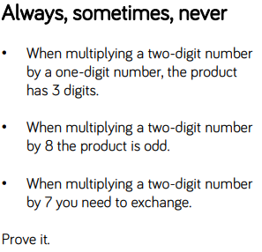
20th May | Lesson 3 – Divide a 2-digit number by a 1-digit number | Follow this link to BBC Bitesize lesson using division of 1 digit by 1 digit:  https://www.bbc.co.uk/bitesize/topics/z36tyrd/articles/zcjh8mn | 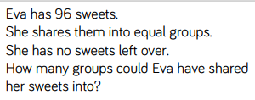
21st May | Lesson 4 – Divide a 3-digit by a 1-digit number | Draw a tens frame and draw counters to show your working – for example the image below shows 609 ÷ 3:  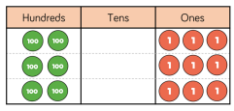  The answer here is 203.  Use this method to help you answer these: | Follow this link to the BBC Bitesize lesson where you can investigate problem solving in both addition and subtraction:  https://www.bbc.co.uk/bitesize/articles/zmbtpg8
22nd May  Friday Challenge | Lesson 5 – Maths Challenge | N/A | N/A
WEEKEND
WEEKEND

Just a quick reminder – here are the activities that you might chose to dip in and out of, over the coming weeks:
This Home Learning pack will be centred on activities around the story ‘Stone Age Boy’. This is available on the school’s website alongside this learning pack.

Activity 1 - Literacy:
At the beginning of the story, the boy trips in the woods and falls down, down, down into a cave. This cave seems to help allow him to travel in time.

For your activity, I would like you to write the next paragraph of the story. Begin your story with “An amazing thing once happened to me. I was wondering in the woods when I tripped and found myself falling down, down, down…”

Decide, where does your character end up in time?
Remember to include…
Show not tell sentences
Adjectives to describe the setting

Activity 2 – Art and Design:
It’s time to design and make your own mud hut.
I encourage you to use any recyclable materials you may have at home and maybe even some real mud!

I have attached some photo examples below:
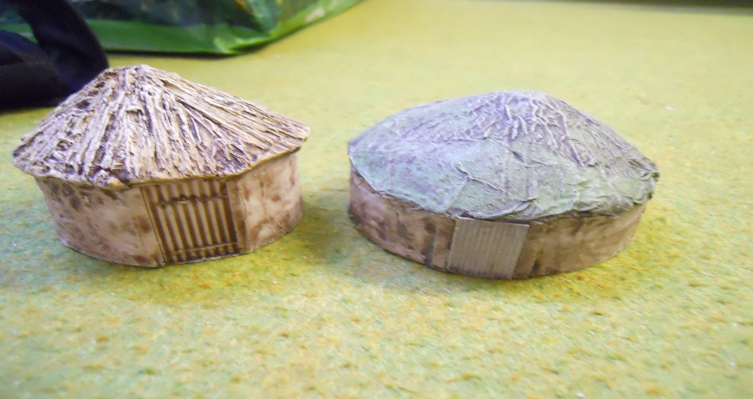
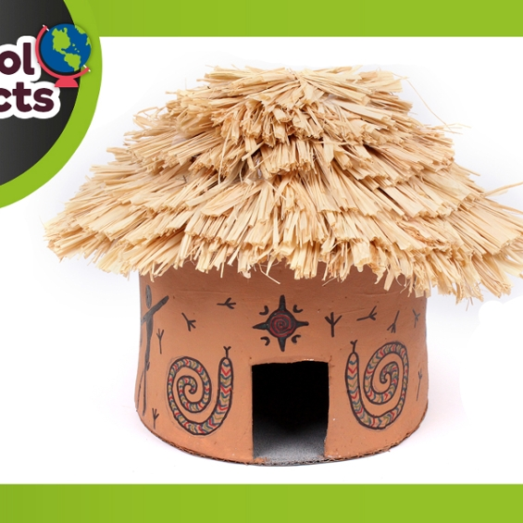
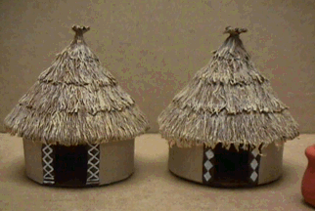

Activity 3 – Design:
On page 17, you see our main characters building a tent. Your task is to build your own tent. You can do this inside or outside of your home. Suggested materials: bedsheets/duvet covers/blankets. You may use rope to fasten your tent but not any official camping equipment, such as tent pegs.

Post your makeshift tent on the JYS Year 4 group.

Activity 4 – Guided Reading:
Read the whole story and write answers for the following questions:
- Can you imagine how Om and the boy would have felt when they explored the cave?
- What are the similarities and differences between the boy and Om?
- Why do you think people in the Stone Age use animal skins for clothing?
- Inside the cave, there are lots of different pieces of cave art on the walls. Research what cave art is used for in the Stone Age.

Activity 5 – Art:
Use the cave art on page 26 to design your own. You might want to use chalks or paints. If possible you could create these on a nearby pavement or in your garden using chalk. Remember your cave art should tell a story.

Activity 6 – History/Literacy:
Research how hunter-gathers lived in the Stone Age. You might want to use this link to help you: https://www.bbc.co.uk/bitesize/topics/z82hsbk/articles/z34djxs

Now write a diary entry showing a day in the life of a hunter-gatherer.

Activity 7 – History:
For today’s activity, I would like you to follow this link to a lesson all about Stonehenge: https://www.bbc.co.uk/bitesize/articles/zv67mfr

Once you have completed this lesson I want you to build a fact file to show your learning. This could be as a poster or leaflet or maybe even a PowerPoint.

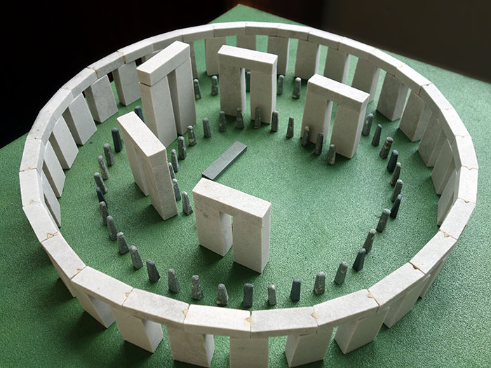
Extension: Can you build your own miniature Stonehenge? Maybe out of biscuits, small pieces of cardboard or Lego. I have attached some examples below:

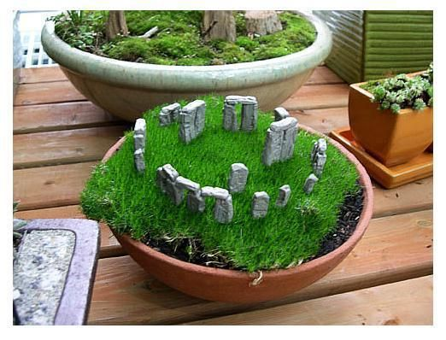
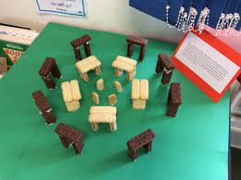
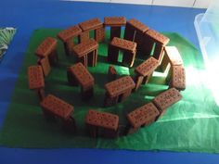

Take a photo and share your creation on our JYS Year 4 page (although, please try and do this before eating it!)

