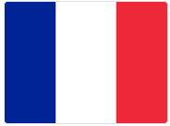 French home learning - Y3 July

Here’s another French project. This time you’ll make a lift the flap book! The project covers colours, which we’ve done already, and introduces dictionary work, which we’ll do more of in Year 4. Like the May project, you can do it a bit at a time. You’ll need a pencil and some paper to make the book, and some scissors too. I’m looking forward to seeing pictures of your chatterboxes, so do please send them to me at rachel.ritchie@jys.org.uk.

https://www.youtube.com/watch?v=xyv93Tyijus

You might enjoy this song too, which is a great introduction to the project: https://www.youtube.com/watch?v=sBj4fC9GMQk

I hope you enjoy this new French work. If you’re stuck on anything or want to ask me a question, email me and I’ll get back to you.

À bientôt! (that means ‘See you soon!’)
Madame Ritchie

