Year 4 Home Learning Monday 13th July – Friday 17th July 2020
Hello everyone,
How are you all? It’s racing towards the end of term and will soon be the summer holidays! This is going to be the last set of Home Learning I will send you, so have fun with it!
Just to let you know, BBC Bitesize, Authorfy, Radioblogging and White Rose are supplying their teaching materials for all of the summer. So although it is a holiday, it might be worthwhile keep up with a tiny bit of learning once or twice a week, just to keep your minds active.
Please do feel free to keep putting your achievements onto the Year 4 Facebook page and you can also still email work to Miss Weir.
All subject objectives, spellings, grammar can be found on this website as guidance. http://www.primarycurriculum.me.uk/
If you have any further questions, please do email me on michaela.cooke@jys.org.uk and I’ll be happy to answer your queries.
Meanwhile, have a super summer and have a great time!
Kind Regards, Mrs Cooke

*See below for activities

Maths
You can follow the White Rose Maths on their Home Learning webpage. Remember there are videos to help you and worksheets to go with them available on the JYS website. https://whiterosemaths.com/homelearning/year-4/
There is also information on what the BBC Bitesize website are providing on different dates and for different year groups here https://bam.files.bbci.co.uk/bam/live/content/zn4pyk7/pdf#sa-link_location=blocks&intlink_from_url=https%3A%2F%2Fwww.bbc.co.uk%2Fteach%2Fbitesize-daily-lessons-schedule%2Fzdtwjhv&intlink_ts=1592483499015-sa
Maths WB Monday 13th July 2020
Lessons continuing on from the White Rose website.
https://whiterosemaths.com/homelearning/year-4/
Date | Title | Activity
Monday 13th July | Lesson 1 – Week 11– Line symmetry: Finding line of symmetry | Activity sheet on school website
Tuesday 14th July | Lesson 2 – Week 11 –  Line symmetry: Complete shape | Activity sheet on school website
Wednesday 15th July | Lesson 3 – Week 11 –  Describing position | Activity sheet on school website
Thursday 16th July | Lesson 4 – Week 11 –  Coordinates in first quadrant | Activity sheet on school website
Friday 17th July | Lesson 5 – Maths Challenge | White Rose Friday Challenge

*Remember to keep practicing your times tables. (TT Rockstars)

Literacy- Challenges 1, 2 & 3.
This week we have Laura Dockrill giving you 3 different writing challenges, as part of celebrating National Writing Day.
https://authorfy.com/10minutechallenges/
Literacy challenges for every day.
Here are some fantastic radio programmes to listen to and then do the creative writing challenges. Choose one from the archive for each time you want a new activity.
https://radioblogging.net/index.php/category/live-shows/
It’s a different way of learning. You listen to the radio show online and stop it when Pie tells you to do a quick writing activity. Then press play again to continue listening. It keeps the ideas fun and creative! Let Miss Weir know what you’ve been doing. (Although the live shows have now stopped, all of the previous shows are available to participate in).
Literacy- Oak National Academy
Follow the link and choose some lessons from the ones you haven’t done yet. These are fun, interactive lessons which will add a bit of variety to your learning.
https://classroom.thenational.academy/subjects-by-year/year-4/subjects/english/

Reading Comprehension activity pack- Literacy Shed
Over the next 4 weeks, I would like you to work your way through these Reading Comprehension activities. Choose one each time and see how you get on. They can be downloaded and printed off, or you can read them online and write the answers in your Home Learning book.
https://www.literacyshedplus.com/en-gb/resource/stage-4-reading-packs
Reading- Mrs Cooke’s Story Time on YouTube.
Lots of fun stories for younger children and chapters of a book for Years 4-6, Neil Gaiman’s ‘The Graveyard Book’. https://www.youtube.com/user/michbott1/videos

Science- How organisms adapt.
https://classroom.thenational.academy/subjects-by-year/year-4/subjects/foundation
Follow the link and scroll down to do the 5 Science lessons;
Lesson 1- What is adaptation?
Lesson 2- How are organisms adapted to hot environments?
Lesson 3- How are organisms adapted to cold environments?
Lesson 4- What adaptations do nocturnal animals have?
Lesson 5– How are organisms adapted to live underwater?

Design Technology- Speakers
Earlier this year you learned lots of interesting things about sound. Here are some fun things to learn all about how speakers work. Follow the link and listen to the short radio programmes about how speakers work. You can also download the free app on your phone!
https://www.funkidslive.com/learn/the-speakers/
https://www.funkidslive.com/learn/the-speakers/listen-speakers-transmission-fun-kids/
Make a passive amplifier
A passive amplifier (or mechanical amplifier) is a device which amplifies sound (makes it louder) without the use of power, it works like a sort of trumpet by changing the flow of the air around the speaker to make your music player louder (eg your phone).
Watch these YouTube videos and then have a go at making your own passive amplifier. I made one out of a kitchen roll tube and it’s awesome!
https://www.youtube.com/watch?v=vIjdZv8xsS0
https://www.youtube.com/watch?v=iEDcUDW2oLc
https://www.youtube.com/watch?v=5RM_rdw9X0A

PE- Choose your own challenge!
Here are 8 PE activities for you to choose from. See how many you can do over the summer!
https://marathonkids.org/best-outdoor-pe-games/

Music- Make your own instruments!
Lots of fun activities for music activities, including making your own instruments!
https://www.bbc.co.uk/teach/bring-the-noise/half-term-music-activities/zmmpxyc/

Challenge- Misfits
You need: Paper and a pen
To play Misfits, the first person draws a head and folds the paper down, leaving a guide where the neck is so the next person knows where to draw the body and arms. They then add a further fold to hide the body. A third person (or the first person again) then draws the legs and unfolds the paper to reveal the whole person/animal/hybrid. Top marks for the most creative body part and once you have done a pile you can choose your favourite and even name and colour in your creatures.

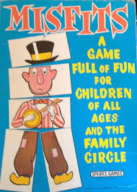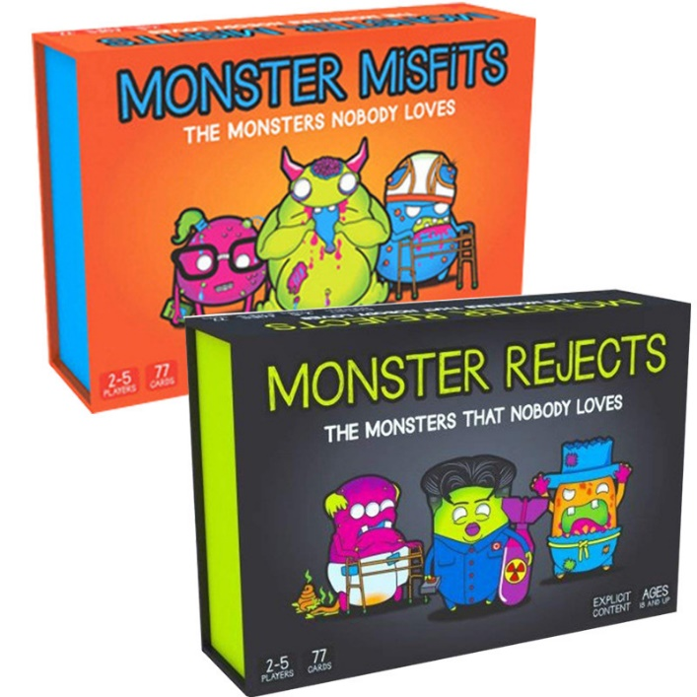

Challenge- Post-it challenge/Guess who?
You need: Post-it notes
Whether you call this game the Post-it Challenge or even Forehead Detectives, the principle is the same. Choose a subject before you start (eg.animals, cartoon characters, people in your family) and then everyone writes something on a post-it note, being careful that nobody else sees what you write. You stick the note to the forehead of the person to your left. Taking turns going around the room, everyone asks one question at a time, trying to guess what it says on the Post-it note on their own forehead. The questions need to be phrased so the answers can only be yes or no. The winner is the one that guesses what it says on their forehead first.
Art- Raised salt painting
There are 10 exciting activities on this great website. Why not have a go at a few of them? I like the idea of raised salt painting.
https://artfulparent.com/top-10-art-activities-for-kids/
https://artfulparent.com/raised-salt-painting/

Challenge- Three Marker Challenge
You need: A pile of marker pens, paper
The rules of the three marker challenge are that you close your eyes, take three marker pens (being careful not to see what colours they are), open your eyes and colour your picture using just those colours, being as creative and making it as beautiful as you can. You can play this by yourself or with another person and see who does the best job of using the colours creatively. You can also use colouring crayons, pencils or even paints if you're feeling adventurous.

Challenge- Memorize challenge
You need: A tray with lots of items laid out on it.
Layout a scene on a tray. It can be of anything you like but toys or small household objects work well. It is best to have a selection of unrelated items. You take it in turns to cover your eyes whilst someone else takes something away and then you try and guess what object has been taken away.
Theme/Topic – Romans
As you may know, the first theme in Year 5 is The Romans. As is tradition at JYS, your theme homework over the summer is to make your own Roman shield. This can be made out of card or wood and can be painted in traditional Roman colours and designs. You can do a little each week, as it is a big project. Here are some ideas;
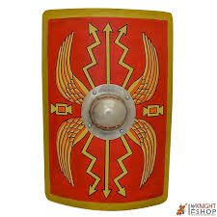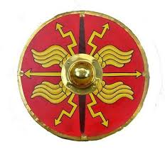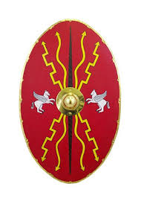
DT- Cookery and baking

Healthy Mini Pizza Quiches
Kids need to achieve something impressive quickly when it comes to cooking, and these mini pizza quiches that use tortillas as the case are the healthy solution.
https://www.bbcgoodfood.com/recipes/mini-pizza-quiches

Prickly but tasty Hedgehog Rolls
There’s something delightful about being able to bake your own bread, and these friendly hedgehog rolls make a wonderful cooking activity for kids.
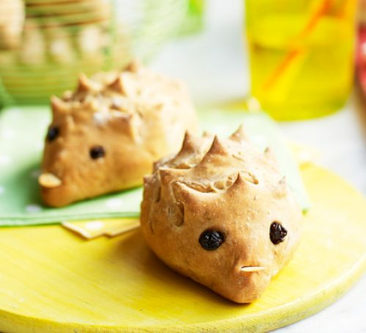
https://www.bbcgoodfood.com/recipes/hedgehog-rolls
Computing- choose an activity
Here are some fun computing lessons and activities to keep you busy!
https://www.bbc.co.uk/bitesize/articles/z4gsy9q
https://teachcomputing.org/home-teaching/key-stage-2
Scroll down this page to find the computing activities.
https://www.stem.org.uk/home-learning/primary

Science- The Water Cycle
Watch this short video to learn about the water cycle.
https://www.stem.org.uk/resources/elibrary/resource/460434/water-cycle
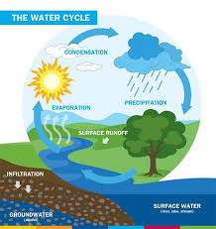

Challenge - Film the news challenge
You need: A box, a smart phone or camera to film with.
Pick something your child loves - space, dinosaurs, animals, tractors etc - and film a news programme all about it! If you've got any big boxes left from Christmas, decorate one together to turn it into a TV. You could do some research and do a news broadcast. Film it all on your phone to watch back or if you have older children they could also pretend to be other characters and be interviewed about their views in the same way you get on a normal news programme. Then you could work on editing together to make a proper news broadcast.

