Year 1 Home Learning Activity Pack 2 – 3rd April 2020
Dear Year 1 Families,
Well done on making it through the first two weeks of ‘home learning’ together! I hope that you are all beginning to settle into this strange new routine. I have loved hearing about all the exciting things that you have been doing via your email updates – thank you.
When putting together this second pack of activity suggestions I am conscious of several things:
- Many of you will be trying to juggle working from home yourselves and/or looking after children of different ages within your family, on top of trying to help each of your children with their learning. This is a huge task which I am sure feels quite daunting and overwhelming for lots of families.

- The next two weeks are of course officially the Easter holidays and therefore, whilst some families will want to continue with the daily routine that they have established, others will want to have a break from the academic learning tasks.

- Because you are working with your child so closely on a one-to-one basis, your learning programme will already have become very personalised and you will have gained a good sense of your child’s individual strengths and the areas with which they still need further practice.
With these points in mind, the new activities suggested in this pack mainly focus around continuing to consolidate and develop ‘key skills’ in reading (including phonics), writing and maths.
In addition to using some of the new activity suggestions, please do continue to use the activities given in the first pack and keep checking the web links given in that pack too – most of these can be revisited many times for new learning experiences and different resources to download.
This is a very stressful and challenging time for everyone. All any of us can do is our best. Don’t put too much pressure on yourselves or your children – just do what you can. The most important thing is for your family to stay happy, safe and healthy.
Don’t try and achieve impossible things! Just encourage your child to practise their skills ‘a little and often’. This is the best way to help them learn, overlearn and embed their knowledge in their longer term memory.
If it is possible, try and keep doing a little bit of the following things each day:
- phonics – looking at one sound per day and practise reading and spelling different words which contain that sound;
- reading – applying phonics skills when reading a longer passage or story for meaning;
- writing – even if it is just a sentence or two;
- handwriting – practising forming letters from a ‘chunk’ of the alphabet (c. 5 letters a day); practising joining different letters to each other;
- maths – practising those key ‘Bronze Award’ mental maths skills and then either adding, subtracting or multiplying by 2, 5 or 10;
- art / creative craft / music / Lego building / imaginative play / cooking;
- ‘keep fit’ and ‘active’ activities such as walks, bike rides, Joe Wicks’ P.E. sessions and Cosmic Kids Yoga sessions.
I am sure that you are already finding that natural and fun opportunities for learning present themselves each day. Do be led by your child’s interests and questions. If they are enthusiastic about learning and see a real purpose for it, it will be a much more enjoyable experience for everyone!

As before, you can find all of the new resource sheets and files that are mentioned in this pack on the Year 1 section of our school website. Go to https://www.jys.org.uk/website, click on the ‘Classes’ tab and scroll down to Year 1. I am also posting links to videos made by people in our class on the Year 1 page of our Virtual Learning Environment (VLE), so check that now and again too!
Please do continue to keep in touch by email over the coming weeks. My email address is: sarah.peart@jys.org.uk. As I will be working in school throughout the Easter holidays looking after Key Worker children, I won’t be able to check my emails as regularly as I have been and I might not be able to reply in as much detail. However, I will respond to you as soon as I can! Thank you in advance for your patience with this.
With very best wishes to you all,
Mrs Neville

Literacy
Writing Opportunities
It really doesn’t matter what your child writes about, as long as they keep writing! Even writing just a sentence or two each day will help them to maintain their skills. Remember to use the ‘Year 1 Phonics Mat’ to help them sound out and write their spellings phonetically.
Here are a few suggestions for writing:
- Keep a daily diary - write about 2 or 3 of your favourite activities every day.
- Ask someone at home to read the attached ‘Egg Hunt story starter’ to you and then continue the story on in your own words.
- Write a diary entry or a letter to a family member about the highlights of your Easter weekend.
- Choose something in your garden to write a description of. Sit and look at it really carefully and see how many adjectives you can use to describe it. Read your sentences out to someone else at home: can they work out what you are describing without you naming it?
- Write some instructions for someone else to follow, for example to make a simple Lego model or to play a board game.
- Ask everyone in your family what their favourite joke is and start to write a ‘Favourite Jokes Book’ which you can add to over time.

Proof-reading / Marking Writing Together
At school we often do a piece of writing on one day and then we re-read it together the next day, when we have had some time away from it.
When your child first finishes a piece of writing, however short or long, read it with them and show that you are enjoying this process! Praise whatever independent efforts they have produced. However, in particular, pick out any time adverbs and good adjectives that you can spot and make a special point of praising these.
The next day (or whenever you re-read the work with them), pick out only a couple of elements to discuss with your child, otherwise the joy of writing is quickly lost! If you can see lots of ‘mistakes’ when you look at their writing, prioritise!
Here are the most common elements that we look at together in school:
- Have I started every sentence with a capital letter and finished every sentence with a full stop (or a question mark or exclamation mark if appropriate)? Children often find it much easier to work out where a sentence finishes if they hear someone else read out their work to them, pausing in the correct place!
- Have I used clear finger spaces between each word?
- Is my handwriting neat, with the letters correctly formed and on the line (rather than floating around in between the lines)?
- Have I accidentally used a capital letter in the middle of a sentence where it doesn’t need to be? For example: Goldilocks rAn inTo the house and broKe the Chair.

- When spelling, have I represented in writing all of the sounds that I can hear when I say the word out loud?
It doesn’t matter if the spelling isn’t correct, as long as it is phonetically plausible. For example, when trying to write ‘Trip to the Weald and Downland Living Museum’, a child might write ‘Trip to the Weeld and Dounland Moozeeum’ which is great because they are choosing one of the right letter strings to represent each sound!
However, look out for words where one of the sounds has been missed out in writing. If this happens, say the word aloud and ask your child to look at the word that they have written. Can they spot which sound is missing? Often they will notice straight away but if they don’t, look at it together.
For example, when trying to write the word ‘place’, a child might write ‘pais’, missing out the ‘l’ by mistake.
The rest of the word is spelt in a phonetically plausible way with the ‘ai’ used instead of the ‘magic e’ split digraph and the ‘s’ used because it is the most common way of representing this sound (instead of the letter ‘c’ making the ‘s’ sound in this particular word). Therefore, in this example you would only pick up on the missing ‘l’ with your child!

With more confident writers, we also look at:
- Some common exception word errors, like the words ‘said’, ‘was’ and ‘put’ which they should know how to spell accurately.
- Some other simple spelling patterns, such as when they have spelt a past tense ending as ‘t’ instead of ‘ed’ - for example ‘jumpt’.
- Is there anywhere that we could add in an adjective to describe something in more detail?
- Could we start a sentence with a time adverb? Which one should we use?

Whichever points you choose to talk about with your child, recap over these just before they do their next piece of writing so that they have the opportunity to practise the skills you have discussed together.

Phonics
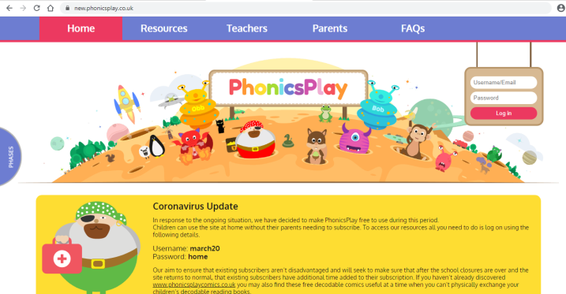
In school, we use a website called ‘Phonics Play’ almost every day as part of our phonics sessions. To help support families at home during the school closure, ‘Phonics Play’ have now given free access to all of their resources, which is brilliant! The website address is new.phonicsplay.co.uk. The log on details are given on the home page and once you are logged in, it is worth clicking on the ‘Parents’ tab at the top as this section has lots of useful information in it.

The games and activities can be found under the ‘Resources’ tab. The children will recognise games like ‘Dragon’s Den’, ‘Buried Treasure’ and ‘Picnic on Pluto’ straight away because we play them all the time! You will need to choose which sound or ‘phonic phase’ you want to practise in the games you play. In school we are working through the ‘Phase 5’ sounds so this will be a good place to start. Some children might need some extra practise on the earlier sounds found in ‘Phase 3’ to start with. These ‘Phase 3’ sounds are then revised in ‘Phase 4’.
The ‘Sentences’ activity is good for giving the opportunity to read three full sentences containing specific sounds, rather than just decoding individual words in isolation. There are also lots of other great interactive activities on the website, including those to help with reading Common Exception Words, so enjoy exploring the whole site over time!
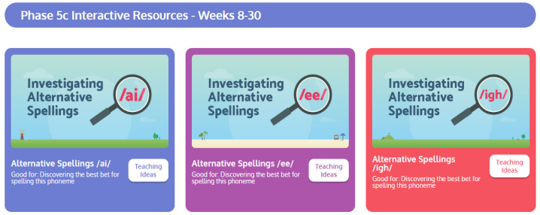
In the ‘Phase 5’ section, if you scroll down towards the bottom of the page, you will find a section called ‘Phase 5c Interactive Resources – Weeks 8-30’. It contains a lot of different resources for ‘investigating alternative spellings’ of a particular sound. The ‘Phoneme Spotter’ stories within each one are great for giving opportunities to practise decoding longer texts and for spotting all the different ways that a particular sound can be spelt.

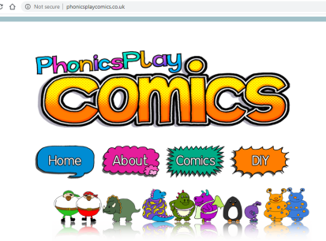
‘Phonics Play’ also has another new site called phonicsplaycomics.co.uk which looks really good. There are lots of short (2 sides of A4), simple, silly comics that can be used to help children apply the phonic skills that they have learned. The comics are divided into the ‘phonic phases’ 2 – 5, so you can easily see the progression of the sounds and choose the ones you want to practise.

Maths
I have included two new documents to support maths learning.
One is called ‘Maths Twinkl Spring Maths Activity Mats’ and it contains 6 different sheets, each with a range of different types of maths questions on it. Please note, we have not covered ‘money’ or ‘time’ in class yet, so your child may need some additional support with these types of questions.
The other is called ‘Maths Open Ended Problems and Puzzles’ and it contains investigations that require the children to apply their maths knowledge to answer questions that often have more than one solution.
Don’t forget to check the White Rose Maths Hub website again as they are continuing to upload new lessons on an on-going basis. The Year 1 lesson videos and worksheets can be found at: https://whiterosemaths.com/homelearning/year-1/.

Science /Geography
Plants
Learning Objectives:
- identify and name a variety of common wild and garden plants, including deciduous and evergreen trees;
- identify and describe the basic structure of a variety of common flowering plants, including trees.
Help your child to work scientifically by observing different plants in your garden closely, perhaps using a magnifying glass. Can they compare and contrast familiar plants, drawing diagrams showing the parts of different plants including trees?
If it is possible, plant some flower and/or vegetable seeds with your child and watch them grow. Talk about the things that plants need to grow well (water, sunlight and nutrients) and keep a diary of the changes you observe as the plant grows over time.
Find out together about the different parts of a plant’s structure (including leaves, flowers (blossom), petals, fruit, roots, bulb, seed, trunk, branches and stem).

Seasonal Changes
Learning Objectives:
- observe changes across the four seasons;
- observe and describe weather associated with the seasons and how day length varies.

Encourage your child to look at, and talk about, the changes that they see in the weather as the season of ‘spring’ continues. Could they record their ideas as pictures or labelled diagrams? What does spring ‘look like’?
Talk about ‘the clocks going forward’ and what this means for the day length in the UK.
Help your child to work scientifically by making tables and charts about the weather. For example, could they measure the outside air temperature at the same time each day, using a thermometer and record this in a table? Could they keep a daily weather diary?

PSHE
Feelings
I shared this book ‘In My Heart’ with those children who were in school on the last day before we closed. It is a book all about feelings. We talked about how, over the next few weeks whilst we’re not in school, we are all going to experience lots of different feelings – some positive and some not so positive. We discussed how ‘it’s okay’ to feel any emotion but that it’s really important that we talk about how we’re feeling with our families at home and that we always try and treat everyone with respect, even if we’re not feeling very happy inside.
I have attached a PowerPoint Slideshow of the story for you to share with your child if you wish to. To accompany this, there is also a document called the ‘In My Heart Feelings Board’. You can use this to explore different feelings together. You might ask the question ‘How is your heart feeling today?’ or you might choose one of the feelings and talk together about times when we might feel that feeling. This is a good way in to helping your child learn how to manage negative feelings like anger. You could talk about a time when you remember feeling angry and then explain what strategies you used to calm yourself down and to resolve the situation – I counted to ten really slowly; I took myself away from the situation and had a drink of water; I started doing a quiet activity that I knew would help me to feel calm, like drawing or reading; when I felt calm I was able to talk about what had made my angry and I was able to sort the situation out.

