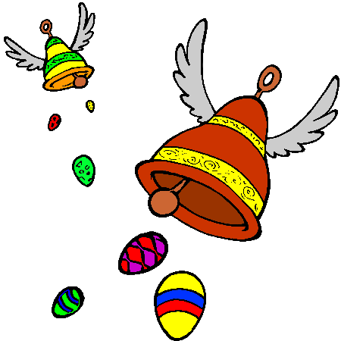 French Easter Y3/4

I hope you’ve had fun trying some of the activities in the home learning pack and the Lumen awards. If you’d like to send me pictures of what you’ve done, or anything you’ve made on the computer, I’d love to hear from you on rachel.ritchie@jys.org.uk.
Easter in France is a very big deal. You can find out more about how Easter is celebrated by going to the Easter Zone on https://www.euroclub-schools.org/easter-zone and trying some of the activities there, including the quiz. The song is fun, but very fast and you’ll have to listen a few times to pick out what’s being sung!

My favourite part of French Easter is the story of the flying bells, or ‘cloches volantes’. In France, a mainly Catholic country, bells ring every day of the year to remind people to go to church, except from the Thursday to Saturday before Easter Sunday. At that time, they say that all the bells fly to Rome, capital of Italy, to get blessed by the Pope. On their way back on Easter Sunday, the bells bring Easter treats to all the good children. When crossing France, they drop chocolate eggs, chickens, chicks, bunnies, lambs, and fish! Children go chocolate hunting in their gardens or parks.

Once you’ve learned about the gorgeous chocolates and the flying bells, make a ‘Joyeuses Pâques’ (Happy Easter) card for a member of your family. Illustrate it with some of the things that you’ve learned and don’t forget to take a picture of it and send to me!
For more of a challenge, make a fact file of Easter in France. You can do this on paper with your own illustrations, or make a collage or produce a poster on the computer.

Remember, online dictionary tools can help with pronunciation and translation. This https://www.collinsdictionary.com/dictionary/english-french is useful, and a really good dictionary that gives you language in context is https://www.linguee.com/english-french which also has sound buttons.

