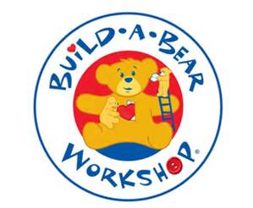
w/b 13.7.20

We are learning to write words using our sounds and spell others correctly.
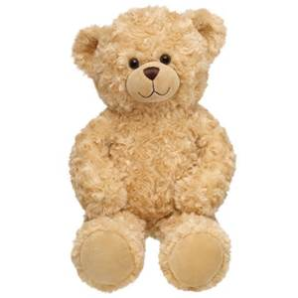
3.
2.
1.
Please help!
Can you write some instructions on how to build a bear so that I can make some friends?

