Literacy Home Learning.
Diary Writing
Over the last two weeks, we have been learning about diary writing. Recently, we looked at some extracts from the Diary of Anne Frank.
https://alphahistory.com/holocaust/anne-frank-diary-1942-44/
Now it’s your turn to be a real-life diarist! I would like you to write a detailed diary of what you do each day while you are home from school. Do a little for each day you are off. Remember, if it’s good, your diary may become well-known in future years for recording what happened at this point in History!
Make sure you write about what you do, how you feel, what’s happening in the news, how it’s affecting your family, what you have to do to keep busy. Lots of things like that.
You can set it out however, you like. You can even use a separate notebook if you have one!
I have included our success criteria to help you to focus on what I’m looking for.
Success Criteria | tick
Written in first person
New day or date each time
Chronological (time) order
Write about your feelings and emotions
Include facts and opinions (about news etc)
Use dashes and hyphens
Relative clauses (recap using twinkl website)
Interesting vocabulary for character’s register (informal language)

Story Writing
You all wrote wonderful stories for the 500 words competition. Now I’d like you to write a story about anything you like. Make sure it has a beginning, middle and an end. It needs to have a problem for the characters to solve and some sort of resolution (ending) – happy ending? Cliff-hanger? Twist? You decide!

Story ideas- check out these two websites for fantastic story ideas!
https://www.bbc.co.uk/programmes/articles/KNWsKPrg7stQ54tTbcf6P7/500-words-the-stories

https://www.literacyshed.com/story-starters.html

Success Criteria for writing a short story.
Objectives; | Tick if achieved
Use a variety of sentence structures to aid flow
Use commas for parenthesis

Use cohesive devices
(-the conjunctions, connectives and pronouns used to link the parts of a piece of writing. Using the same verb tense throughout a text)

Non-negotiables (you MUST have these);
Use capital letters
Use full-stops
Use paragraphs
Use commas to separate clauses
Joined-up and readable handwriting
Using a ruler for headings and crossing out

Persuasive writing
We did a piece of persuasive writing based on why children feel they should use phones in school or on stopping climate change. This time, I want you to choose a subject that you feel passionately about. This website has some good ideas, just scroll down to find them.
https://www.summerboardingcourses.co.uk/blog/persuasive-writing-prompts/
Write a persuasive piece to make me understand why I should agree with you.
I have included the AFOREST prompts to help you.
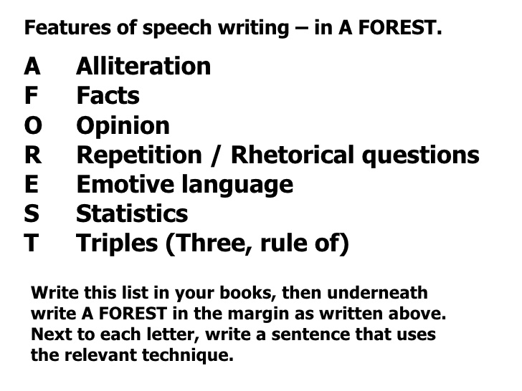

Explanation Text
Earlier in the year, we researched about rivers and wrote an explanation text in the style of a non-fiction book. This time, you can pick any subject to design an explanation text about. Look through the non-fiction books at home, what inspires you? Football rules? A football team? Animals, reptiles, dinosaurs, fish, birds? A famous person? Sportsperson? A style of cookery? Knitting? Dance?
Follow the Success Criteria to know what to include. Make sure you have fabulous, coloured-in drawings, sketches and diagrams too!
Success Criteria for Explanation Text | Me | My teacher
Title- explains what it is about. It can be a question.
General opening statement- to introduce the topic.
Clear, simple points about how or why something occurs.
Written in the present tense
Labelled pictures and diagrams
Time conjunctions- meanwhile, first, last, next, secondly, finally, eventually etc
Causal conjunctions- because, then, although
Technical words
Comments

Good luck. Make sure you proof-read and edit your work as you go. I’m looking forward to reading it all!
Mrs Cooke

