What has your bear done today?

 [](http://www.bing.com/images/search?q=Bear+cartoon&view=detailv2&&id=326290433C4F2363769ED049E9FF42F63EF5C972&selectedIndex=171&ccid=SU0oPn/F&simid=608048223417337972&thid=OIP.M494d283e7fc5257830d864f376a08894o0) [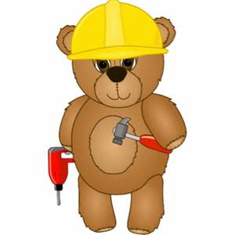](http://www.bing.com/images/search?q=Bear+cartoon&view=detailv2&&id=98611F17F480D4A12C49FB286D259863306095B8&selectedIndex=103&ccid=/%2bDM8Afo&simid=608034380737479209&thid=OIP.Mffe0ccf007e8396ef75a3b853a2af8d5H0) [](http://www.bing.com/images/search?q=Bear+cartoon&view=detailv2&&id=E3A9951A16FD173392DC0D160469D40E8EE22668&selectedIndex=123&ccid=6FKRUqri&simid=607989459673941364&thid=OIP.Me8529152aae2812d5add83578551ab54H0)

# My Build-a-Bear adventures

[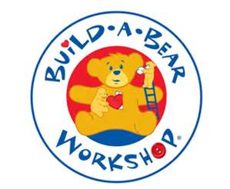](http://www.bing.com/images/search?q=build+a+bear&view=detailv2&adlt=strict&id=CA6EA9AEA55EC9715B84F8F5C6D269D492F84CC2&selectedIndex=6&ccid=vx2baMIU&simid=608028732849913955&thid=OIP.Mbf1d9b68c214076f946f56e2c6144810o0)