w/b 22.4.19 AD

We are learning to write sentences.

We are learning that information can be retrieved from books.

[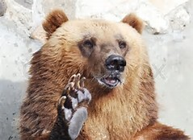](http://www.bing.com/images/search?view=detailV2&ccid=cbVU8s7x&id=27698F75A420137E565D4654F6F0B8414F124457&q=brown+bear+paw&simid=608044083507824017&selectedIndex=6&adlt=strict)

Brown Bears have