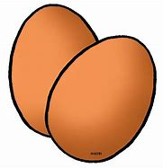

Either:

Write an adventure about baby egg

Or

Write what might come out of your egg if it hatched and what it would do e.g. dinosaur that destroyed the school.