Math’s times table questions
(One set for ever day):
Set One: 2, 5 and 10 times tables:
Quick Fire (answer without writing down):
- a) 4 x 5 = b) 2 x 10 = c) 3 x 2 = d) 8 x 5 =
- a) 18 ÷ 2 = b) 35 ÷ 5 = c) 100 ÷ 10 = d) 4 ÷ 2 =
- a) 8 x 10 = b) 6 x 2 = c) 15 ÷ 5 = d) 70 ÷ 10 =
Now try these:
What is:
- nine multiplied by ten? b) fourteen divided by two? c) How many fives are there in thirty? d) What is eleven lots of two? e) How many tens make thirty?
f) There are nine palm trees on a desert island. Each palm tree has five coconuts growing on it. How many coconuts are growing in total?
Problem solving:
- Keisha and Sam are taking part in their school sports day.
At the sports day, each first place gets 10 points, each second place gets 5 points, and each third place gets 2 points.
How many points did Keisha get?

- Sam scored forty-five points. He can second in every event he took part in.
How many events did Sam take part in?

Set Two: 3 and 5 times tables:
Quick Fire (answer without writing down):
- a) 7 x 3 = b) 9 x 5 = c) 6 x 5 = d) 2 x 3 =
- a) 40 ÷ 5 = b) 9 ÷ 3 = c) 36 ÷ 3 = d) 10 ÷ 5 =
- a) 10 x 3 = b) 3 x 5 = c) 18 ÷ 3 = d) 55 ÷ 5 =
Now try these:
- How many threes make twenty-seven? b) What is twelve times five?
What is:
a) four multiplied by three? b) twenty divided by five? c) eight times three?
d) A mouse was given 24 pieces of cheese for his birthday. He shared them equally with two of his friends. How many pieces of cheese did they each have?
Problem Solving:
Sid Squirrel is collecting acorns. The answer to the question in each tree shows the number of acorns that tree has.
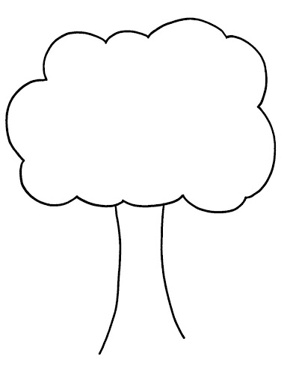
Sid wants to collect all the acorns. He wants to start at the tree with the most, and go in decreasing order to end at the tree with the fewest. Draw a line to show the path that Sid should follow.
27 ÷ 3
7 x 5
10 ÷ 5
8 x 5
50 ÷ 5
3 ÷ 3
12 x 3
2 x 3

Set Three: 2, 4 and 8 times tables:
Quick Fire (answer without writing down):
- a) 6 x 2 = b) 7 x 4 = c) 4 x 8 = d) 3 x 4 =
- a) 32 ÷ 8 = b) 22 ÷ 2 = c) 24 ÷ 4 = d) 56 ÷ 8 =
- a) _____ x 4 = 16 b) 9 x ____ = 18 c) 10 ÷ ____ = 5 d) ____ ÷ 8 = 9
Now try these:
- What is twelve times two? b) How many eights make forty-eight? c) What is eleven fours?
What is:
- Sixteen divided by two? b) nine multiplied by four? c) Ninety-six tourists have come for a tour of Mathsalot Castle.
Each guided tour group with have eight people in it.
How many groups are there going to be?
Set Four: 6 times tables:
Quick Fire (answer without writing down):
- a) 2 x 6 = b) 5 x 6 = c) 9 x 6 = d) 11 x 6 =
- a) 18 ÷ 6 = b) 42 ÷ 6 = c) 6 ÷ 6 = d) 24 ÷ 6 =
- a) 6 x 6 = b) 12 x 6 = c) 48 ÷ 6 = d) 60 ÷ 6 =
Now try these:
- What is seven multiplied by six? b) What is seventy-two divided by six? c) What is three times six? d) What is eight lots of six? e) Cecil the caterpillar eats 3 radishes for every meal.
He has 6 meals every day.
How many radishes does Cecil eat every day?
Problem Solving:
Adventurer Clara Loft is trying to find a teasure chest. To get to it, she must follow an ancient path. Each stone on the path has a question. She knows that:
- If the answer ends in 1, 2 or 6, that stone is safe.
- If the answer ends in any other number, she’ll fall.
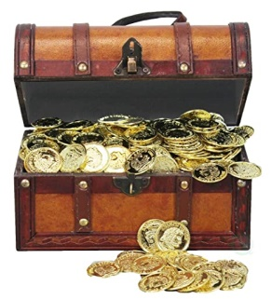
Colour in the safe stones to show Clara how to get to the treasure.
66 ÷ 6
7 x 6
4 x 6
30 ÷ 6
6 ÷ 6
12 x 6
60 ÷ 6
8 x 6
54 ÷ 6
6 x 6
13 x 6
12 ÷ 6

Set Five: 6 times tables:
Quick Fire (answer without writing down):
- a) 8 x 6 = b) 7 x 6 = c) 10 x 6 = d) 2 x 6 =
- a) 54 ÷ 6 = b) 36 ÷ 6 = c) 66 ÷ 6 = d) 18 ÷ 6 =
- a) ____ x 6 = 6 b) _____ x 6 = 72 c) 42 ÷ _____ = 6 d) _____ ÷ 6 = 4
Now try these:
- How many lots of six are there in twelve? b) What are four sixes? c) What is sixty divided by six? d) How many sixes make up forty-eight?
d) Yesterday, Farmer Sally’s chickens laid thirty-two eggs.
Today, they laid thirty-four eggs. She sells the eggs in boxes of six.
How many boxes will she be able to fill?
Final Puzzle to complete week 1:
Class 4B are growing four sunflowers. The height of the sunflowers are shown using multiplication questions.
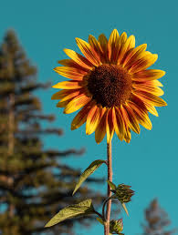
Sunflower A Sunflower B Sunflower C Sunflower D
7 x 5 cm 20 x 2 cm 5 x 10 cm 8 x 5cm

Use more than, less than signs (<, >) and = to fill in the gaps below:
Sunflower A ___________ Sunflower B
Sunflower D ___________ Sunflower C
Sunflower C ___________ Sunflower B
Sunflower B ___________ Sunflower D

