Literacy lesson pack.
Writing:
This literacy pack follows a similar format to the mathematics home learning pack however, will be a little more open-ended. I will be asking children to write in a variety of ways and in these pieces I will be looking for key skills.
Every activity in this pack should take two days to complete. Day one - planning and writing, day two – finishing planning and editing.
A dictionary of skills will be added as the front page of this pack, to re-fresh children’s memory on what each skills means.

Reading:
Reading daily with your children will benefit their overall literacy skills greatly. Exploring new books and genres of texts will open up new vocabulary for children.
Listening to children read as well as reading to your children will both be beneficial to their overall learning.
E-books are also great for those ‘reluctant readers’ and these can be accessed for free at the local library.
I have also included a specific reading activity at the end of this pack for children to carry out.

Thank you for your continued support,
Miss Weir.
Skill | Definition | Example
Fronted Adverbial | Goes at the front of the sentence to describe the verb.  It identifies when, where or how. | Before the sun came up, he ate his breakfast.  All night long, she dances.  After that, she went to bed.
Inverted commas | Punctuation marks in writing to show someone is speaking. | “I can’t believe you said that!” Sarah shouted.
Reported Speech | Representing what someone else said, indirectly. | Sarah told us that she shouted at him when she found out what he had said.
Pronouns | Replaces the noun so not to repeat the same names over again. They, Them, He, She, We | Ciara goes to the shop with Tim. They both walked their when he said, “We need to remember milk.”
Determiners | Modify a word that determines the kind of noun or noun group. | For example: An angel  A angel  The determiner is an because a angel doesn’t make sense.
TiP ToP Paragraphs | This helps you to decide when you should being a new paragraph. A new paragraph should be used when the writer is using a new:  Ti = Time P = Person  To = Topic P = Place | ……… Sam was very upset. He was unsure what he was going to tell his mum about his bad day at school.  When Sam arrived home, he settled down with a cup of tea.  Here the new paragraph shows we are in a new place. Sam is no longer at school and is now at home.
Apostrophes for plural nouns | Apostrophe is added to the noun to show that there is more than one (plural). | He received four A’s and two B’s.
Subordinating conjunctions | A conjunction (joining word) that connects two clauses.  i.e. if, since, as, when, although, while, after, before, until, because.  Acronym = I SAW A WABUB | She was good at maths because she listened carefully in class.  He went to the shops although he didn’t need to buy anything.
Imperative verbs | These are known as “bossy” verbs. They are usually found in commands or instructions. | Put the eggs in the pan.  Mix the batter.  Pour the mixture into the pot.
AFOREST Features | This is an acronym.  A = Alliteration  F = Facts  O = Opinions  R = Rhetorical questions  E = Exaggeration  S = Statistics  T = The rule of three. | Alliteration: Animals acting angrily.  Facts: It is a fact that sweets can cause tooth decay.  Opinion: This pizza is the best in the world.  Rhetorical question: Do you really want to miss out?  Exaggeration: This food will blow your taste buds away.  Statistics: 98% of people enjoy our food.  Three: stop, look and listen.
Formal Language | Ensuring that you use the appropriate language when writing a letter. | Sorry is informal and can be changed to:  ‘I am sorry to inform you that.’  Or  ‘I apologise’
Expanded noun phrase | Adding one or more adjectives to the sentence (before the noun) to expand the sentence. | For example:  The lake.  Is expanded to:  The glistening, blue lake.
Relative clause | A relative pronoun added to a clause. For example: who, which, whose, whom, that. | For example:  The woman, who called yesterday, wants to buy the house.  The teacher, that teaches French, is speaking to the class.

Activity 1 – writing a story:
Chose one or more of these images, to inspire you to write a story. You might want to plan your story carefully so that you include a beginning, a middle and an end.
Inverted commas for direct speech.
Pronouns
TiP ToP paragraphs
Don’t forget to include:
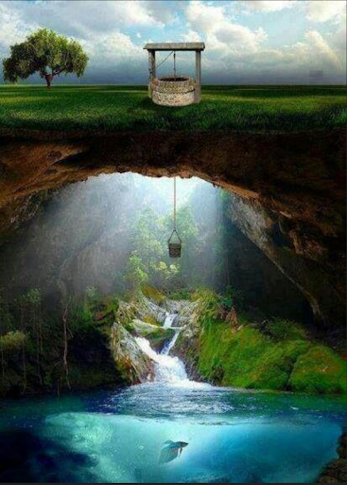
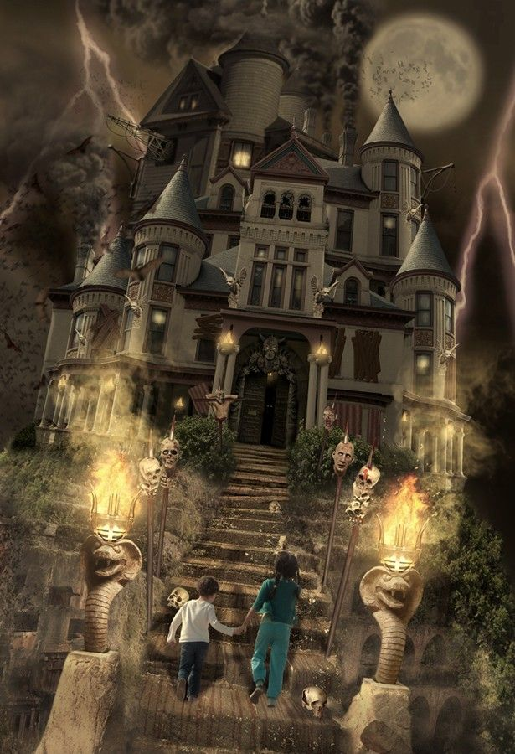
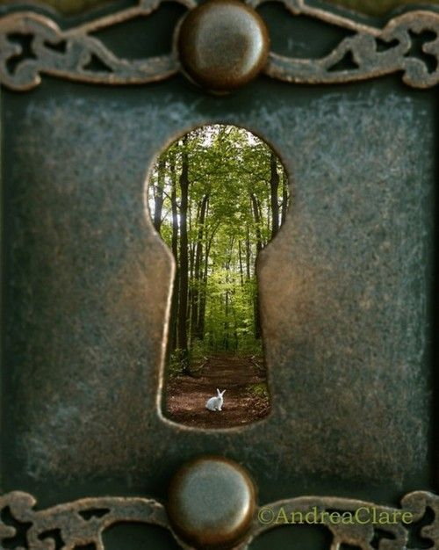

Activity 2 – newspaper report:
Above Chichester Cathedral, in the dead of night, a strange sound occurred. When the residents of Chichester ran to see where this unusual noise was coming from, they looked up and saw an Unidentified, Flying Object (UFO).
Key eye-witnesses: Sally, 63, shop keeper; Mr and Mrs Smith, 48 and 49, gardeners at Chichester Cathedral, Billy, 10.
I would like you to plan and design a newspaper report for this incident. Can you remember to include:
Inverted commas for direct speech
Reported speech
Pronouns
Alliteration (AFOREST)

Activity 3 – description writing:
Imagine you are about to pack for a holiday. Can you describe your dream holiday destination? What is the weather like? What are you going to do each day? Describe what the hotel is like.
Remember to include:
Determiners
TiP ToP paragraphs
Apostrophes for plural nouns
Activity 4 – instructional writing:
You are designing recipes for a cookbook called ‘Revolting Recipes’. This book includes ‘Worm and Crisps on toast’, ‘Snot soup with Giants Toenails’ and ‘Crusty Mud and Rice Curry’.
Can you write two new revolting recipes to go into this cookbook?
Don’t forget to include ingredients and the step-by-step method.
Remember to include:
Subordinating conjunctions
Imperative verbs
Fronted adverbials
Activity 5 – letter writing:
Suddenly, video games have been banned for anyone under the age of 13 year old by our Prime Minister, Boris Johnson. Roblox, X-box and PlayStation games ALL banned!
Write a letter to persuade Boris Johnson to either lift the ban or enforce the ban on video games.
Remember to include:
Address of the recipient and return address
Formal language
AFOREST features (Facts/opinions/Statistics)
Capital letter for proper nouns

Activity 6 – diary writing:
Imagine you are an explorer. You are spending your weekend climbing the mountainous, famous and exceptional Mount Everest.
Write a diary entry for both days. Did you make it to top? Where did you sleep? What is the temperature like?
Remember to include:
Expanded noun phrases
Relative clauses
TiP ToP paragraphs

Comprehension Activity:
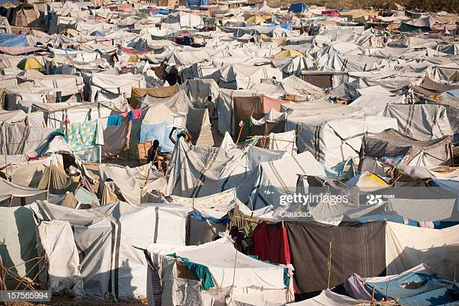
Look at the picture carefully for a couple of minutes. Discuss what you can see with another person in your house. Ask one another questions about the photo. Find out where it might have been taken.
Answer the following questions:
Why might people be living in a camp like this?

Describe the photo in your own words:

What have the tents been made from?

State TWO facts and TWO opinions about this photo:

List 5 nouns that you can see in this photo.

How does this photo make you feel?

What do you think it is like living in this camp?

This photo was taken on a sunny day. Describe what you think it would be like in the camp if it had been raining.

