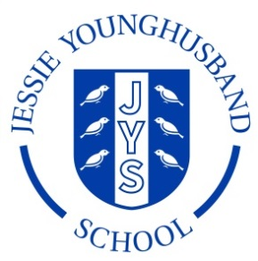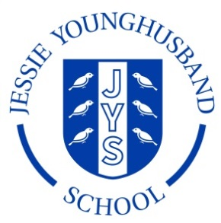

**School Council Agenda 7**

**Aspire ~ Respect ~ Enjoy**

|  |
| --- |
| Meeting of: JYS School Council |
| Place: ICT Suite |
| Date: Friday 10th May 2019 |
| Time: 13.00-13.30 |
| Apologies for absence: |
| This meeting’s business:  Chairperson: Lola Secretary: Matthew   1. Welcome the Council 2. Review the minutes from the last meeting 3. New projects 4. Are there any further projects the council would like to tackle? 5. AOB 6. Arrange date and roles for the next meeting. |