Home Learning Pack – Summer 2 – Weeks 1 and 2

Welcome back after (what I hope!) was a restful half term for you all. And, as always, I would like to extend a huge thanks to everyone who has been working so hard to complete work during these unusual times. You have all done fantastic jobs (children and parents!) and I’m very proud to have such a wonderful class.

As we move into the summer months, I have tailored a lot of this learning to be completed outside, maybe on a daily walk or in an outdoor space if you have one.

I have really enjoyed continuing to watch your videos and look at photos of your work on our JYS Year 4 Facebook group and via email, so please feel free to continue to do this.

As I’m sure you are all aware, school is starting to look a little different from this week. Many of the staff are in full time, working as hard as they can to provide learning for children both in school and outside of school. Because of this, I will be pre-recording some guided reading lessons (for Facebook) to see us through to the end of the story. I will re-address how much time I will have for this, once they finish. I’ve really enjoyed reading to the class and it’s something I would like to continue if possible.

As always, I have attached the White Rose timetable below. Happy learning everyone!

Miss Weir

Just a brief reminder before we move into this new home learning pack:

All packs have activities that can be changed and adapted as well as games that can be played more than once.
Please refer back to these packs at any time.

Date | Title | Activity
Monday 1st June | Lesson 1 – Week 5 – Recognising tenths and hundredths | Activity sheet on school website
Tuesday 2nd June | Lesson 2 – Week 5 – Equivalent fractions (1) | Activity sheet on school website
Wednesday 3rd June | Lesson 3 – Week 5 – Equivalent fractions (2) | Activity sheet on school website
Thursday 4th June | Lesson 4 – Week 5 – Fractions greater than 1 | Activity sheet on school website
Friday 6th June | Lesson 5 – Maths Challenge | White Rose Friday Challenge
WEEKEND
WEEKEND
Monday 9th June | Lesson 1 – Week 6 – Add 2 or more fractions. | Activity sheet on school website
Tuesday 10th June | Lesson 2 – Week 6 – Subtract fractions | Activity sheet on school website
Wednesday 11th June | Lesson 3 – Week 6 – fractions of quantities | Activity sheet on school website
Thursday 12th June | Lesson 4 – Week 6 – calculate fractions | Activity sheet on school website
Friday 13th June | Lesson 5 | White Rose Friday Challenge

Activity 1 – Writing:
Try out the 10 minute writing challenge on Authorfy: https://authorfy.com/10minutechallenges/ . In this challenge you should select an animal, and think about how the world might look from their perspective. If they are small you might only see chair legs and feet crashing through the house. If they are a bird, they might fly above the busy streets, watching from above.

Once you have selected your animal, think about what the world would look like from their eyes. Think about the different challenges that animal might face in a busy home or street.
Now, it’s time to get writing. Write a paragraph from that animals perspective!
Activity 2 – Art and Design:
You need to go on a colour hunt. I want you to find items inside and outside the home with are all the colours of the rainbow. You are going to use these items to create your own rainbow collage.

Don’t forget to take a photograph of your rainbow collage to share on our Facebook group!
Here is an example of what this collage might look like:

Activity 3 – Science:
Watch this clip on BBC all about Michael Faraday: https://www.bbc.co.uk/teach/class-clips-video/science-ks2-discovering-the-work-of-Michael-Faraday/zj7f47h

Michael Faraday lived 200 years ago and is most known for his work on electrical energy. Without the works of key scientists like Michael Faraday, we wouldn’t have the electrical items we have today… which leads me on to…. TODAY’S TASK:

I want you to go on an electricity hunt around your home. Make a graph similar to the one below and track how many electrical items are in your home:

Item | Purpose | Mains/Battery?
Remote control | To work the television i.e. turning it off and on. | Battery powered
Kettle | To boil water. | Mains powered

Extension: I wonder if there are any items that you were surprised to find were electrical?

Activity 4 – Literacy:
For the next set of literacy activities, you will need to watch the following clip: https://www.youtube.com/watch?v=c88QE6yGhfM
This will help you to answer questions for each activity. You might want to refer back to this clip when completing literacy work.
The first task is to pause the film after 44 seconds (as the animals emerge from their burrow) and answer the following questions:
- Where are the animals sleeping?
- What is the name for the long, seasonal sleep that some mammals partake in?
- Describe the landscape around them – what is their natural habitat?

Now pause the film at 1:27 when the vulture lands on the tree:
- What are the meerkats thinking as they climb the tree and find the fruit?
- How can you tell that the meerkats are happy to see the fruit? What gestures do they make?
- Why do they sway when they look at it?
- Describe their movements as the vulture lands.
- Do you think the vulture is going to be a hero or a villain in the story? Explain your answer.

Now pause the film at 3:24 as the fruit is dropped and none of the animals have it:
- Why do you think all of the animals are so desperate to catch it?
- What sports does the meerkat formation remind you of?
- Explain how the meerkats work as a team.
- Think of three sentences to describe the way in which the vulture moves against the meerkats.

At the end of the film talk with a partner:
- What word would you use to describe the fruit at the end of the clip?
- Who do you think won in the end?
- Do you think there is a moral to the story? What is it?

Activity 5 – Word search:
Activity 6 – Science/Design and Technology:
Watch this clip from the BBC all about Sir Isaac Newton: https://www.bbc.co.uk/teach/class-clips-video/science-ks2-discovering-the-work-of-Sir-Isaac-Newton/zr4mf4j

Sir Isaac Newton discovered gravity. Gravity is the force that pulls us back down towards earth. It is the reason that when you jump in the air, you come back down rather than float off into space.

For your science activity, I want you to explore gravity. NO you do not have to go to space, because today you will be learning about the strength of gravity.

This project is called the egg drop – it might last a couple of days or even a few weeks to complete!
- I want you to make a casing to protect your egg from cracking as you drop it from a height.
- Think carefully about the materials you use.
- The aim is for your egg to stay intact once it has hit the ground WITHOUT HARD BOILING IT…!!!

GOOD LUCK!

Activity 7 – Literacy:

Activity 8 – Design and Technology:
Linking quite closely to your previous lesson on Sir Isaac Newton and gravity, I would like you to design and build your own working catapult, but there is a catch..

You can only use sticks to build your contraption. I have attached an example of how this might look below.
You need to think carefully about:
- The angle of your catapult;
- How sturdy it is;
- What materials you might use to fix the pieces together;
- What you are going to use to shoot out of your catapult.
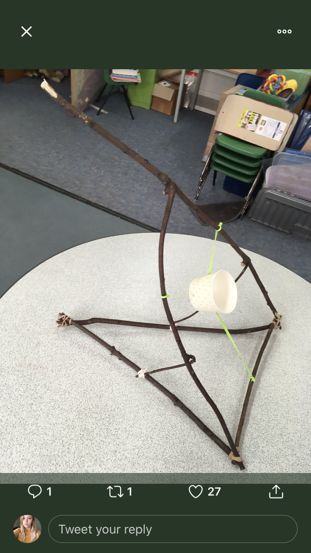
I have attached a photo of how it might look below:

Extension – maths/science: measure how far your object travels. Test what happens when you apply more/less force to your catapult.

Activity 9 – Art and Design:
This activity is simple and full of creativity. Today, I would like you to create a piece of clothing out of recycled materials. It doesn’t matter if it is footwear, a hat, a top or some trousers.

I have attached some photos of how this might look below:

Activity 10 – Literacy:
Extension: Think of a time when you have had to work within a team to achieve something. Write about it in your Literacy books. You may want to think about:
- How you organised your team;
- What you needed to do to work together;
- Any disagreements you had and how you overcame them;
- How the end result made you feel.

