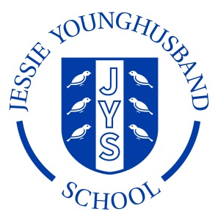

**School Council Agenda 2**

**Aspire ~ Respect ~ Enjoy**

|  |
| --- |
| Meeting of: JYS School Council |
| Place: Rainbow Room |
| Date: Wednesday 16th November |
| Time: 12.40 – 1pm |
| Apologies for absence: |
| Minutes of the last meeting:   * Are they agreed as an accurate record? * Matters arising from these minutes: **See below** |
| This meeting’s business:   1. Agree a chairperson and secretary for this meeting. 2. Discuss ground rules for school council meetings. 3. Agree a Code of Conduct for behaviour. 4. JYS pet rabbit |
| Any other business:   1. A query about the functioning of the water fountains. 2. A query about the condition of the playhouse on the small playground. 3. A query about the condition of car track. 4. Discuss results of action research at lunchtime play. |
| Date of the next meeting:  Monday 21st November ~ 12–12.15pm in the outdoor classroom |