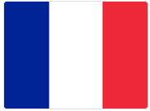 French home learning - Y3 June

Bonjour!
One of my favourite artists is the French artist, Henri Matisse. You may have looked at some of his work in KS1 – he’s very famous for pictures made of torn paper, like these:
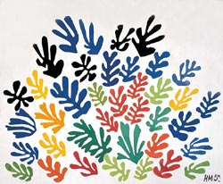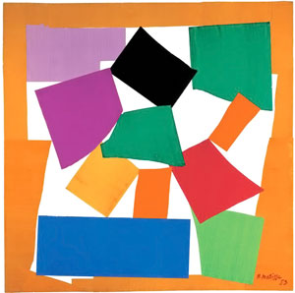

He also painted amazing bright flower pictures, like these:
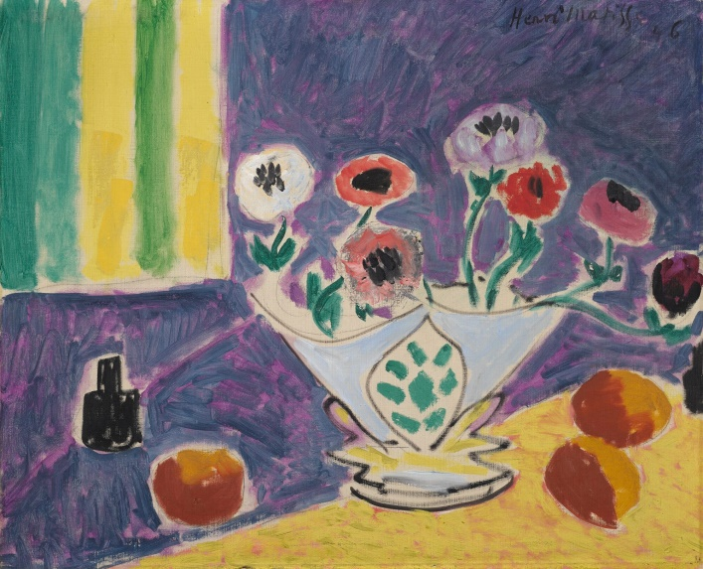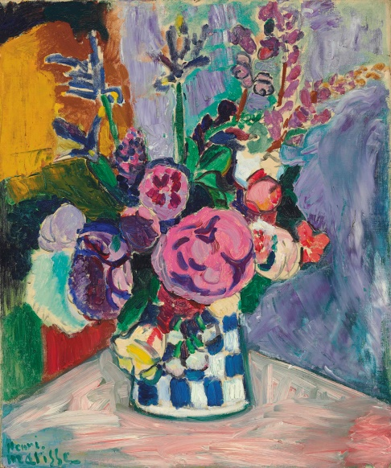

Your new task is to paint like Matisse, following the French instructions on the new Y3 powerpoint. If you get stuck, the English version is available here: https://artprojectsforkids.org/draw-like-matisse/

I hope you enjoy this new French work. Do send me a picture of your Matisse artwork at rachel.ritchie@jys.org.uk ! If you’re stuck on anything or want to ask me a question, email me and I’ll get back to you.

À bientôt! (that means ‘See you soon!’)
Madame Ritchie

