Year 1 Phonics Mat
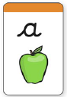
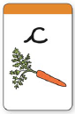
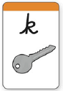
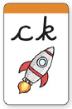
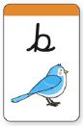
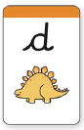
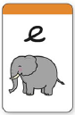
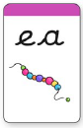
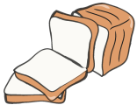
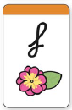
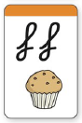
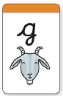
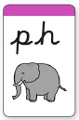
Aa Bb Cc Dd Ee Ff Gg Hh Ii Jj Kk Ll Mm Nn Oo Pp Qq Rr Ss Tt Uu Vv Ww Xx Yy Zz

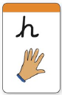
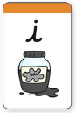
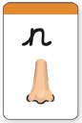
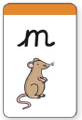
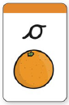
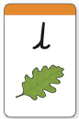
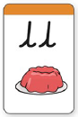
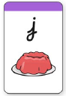
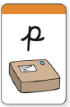
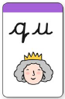
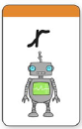
muffin
bread

nose
gem
parcel
ink
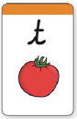
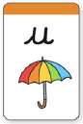
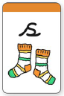
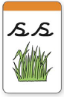
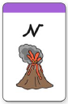
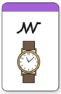
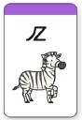
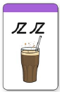
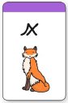
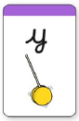
yo-yo
fizz
circus
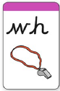
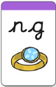
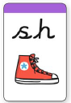
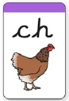
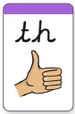

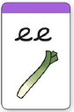
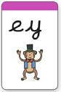
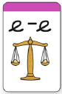
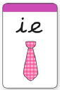
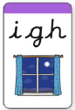
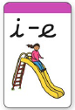
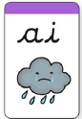
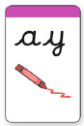
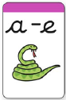
‘E’ sound
‘I’ sound
‘A’ sound
leek
night
field
even
bead
crayon

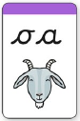
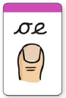
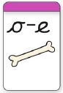
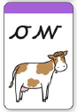
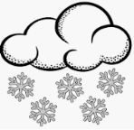
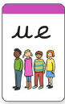
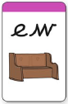
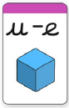
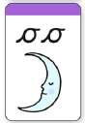
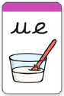
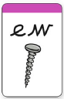
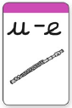
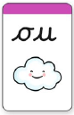

‘U’ sound
‘O’ sound
snow
soup
flute
screw
queue
glue
pew
toe
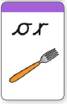
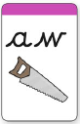
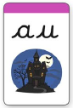
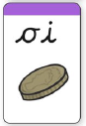
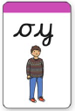
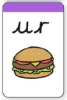
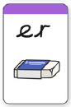
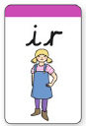
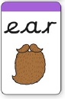
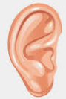
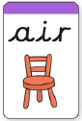
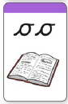
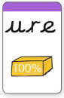
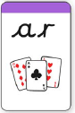
book
coin
pure
haunted
rubber

