Diet and Exercise

Introduction
Have you ever heard the phrase, ‘Your body is a temple’? What this phrase means, is that you need to treat your body with the same respect and care as you would treat an important historic or religious place. If you don’t look after your body, just like if you don’t look after a religious or historic place, it becomes damaged. Although you can’t see the damage, we know it is there thanks to medical science. In addition, you probably know about the physical effects of diet and exercise, but do you know about the mental effects too?

Eating Healthy – The Benefits
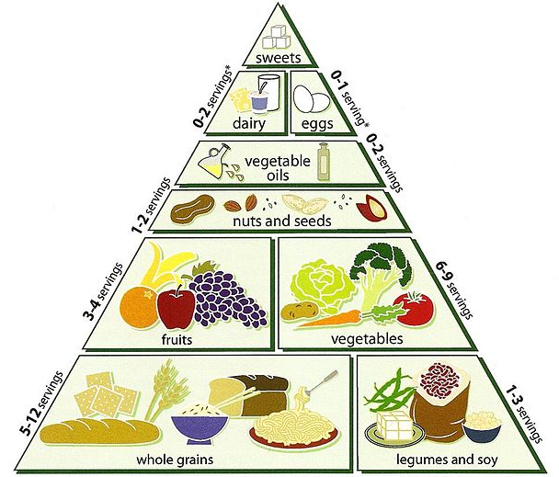
Eating the right sort of diet is one way of looking after your body. You have probably heard of eating a ‘balanced diet’ and seen a picture of a food pyramid before. Foods from the carbohydrates section of the food pyramid, such as potatoes, rice, bread, pasta and so on, give us glucose which fuels our bodies. Plant-derived foods provide us with fibre, which helps with digestion. Fibre can be found in wholemeal bread, root vegetables, bran cereals and fruit. Some food contains plenty of protein, which helps our bodies to grow and to repair themselves. Rich sources of protein include meat, fish, dairy products, eggs, beans and nuts. Vitamins also come from food and there are several types of them, all named using a letter of the alphabet. Each vitamin helps our body in different ways; for instance Vitamin C, which we can get from fruit and vegetables, helps wounds to heal and helps our immune system. Minerals, such as iron and calcium, are also important. Calcium helps to keep our bones strong and our teeth healthy – it can be found in dairy products. Iron helps our bodies to make red blood cells, which carry oxygen around our bodies – it can be found in liver, meat, beans and nuts. Eating healthily also helps us to feel more energetic and happy, while drinking enough water helps us to concentrate, and protein and fatty oils (oily fish, nuts and seeds are rich in these) keep our brains working well!
Food Pyramid

Poor Diet – The Consequences
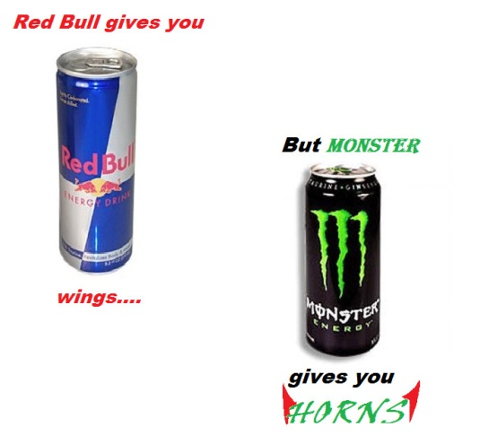
Saturated fat and sugars have negative effects on our bodies. Unfortunately they are in lots of things that people often enjoy, like cakes, sweets and fizzy drinks. Having too much saturated fat leads to high cholesterol, thus increasing your risk of heart disease. Too much refined (unnatural) sugar causes problems with how you produce or react to insulin (a hormone that controls the amount of glucose in your blood), and this can lead to a diabetes. People with diabetes need to take medication and, if diabetes is not diagnosed, it can cause blindness, kidney failure and even mean that people need to have their lower limbs amputated (surgically cut off). As well as having negative physical effects, poor diet has mental and emotional consequences. Missing meals leads to low blood sugar levels, and this can lead to low mood, irritability and fatigue. Snacks which are high in refined sugar, such as sweets and chocolate, can produce an initial surge of energy, but leave you feeling tired and low when this wears off. Healthier options, for example pulses, fruit and vegetables, don’t cause this problem, as the natural sugar in them is absorbed more slowly in the body. Some foods and drinks, for instance coffee, ‘energy’ drinks and chocolate contain caffeine. Over-consumption of caffeine has negative consequences, such as high-blood pressure, anxiety, insomnia (inability to sleep) and addiction. Finally, there is also some evidence that a good diet can help to avoid mental health problems.
Some ‘energy’ drinks

Types of Exercise
There are two main types of exercise: aerobic exercise and anaerobic exercise. Aerobic exercise makes the heart and the lungs work harder, whereas anaerobic exercise makes one or more of our muscles work harder. Running is an example of aerobic fitness, while lifting weights is an example of anaerobic exercise. Each type of exercise has different benefits, which you can read on to find out about!
Aerobic
Anaerobic
Improved Skill and Stamina
Exercise has numerous benefits for our bodies and for our minds. The more we exercise, the more physical activity we can do without becoming fatigued – in other words, the more stamina we have. Similarly, if we spend more time doing a particular sport or activity, we become better at it. A professional sportsperson spends thousands of hours exercising and training in his or her lifetime! Exercise can help us to become more agile, co-ordinated or powerful, as well as helping our balance and reaction times.

Benefits for the Circulatory System
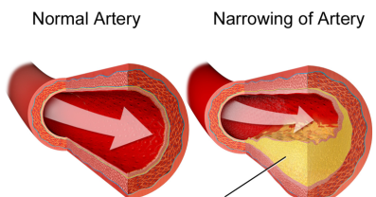
Aerobic exercise has a positive impact on the heart, the blood vessels and the lungs. It increases the size of your heart, so that it has to pump less often to get the blood around your body, making your resting heart rate lower. (Your heart rate is how often your heart beats in a minute). Reducing the stress on your heart in this way reduces your chances of heart disease in later life. Aerobic exercise also prevents the build-up of cholesterol in your arteries. Cholesterol is a substance that builds up in your arteries, making them narrower. Because they become narrower, the heart has to pump harder to push the blood through them to all parts of the body – this increases blood pressure. Increased blood pressure makes a heart attack more likely. By helping to keep blood sugar levels stable, aerobic exercise also protects against diabetes. Finally, aerobic exercise strengthens the lungs, meaning that fewer breaths are needed to take in the same amount of air; hence the lungs do not need to work as hard.
Diagram of cholesterol narrowing an artery
Other Physical Benefits
Regular exercise also helps the immune system to fight off diseases, helps our bodies to grow, improves posture (the way you hold your body), burns excess fat, makes your bones more dense (and therefore more strong), helps with digestion by speeding up the passage of food through the body, helps us to sleep because it uses up excess energy and it increases your chances of living for longer. Being outside to exercise can even help you get a vitamin (Vitamin D), which helps to prevent problems with our bones. Exercise even keeps our skin looking at its best, since it causes us to sweat and sweating keeps the pores (holes) in our skin clean!

Mental and Emotional Benefits
In addition to its physical benefits, exercise also has psychological benefits. Exercising causes the brain to release endorphins, which reduce pain and make you feel good. By reducing our blood pressure, heart rate and breathing rate, exercise makes us feel calmer and less stressed. Exercise makes us more alert and helps us to concentrate. Improving our posture and figure (the shape of our bodies) can give us more confidence and self-esteem. Sport and other activities can be great ways to make new friends and to have fun.
Sport is fun!

Exercise – The Risks
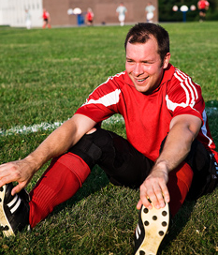
Although the benefits of exercise far outweigh the risks, you do need to be aware of what the risks are. Exercise can result in injuries, such as cuts, bruises, muscle strains and tears and fractured or broken bones. To avoid injuries, you should warm-up and cool-down, use the right technique (you can get advice on this from coaches, teachers, books and elsewhere) and not push yourself too hard, especially when getting started. Although you can do things to reduce the risk of being injured, there is always a chance that you will be unlucky and pick up an injury.
Stretching can help avoid injury

Summary
In the same way that it takes a number of people to maintain a temple, you need to do a number of things to look after your body. Just like if some people do not do their job in maintaining the temple, if you neglect any of the things above, your body and your mind will not be at their best. Diet and exercise are important for our mental and emotional well-being, as well as for our physical health.
References
http://www.nhs.uk/chq/pages/1141.aspx?categoryid=51
http://www.bbc.co.uk/northernireland/schools/4_11/uptoyou/healthy/nutrientfacts.shtml
http://www.cdc.gov/nutrition/everyone/basics/vitamins/index.html
http://www.mentalhealth.org.uk/help-information/mental-health-a-z/d/diet/
http://www.nhs.uk/conditions/Diabetes-type2/Pages/Introduction.aspx
http://www.nhs.uk/chq/pages/1124.aspx?categoryid=51
https://en.wikipedia.org/wiki/Health_effects_of_caffeine
http://www.mind.org.uk/information-support/tips-for-everyday-living/food-and-mood/#.VelpIPm6fIU
Healthy Body: Exercise and Your Body by Polly Goodman

Sources of images
Food pyramid - https://commons.wikimedia.org/wiki/File:Loma_Linda_University_Vegetarian_Food_Pyramid.jpg
Energy drinks - http://twffoma-xd.deviantart.com/art/Red-Bull-VS-Monster-165502642
Cholesterol - https://en.wikipedia.org/wiki/Coronary_artery_disease#/media/File:Blausen_0259_CoronaryArteryDisease_02.png
All other images clipart.com

