

**Year 2 Home Learning Monday 22nd June – Friday 3rd July 2020**

Hello everyone,

How are you all? I’m well and enjoying planning the Home Learning for Years 2-6. It’s so interesting to see how differently the teachers approach their individual lessons and activities.

This week, Mrs Sadler has asked me to pop in a sample timetable, for anyone who is finding it difficult to structure their days. It is only a guideline but may be helpful for reluctant learners. The lessons are flexible and can be swapped around to fit in with your schedule. It is important that the children do some work to keep up with their year group, so that they are not hugely behind next year (please feel free to pass this information on to the children).

This set of work is carrying on with the minibeasts and foodchains theme and contains lots of fun work to do with animals.

|  |  |  |  |  |  |
| --- | --- | --- | --- | --- | --- |
| **Day** | **Lesson 1** | **Lesson 2** | **Break/lunch** | **Lesson 3** | **Lesson 4** |
| Monday | Maths | Literacy |  | PE | Theme/Topic |
| Tuesday | Literacy | Maths |  | Science | French/Music |
| Wednesday | Maths | Literacy |  | Theme/Topic | Art/DT |
| Thursday | Literacy | Maths |  | RE/PSHE | Science |
| Friday | Maths | Literacy |  | Art/DT | PE |

We usually get children to do Maths and Literacy in a morning, as they are more receptive at that time of day. Afternoons can be more laid back and creative. We usually give them a short break between each lesson but our lessons are longer than 40 minutes. This is just a sample suggestion of a timetable and can be adapted. Each lesson should usually be around 30-40 minutes long. Some may take less time and some may take more. Reading should be done every day and spellings/grammar once or twice a week, in an ideal world.

Of course, I realise that this is not an ideal world and you must just do what fits in well with your family timetable. This timetable is only a suggestion.

All subject objectives, spellings, grammar can be found on this website as guidance. <http://www.primarycurriculum.me.uk/>

If you have any further questions, please do email me on [michaela.cooke@jys.org.uk](mailto:michaela.cooke@jys.org.uk) and I’ll be happy to answer your queries.

Kind Regards, Mrs Cooke ☺

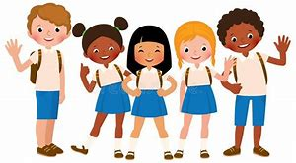

*See below for activities ☺

**Maths**

You can follow the White Rose Maths on their Home Learning webpage. For the next couple of weeks, we are working on measurement. Remember there are videos to help you and worksheets to go with them available on the JYS website. <https://whiterosemaths.com/homelearning/year-2/>

 There is also information on what the BBC Bitesize website are providing on different dates and for different year groups here <https://bam.files.bbci.co.uk/bam/live/content/zn4pyk7/pdf#sa-link_location=blocks&intlink_from_url=https%3A%2F%2Fwww.bbc.co.uk%2Fteach%2Fbitesize-daily-lessons-schedule%2Fzdtwjhv&intlink_ts=1592483499015-sa>

**Literacy activities for The Book of Butterflies**

Watch the animation ‘The Book of Butterflies’ on the Literacy Shed website.

<https://www.literacyshed.com/butterflies.html>

**Activity 1-**

Tell the story of what happens in the animation. Use sentences that use describing words to capture the beauty of the butterflies. (Use the sheet which has two pictures on it).

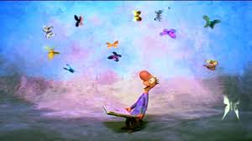

**Activity 2-**

Retell the story of The Book of Butterflies but choose another animal to come out of the book. What would happen if it were tigers, snakes or elephants that came out of the book? You can choose any animal, fish, insect, bird or other creature to come out of your book- go wild! Describe what they look like and what happens to the man. Does he stay still or do they scare him? Draw a picture of the animals coming out of the book in the blank square. (Use the sheet with the blank square).

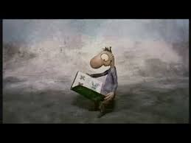

**Activity 3-**

Write a short story about the adventures of a butterfly. Where could it go? Who could it meet? Does it make friends with other animals or humans? Does it help someone? Does it get hurt and someone helps it to get better? Does it fly away to another country?

The possibilities are endless! Remember to include lots of describing words in your story.

**Correct the spelling mistake activity**

Choose the level of activity that is right for your child and either print out the sheet or copy down the sentences and complete the activity. Answers provided on separate sheet.

**Adjectives- complete the sentences using fantastic describing words.**

|  |
| --- |
| The sea is….  MPj04230510000[1] |
|  |

|  |
| --- |
| The sun is….  MPj01826760000[1] |
|  |

|  |
| --- |
| The grass is….  MPj04230580000[1] |
|  |

|  |
| --- |
| The clouds are….  MPj04229870000[1] |
|  |

|  |
| --- |
| The mountain is….  MPPH01229J0000[1] |
|  |

**Extra Literacy ideas**

If you get through your Literacy activities in the first week, have a look at these links to find lots of fun things to do that will help you with your writing.

Oak National Academy- continue with the lovely lessons on The Firework Maker’s Daughter <https://classroom.thenational.academy/subjects-by-year/year-2/subjects/english>

**Twinkl-** hundreds of activities, free to download- <https://www.twinkl.co.uk/resources/covid19-school-closures> Tailor them to your child’s needs.

## Did you know? Butterfly facts from the RSPCA

* Caterpillars have more than 4,000 separate muscles. Humans have only 792.
* Butterflies have six jointed legs, a pair of antennae and three body parts called the head, thorax (chest) and abdomen (tail end). The four wings and six legs of a butterfly are attached to its thorax.
* Butterflies have four brightly-coloured wings, covered in tiny scales. They are the only insects with scaly wings.
* Each scale on a butterfly's wing is a single colour - either red, yellow, black or white. Other colours, including green and blue, are created by light refracting on the butterfly's wings.
* Special sensors on a butterfly's feet allow the insect to taste food. It cannot taste through its mouth parts.
* Butterflies prefer pink, yellow, red or purple flowers.
* Sweet William, buddleia, lavender and echinacea are favourite food plants for butterflies.
* If you see a cluster of butterflies on wet soil this is called puddling. It is when the males draw minerals from the water and soil.

**Phonics games- Literacy**

### Phonic games

* Use the levelled reading books your child brings home from school to see how many words your child can find with a particular sound – for example, the sound ai even if it’s spelled in different ways: ay, a-e – in two minutes!
* Play full circle! Use magnetic letters to make a word. Change one letter each time to make a new word until you get back to the original. For example, ‘park-part-tart-dart-dark-park’ (you can do this with pieces of paper/card too).
* There are masses of [online phonic games](http://www.bbc.co.uk/bitesize/ks1/literacy/phonics/play/) to discover too.

**Science- Food Chains**

Watch the BBC clip about food chains. Can you draw your own food chain for either an animal or an underwater creature?

<https://www.bbc.co.uk/bitesize/clips/z96r82p>

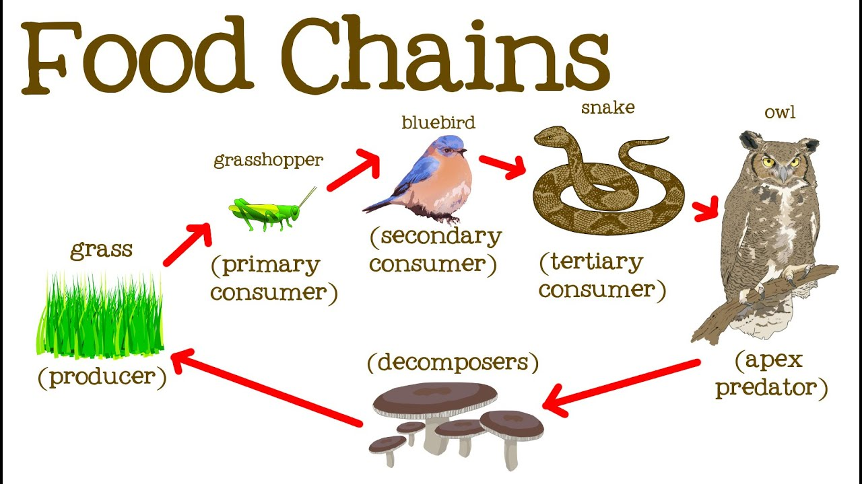

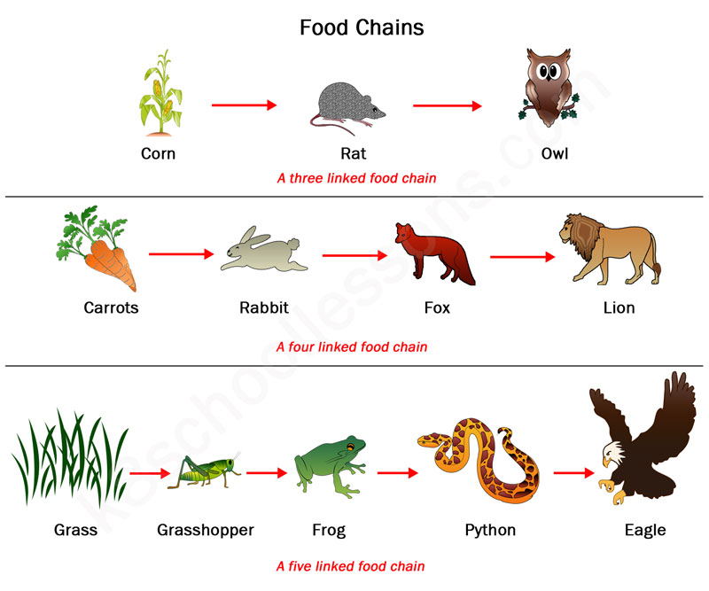

**Science- Minibeasts**

WALT: create a **tally chart, a pictogram and a bar chart** of the minibeasts found in the grounds of JYS. (Resource sheets provided separately- the ones with little beasts and charts on them).

**Minibeasts Maths activity**

# WALT: solve number problems—

Write the number sentence and draw a picture to show the problem (part whole, bar diagram, number line) – See separate sheet marked ‘butterfly 1’.

**Extra ideas for Maths**

<https://www.teachwire.net/teaching-resources/>

**Art- Activity 1-** Draw 2 separate backgrounds for the man to read his book in. The first one should be a cold background with cold colours (blue, purple, grey, white, green) and the second one should be a warm background (yellow, orange, red. Pink). Then you can draw in the man on each background or print him out and cut him out. How does each background change the way you feel about the picture? I suggest using chalk, wax crayons or pastels for this. Otherwise you could use paints. Coloured pencils and felt-tips might not be as good but will be ok if you have nothing else to hand. Get drawing!

Here are some resources to help you get started:





**Activity 2-**

Printing your own butterfly.

Get some paints and a plain piece of paper. A big one of you can. You can either draw a butterfly shape onto the paper or cut one out. Dollop bits of paint onto one side of the paper and then fold over and press down and ‘voila!’ you have a butterfly! Follow the video for more instructions. Enjoy!

<https://artfulparent.com/butterfly-symmetry-paintings/>

**DT (activity requires adult supervision)- Make a butterfly feeder**

**Make a butterfly feeder**

**Plastic bottle and cap feeder**

**What you need**

* Plastic bottle and cap
* String or garden wire
* Sugar water
* Pliers or scissor
* Small nail or drawing pin

**What to do**

1. Cut about 20cm of string/wire and place the neck of the bottle in the middle of the string/wire. Twist the wire (or tie the string) around the bottleneck until it is held tightly. Tie or twist the ends of the string/wire to make a loop, so you can hang the bottle up by its neck.
2. Using the nail/drawing pin, carefully make two holes in the bottom of the bottle. Try to make the holes as small as possible.
3. Place the bottle in a bowl and pour sugar water into the bottle. To make sugar water, dissolve some sugar in warm water. Don’t make it too sweet – one part sugar to 10 parts water should be just right. Fix the cap back on the bottle and carry the bowl and bottle outside, to avoid making a mess.
4. Hang your bottle outside in an area where you have seen butterflies. The sugar water will slowly drip out of the bottle and the butterflies will be able to drink from the puddle it makes on the ground. Try and place the feeder in a place where the butterflies will be protected from predators, for example away from trees and bushes where cats and birds can hide.
5. Remember to dispose of the bottle carefully once the feeder is empty.



## **Creepy crawly collage**

Natural objects make wonderful art materials and they provide a great sensory experience for children too.

To make a minibeast collage, collect flower petals, leaves, sticks and feathers. (Never pick wild plants, please only gather what’s fallen naturally to the ground.) You can make your creepy crawly on the woodland floor or stick your items onto a piece of card.

**Hunt for creepy crawlies.** Peep under stones and logs to find beetles, woodlice and centipedes.

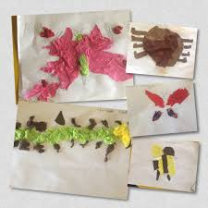 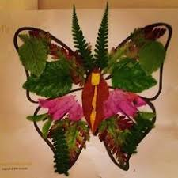 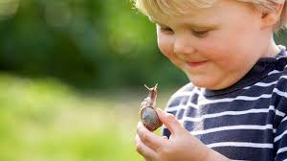

## **Ladybird potato stamps**

This craft is ideal for very small children who will enjoy making cheerful ladybirds. You can even turn them into handmade cards for family and friends.

1. Cut a potato in half and poke a stick into the rounded side – this twig handle will be easier to hold when the potato stamp gets slippery.
2. Help your child dip the potato in red paint and stamp it onto the paper. Let it dry.
3. Paint a black line down the middle of the red splodge and add a black head at one end.
4. To add spots, dip your child’s finger in the black paint and dab some dots on the body.
5. Finally, add two eyes to the head.

**Look out for ladybirds.** Keep your eyes peeled for their bright, shiny bodies. How many spots can your little one count?

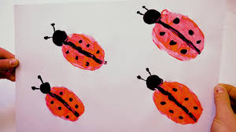 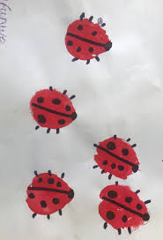

## **Rock bugs**

Youngsters will love making these cute rock bugs, all you need are some pebbles and colourful paints.

Get creative with colours and patterns, you could make beetles, bumblebees, or even a swirly snail. In fact, why not make a whole bunch of minibeasts your child can play with?

<https://www.woodlandtrust.org.uk/blog/2019/06/minibeast-activities-crafts/>

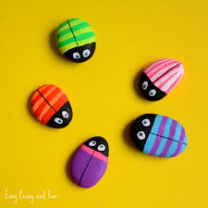 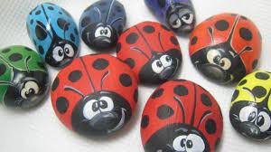

**Paper roll minibeasts**

* Cardboard Tubes or Toilet Paper Rolls one per bug or minibeast
* acrylic paint,
* pipecleaners,
* googly eyes,
* masking tape,
* acetate sheets (or similar, we used old subject dividers – acetate would be stiffer, so a case of preference or what you have at home),
* glitter (remember our [*Tinkerbell*](https://www.redtedart.com/2013/04/03/tinkerbell-clothes-pin-doll/)? Same wings!!)

**Follow the instructions on the RedTedArt website;**

<https://www.redtedart.com/cardboard-tube-minibeasts/?cn-reloaded=1>

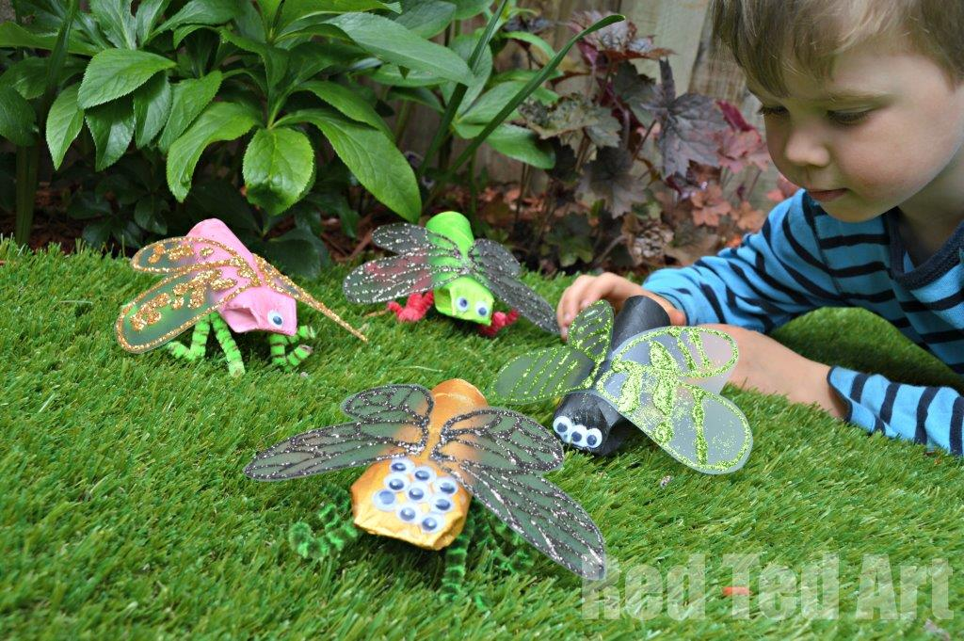

**Music- Bring on the noise!**

Fun video clips and musical activities for children in Key Stage 1.

<https://www.bbc.co.uk/teach/bring-the-noise/music-games-and-activities-for-teaching-primary-school-children/zrxmd6f>

**Minibeast cookery ideas.**

**Worms in soil**  
  
clear plastic cup  
chocolate angel delight  
crunched up dark chocolate cookie on top of angle delight  
jelly worm resting 1/2 in mix

***Dare you eat them?***

**Ladybird biscuits**

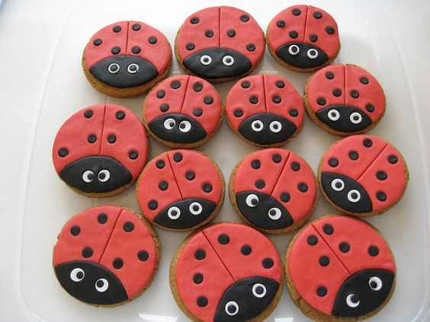

You can either decorate existing biscuits with ready-made fondant icing from the supermarket, use existing biscuits and experiment with regular icing or be adventurous and make them from scratch. Here is a link to a simple biscuit recipe;

<https://www.bbcgoodfood.com/recipes/collection/kids-biscuit>

If you prefer savoury biscuits, here is a cute recipe for cheesy ladybird biscuits. Have fun and send Mrs Saunders some photos!

<http://www.picnicsintherain.co.uk/2017/06/cheesy-ladybird-biscuits-recipe/>